Order of Worship
December 7, 2014
2nd Sunday of Advent

Prelude

Welcome Announcements & Congregational Greeting

CHIMING OF THE TRINITY

Introit Surely The Presence Of The Lord
Is In This Place Choir
Lanny Wolfe
Greeting:
The grace of the Lord Jesus Christ be with you.
And also with you
The risen Christ is with us.
Praise the Lord!

*Hymn #220 Angels From the Realms of Glory

Lighting of the Advent Wreath Johnson Family

Invitation
Christ our Lord invites to his table all who love him,
who earnestly repent of their sin
and seek to live in peace with one another.
Therefore, let us confess our sin before God and one another.

Confession and Pardon:

Merciful God, we confess that we have not loved you with our whole heart. We have failed to be an obedient church. We have not done your will, we have broken your law, we have rebelled against your love, we have not loved our neighbors, and we have not heard the cry of the needy. Forgive us we pray. Free us for joyful obedience, through Jesus Christ our Lord. Amen.

Hear the good news:
Christ died for us while we were yet sinners;
this proves God's love toward us.
In the name of Jesus Christ, you are forgiven!

In the name of Jesus Christ, you are forgiven! Glory to God! Amen.

Offering

*The Doxology

Anthem Advent Processional Choir
Anna Laura Page

Scripture Lesson Luke 3:1-18

This is the Word of God, for the people of God
Thanks be to God

Sermon “How Sweet It Is” Rev. Belman

THE GREAT THANKSGIVING

The Lord be with you.
And also with you.
Lift up your hearts.
We lift them up to the Lord
Let us give thanks to the Lord our God.
It is right to give our thanks and praise.

…And so, with your people on earth and all the company of heaven we praise your name and join their unending hymn:
Holy, holy, holy Lord, God of power and might, heaven and earth are full of your glory. Hosanna in the highest. Blessed is he who comes in the name of the Lord. Hosanna in the highest.

…And so, in remembrance of these your mighty acts in Jesus Christ, we offer ourselves in praise and thanksgiving as a holy and living sacrifice, in union with Christ’s offering for us, as we proclaim the mystery of faith.
Christ has died; Christ is risen; Christ will come again.

…All honor and glory is yours, almighty Father, now and forever.
Amen.

The Lords Prayer

Our Father, who art in heaven,
Hallowed be thy Name.
Thy Kingdom come.
Thy will be done on earth,
As it is in heaven.
Give us this day our daily bread.
And forgive us our trespasses,
As we forgive those who trespass against us.
And lead us not into temptation,
But deliver us from evil.
For thine is the kingdom,
The power, and the glory, forever.
Amen.

Giving of Bread and Cup
(It is customary to leave an offering for the poor at the
communion rail)

*Hymn #229 INFANT HOLY, INFANT LOWLY

During the singing of the closing hymn, you are invited to the altar for prayer, to unite with the church, or for other responses to
God's love.

*Benediction Gaelic Benediction Choir
Jerry Ulrich

*Postlude

*******************************

WELCOME VISITORS!

Welcome to our church family, we're glad that you could come.
We're honored to share this day with you as we worship God's risen Son. We hope that God has touched your life as we worshipped side by side and that you left this place today with the peace of God inside.

THOSE WHO SERVE THIS WEEK

Ushers: Alex Rabb and Roy Barnett
Counters: Mary Jim Gunter and Patsy Black

ANNOUNCEMENTS

- Today at 3:00 p.m., Bethel ARP Church. Messiah.
- Monday, December 8 at Noon. Luncheon, Curlee McMaster Douglas Jennings Circle
- Remember to bring an ornament to place on the tree in the Fellowship Hall. This is an ornament exchange hosted by the Young Adults.
- Mark your calendar for next Sunday, the 14th. The Children’s Christmas program will be held during the Worship Service (Children’s Time). Also, Christmas Caroling that evening. Meet at the church at 4:00 and Chili Supper following at 6:00 p.m.
- Save the Date. Holiday Drop In at the Parsonage on December 21st, 2:00 -4:00 p.m.

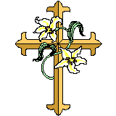 The flowers in the sanctuary this morning are placed to the Glory of God and in memory of our son, Mark’s birthday by Bundy and Betty Bynum.

A special thank you to Marcia Bonds and Family for the gift of the Advent Wreath Stand given in loving memory of Berry Bonds.

PRAYER LIST

Bill Bundy, Forest Hughes, Katherine Douglas, Tam Lark, Sara Duncan, Rev. Don McKinney, Billy Boulware, Jr., Betty Coleman, Julie Reese, Taylor Novinger, Frank Martin, Brent Dorrier, Lynne Moore, Blaine Riley, Mary Thomas, Chip, Julie and Madeline Fischesser, Stewart Goudelock, Merrill Jennings Wood, Paul Cramer, Annette Clowney, Albertia Bundy, Becky McAlister, Scott Vanvick, and family of Terrell Dyches.

When you can, please visit or send a card to

Katherine Rabb 1330 India Hook Road, Apt. 108 Rock Hill, SC 29732
Lisa Lewis Meyer The Heritage at Lowman, PO Box 444
White Rock, SC 29177
Dot Yon Goodwin House Apt. #401, 3440 S. Jefferson St.
Falls Church, VA 22041
Elise Williams Respite Care, Room 13 Fairfield Memorial Hospital, Winnsboro SC 29180
Edith McAlister 110 Summit Hills Drive, Apt. #317,
Spartanburg, SC 29307
Becky McMaster NHC Room 311, 7601 Parkland (PO Box 25548), Columbia SC 29223
Forest Hughes Fairfield Health Care, 117 Bellfield Road
Ridgeway, SC 29130
Doris Myfelt, 3195 Rio Dosa Drive #2103, Lexington, KY 40509
Susan Jackson, Harbor Chase, 1611 Constitution Blvd., Rock Hill, SC 29732

Remember to say a prayer for our men and women who are in the Armed Services both here and abroad.

Stewardship Report for November 30, 2014

Sunday School Attendance | 28
Worship Attendance | 104
Sunday School Offering | 14.00
Worship Offering | 5,243.54
Needed Each Week | 3,714.75
Received Year to Date | 184,723.64
Needed Year to Date | 178,308.00

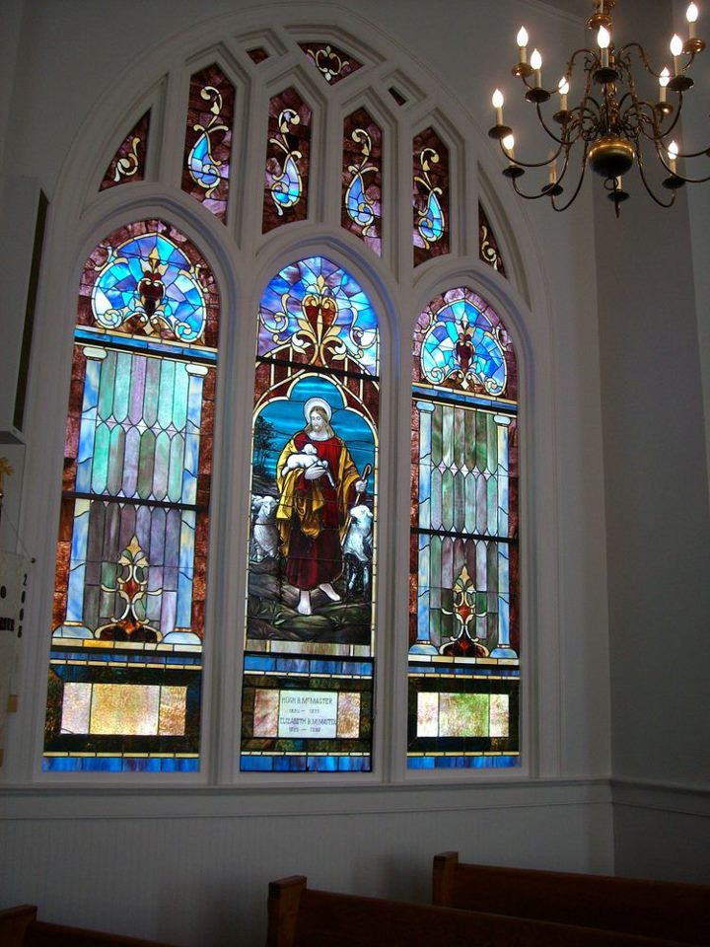
Seek God. Love All People. Change the World.

First United Methodist Church
109 W. College Street
Winnsboro, SC 29180

firstumc@hotmail.com (office)
FCWpastor@hotmail.com (pastor)
www.firstmethodistwinnsboro.com

Pastor: Rev. Julie Songer Belman
Choir Director: Wanda Neese
Organist: Esther J. Baughman
Lay Leader: Marcia Bonds
Church Secretary: Julie Barfield
Financial Secretary: Peggy H. Ayers
Treasurer: Paul Dove
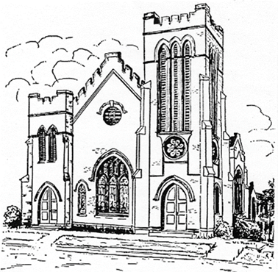
Pastor Emeritus: Rev. F. Bundy Bynum

