Order of Worship
October 19, 2014
19th Sunday after Pentecost

PRELUDE

WELCOME AND ANNOUNCEMENTS

INTROIT May the Mind of Christ My Savior CHOIR
Wilkinson/Gould

PRAYER
Living God, move among us and awaken us to your loving presence. When we lose our way and put our confidence in our possessions and our wisdom, call us back to you. Remind us that our very identity is dependent on your abiding mercy. Show us how to walk with steadfast faithfulness, following the path of justice and goodness in our daily lives. May our days be filled with joy and hope as we share the good news of abundant life that comes from following Jesus Christ. In the power of the Holy Spirit, we pray. Amen.

*HYMN: #92 For the Beauty of the Earth

MORNING PRAYER

LORD’S PRAYER WITH CHORAL RESPONSE

Our Father, who art in heaven,
Hallowed be thy Name.
Thy Kingdom come.
Thy will be done on earth,
As it is in heaven.
Give us this day our daily bread.
And forgive us our trespasses,
As we forgive those who trespass against us.
And lead us not into temptation,
But deliver us from evil.
For thine is the kingdom,
The power, and the glory, forever.
Amen.

ANTHEM What I Have I Will Give Thee CHOIR
Mark Patterson

*RESPONSIVE READING #853 Psalm 138

*GLORIA PATRI # 71 Greatorex

*AFFIRMATION OF FAITH #881

The Apostles’ Creed

I believe in God the Father Almighty,
maker of heaven and earth;
And in Jesus Christ his only Son our Lord:
who was conceived by the Holy Spirit,
born of the Virgin Mary,
suffered under Pontius Pilate,
was crucified, dead, and buried;
the third day he rose from the dead;
he ascended into heaven,
and sitteth at the right hand of God the Father Almighty;
from thence he shall come to judge the quick and the dead.
I believe in the Holy Spirit,
the holy catholic church,
the communion of saints,
the forgiveness of sins
the resurrection of the body,
and the life everlasting. Amen

CHILDREN’S TIME

OFFERTORY

*DOXOLOGY #95 Old 100th

*HYMN: #141 Children of the Heavenly Father

SCRIPTURE LESSON 2 Corinthians 9:6-15

This is the Word of God, for the people of God
Thanks be to God

SERMON “Prayer and the "S" word!” Rev. Belman

*HYMN: #102 Now Thank We All Our God

During the singing of the closing hymn, you are invited to the altar for prayer, to unite with the church, or for other responses to God's love.

*BENEDICTION Tender Shepherd CHOIR
Douglas Nolan

*POSTLUDE

WELCOME VISITORS!

Welcome to our church family, we're glad that you could come. We're honored to share this day with you as we worship God's risen Son. We hope that God will touch your life as we worship side by side and that you leave this place today with the peace of God inside.

THOSE WHO SERVE THIS WEEK

Ushers: Terry Melvin and Jackie Wilkes
Counters: Jay Lucas and Alex Rabb
Acolyte: Berkley Derrick

Announcements

- Finance Committee, Tuesday, Oct. 21st, 6:30 p.m.

Conference Room
- Daycare Feasibility Committee, Wednesday, Oct. 22, 6:00 p.m Conference Room
- Shepherd Committee, Thursday, Oct. 23, 6:00 p.m.,

Conference Room
- Halloween Carnival – Saturday, Oct. 25. 6:00 pm-8:00 pm. Please fill out the volunteer form and place in offering plate if you would like to help.
- Operation Christmas Child (Samaritan’s Purse). Shoeboxes available in Conference Room – Due back to Church by Monday, November 17

- Please sign up for flowers on the board behind the sanctuary. We have four open dates for November.

The altar flowers are given to the glory of God and in honor of the Young Adults by Bill and Lenora Bundy.

If you would like to provide altar flowers, please sign up on the flower calendar in the hall behind the sanctuary.

Prayer List

Paul Cramer, Sara Duncan, Rev. Don McKinney, Billy Boulware, Jr., Betty Coleman, Chip, Julie and Madeline Fischesser, Brent Dorrier, Frank Martin, Taylor Novinger, Lynne Moore, Mabel Ward, Mary Thomas, Rosetta Watson, Julie Reese, Russ Pearson, Stewart Goudelock, Merrill J. Wood, Carl and Katherine Douglas, Maudie Douglas, Vicky Melvin, Annette Clowney, Scott Vanvick, Becky McAlister, Albertia Bundy, Gary Brown, Blaine Riley

Please remember in prayer those serving our country in our armed forces both at home and overseas.

When you can, remember to send a card, call or visit

Susan Jackson, Harbor Chase, 116 Constitution Blvd., Rock Hill, SC 29732. Phone 803 366-7431

Dot Yon Goodwin House Apt. #401, 3440 S. Jefferson Street
Falls Church, VA 22041

Elise Williams 9423 Old Douglass Road, Blackstock, SC 29014

Edith McAlister 110 Summit Hills Drive, Apt. #317,
Spartanburg, SC 29307

Becky McMaster NHC Room 311, 7601 Parkland (PO Box 25548), Columbia SC 29223

Forest Hughes Fairfield Health Care, 117 Bellfield Road
Ridgeway, SC 29130

Katherine Rabb 1330 India Hook Road, Apt. 108 Rock Hill, SC 29732
Lisa Lewis Meyer The Heritage at Lowman, PO Box 444
White Rock, SC 29177

Mabel Ward 9370 Windsor Lake Blvd. Apt. #206 Columbia, SC 29223

Stewardship Report for October 12, 2014

Sunday School Attendance | 16
Worship Attendance | 93
Sunday School Offering | 13.00
Worship Offering | 3408.54
Needed Each Week | 3,714.75
Received Year to Date | 155,795.86
Needed Year to Date | 152,304.75

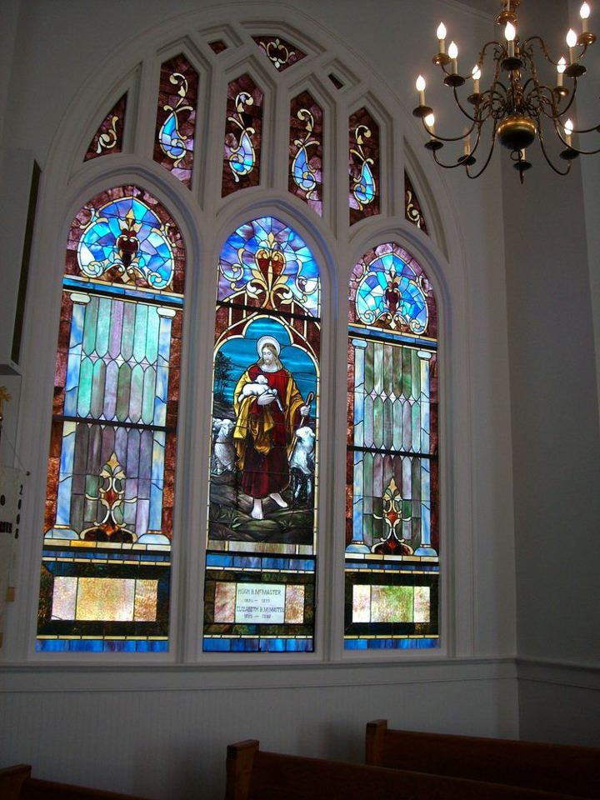

Seek God. Love All People.
Change the World.

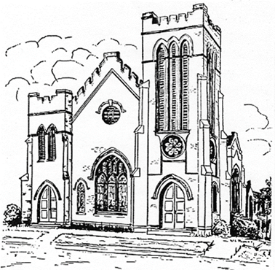
First United Methodist Church
109 W. College Street
Winnsboro, SC 29180

firstumc@hotmail.com (office)
FCWpastor@hotmail.com (pastor)
www.firstmethodistwinnsboro.com

Pastor: Rev. Julie Songer Belman
Choir Director: Wanda Neese
Organist: Esther J. Baughman
Lay Leader: Marcia Bonds
Church Secretary: Julie Barfield
Financial Secretary: Peggy H. Ayers
Treasurer: Paul Dove
Pastor Emeritus: Rev. F. Bundy Bynum

