THE FIRST WORD

2014 - 10 First United Methodist Church – 109 West College Street – Winnsboro, SC 10 - 2014

I need a silent night, a holy night
To hear an angel voice through the chaos and the noise
I need a midnight clear, a little peace right here
To end this crazy day with a silent night
Words and music by Amy Grant
If you haven’t already noticed, Christmas is on its way. In fact, since Christmas decorations have been in the stores for the past month, it’s hard to believe that we still have almost a month until the big day. And even though it amazes me every year how early everything gets displayed, I will admit something – I LOVE Christmas. It is my all-time, absolute favorite time of the entire year. The smells of cinnamon and pine needles soothe me, the hymns and songs sung only in December make my heart swell, the twinkling lights that warm up the cold, dark night skies comfort me, and the ancient story of Jesus’ birth engages and inspires me. I love everything about Christmas – the nativities and the Santa’s, the angels and the snowmen, the carols and the hymns, the trees and ornaments and gifts and family gatherings. I know that many of you love this season too. And yet I know that as wonderful as it is, the Christmas season can also spiral into a chaotic and stressful time. There are many moments when we find ourselves saying – like the Amy Grant song – I need a silent night...
This is where our faith comes to our aid for we are blessed with the wonderful season of Advent. Many of us know Advent as the season before Christmas, encompassing the four Sundays leading up to December 25th where we light candles on the Advent wreath. But Advent is more than just lighting candles. Advent is a season of preparation, of expectation, of anticipation as we remember those who waited for the birth of Christ and we in turn watch and wait for the fulfillment of Christ’s presence as the harmony for all creation. It is a season marked by long dark nights, by reflective hymns and by scriptures that challenge. Advent invites us into an active waiting, a time when we anticipate and reflect on how Christ can be born into our lives and hearts again this year. Advent gives us those “silent nights” that we long for in the commercial chaos that often leads us to Christmas...
I invite you to celebrate Advent in our church home and in your own homes. Join us for worship as we explore what it means to be an Advent people, watching and waiting for the birth of Christ. Use the resources on the next page to deepen your appreciation of this oft-forgotten season in your homes and with your family. Treasure this gift of anticipation, of expectation, of wonder as we journey towards the stable of Bethlehem.
May Advent give you the opportunity to hear the angels’ voice declaring the good news of the ages “Glory to God in the highest and on earth, peace to those on whom God’s favour rests”. May you experience God’s peace and love as we watch and wait for the birth of the One who is light and life to us all.
Blessings,
Rev. Julie Belman

OUR MINISTRY FOR
December

USHERS:
Joe Sanders and Kenny Martin

COUNTERS:
Mary Jim Gunter and Patsy Black
Sallie Kate and Donnie Laird
Alex Rabb and Jay Lucas
Roy Barnett and Jim Baughman

Acolyte:
Berkley Derrick

PRAYER LIST

The family of Carl Doulas, Forest Hughes, Susan Jackson, Sara Duncan, Billy Boulware, Jr., Betty Coleman, Becky McAlister, Brent Dorrier, Vicky Melvin, Stewart Goudelock, Frank Martin, Rev. Don McKinney, Lynne Moore, Julie Reese, Maudie Douglas, Taylor Novinger, Rosetta Watson, Merrill Jennings Wood, Mary Thomas, Chip Julie and Madeline Fischesser, Scott VanVick, Russ Pearson, Albertia Bundy, Annette Clowney, Paul Cramer, and Blaine Riley

Please, remember in prayer those serving our country in our armed forces both at home and overseas.

When you can, remember to send a card, call or visit

Mabel Ward 9370 Windsor Lake Blvd. Apt. #206 Columbia, SC 29223
Katherine Rabb 1330 India Hook Road, Westminister Towers Apt. 108
Rock Hill, SC 29732
Lisa Lewis Meyer The Heritage at Lowman, PO Box 444
White Rock, SC 29177
Dot Yon Goodwin House Apt. #401, 3440 S. Jefferson St.
Falls Church, VA 22041
Elise Williams 9423 Old Douglass Road, Blackstock, SC 29014

Edith McAlister 110 Summit Hills Drive, Apt. #317, Spartanburg, SC 29307

Becky McMaster NHC Room 228, 7601 Parkland (PO Box 25548), Columbia SC 29223

Forest Hughes Fairfield Health Care, 117 Bellfield Road, Ridgeway, SC 29130

Doris Myfelt 2195 Rio Dosa Drive #2103 Lexington, KY 40509 (859) 309-9284

Susan Jackson Harbor Chase, 1611 Constitution Blvd., Rock Hill SC 29732 (803) 366-7431

****************************
First United Methodist Church will host a
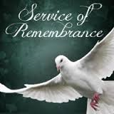
for community members who passed away this past year. This event is prepared by Pope Funeral Home. Reverend Julie Belman will perform the service. Please join us on November 30th at 6:00 p.m. as we remember family and friends who have gone ahead of us as we enter into the coming holiday season.
**********************************
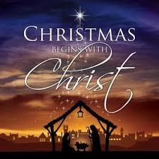
Carolina Clemson
Blood Drive

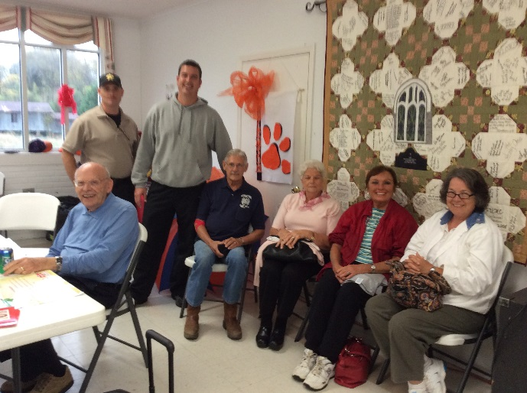

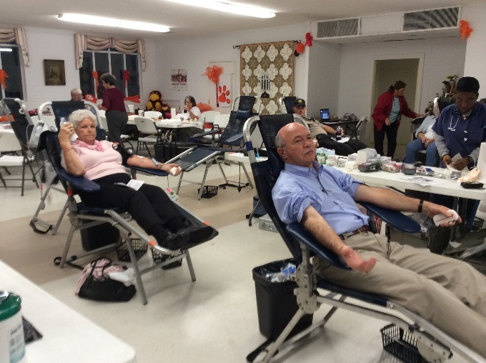

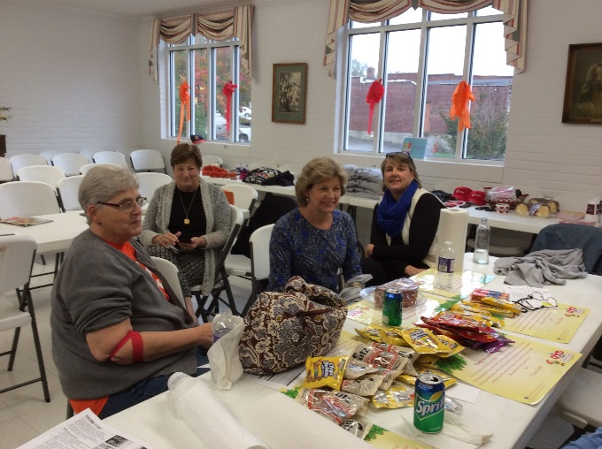

The annual American Red Cross Clemson – Carolina Blood Drive was held from 2:00 until 7:00 at First United Methodist Church in Winnsboro, SC. on Thursday November 13th. The drive was successful with thirty-five people donating. The winner of the Clemson-Carolina competition was Clemson with 23 and Carolina with twelve. Door prizes were American Red Cross T shirts, two homemade pound cakes, homemade fudge, and USC and Clemson memorabilia.

Please consider making a donation at the next local blood drive. There is a continuous need for blood all year round but especially during the holidays. Other donations to support the programs of the Fairfield County Unit of the American Red Cross may be sent to PO Box 314, Winnsboro, SC 29180 anytime.

**************************
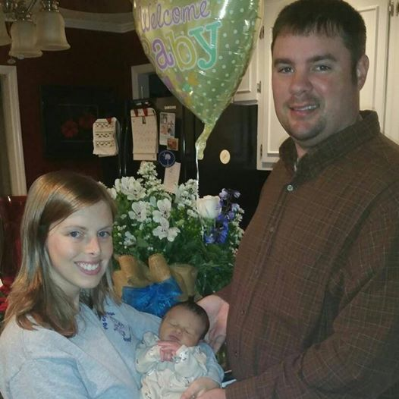

Congratulations to Sallie and Brad Williams on the birth of Wesley Bradford “Brady” Williams, Jr. A perfect 5 lb. 14 oz. bundle of joy born on November 13, 2014. We welcome Brady to the First United Methodist Church!



Summary of Committee Meetings:

** You are invited to attend all committee meeting with the exception of the SPRC (personnel related matters).

Initial Pledges for 2015 Off to a Great Start
On Commitment Sunday November 9, members submitted pledge forms for 2015. The total for the first round was $123,692, which is some $2500 above the same date in 2013 for FY 2014. Sixteen families or individuals who did not pledge last year made commitments this time, although nineteen who did pledge last year did not submit pledges on Commitment Sunday.

One of the most impressive results from the 2015 pledges thus far is the level of participation by the Church’s young adults.

Hopefully those who have not yet submitted 2015 pledges will do so as soon as possible. Current pledges are some $110,000 short of the adopted FY 2015 budget of $ 233,482.

Third quarter receipts were very healthy, and fourth quarter receipts will determine whether or not First United Methodist Church Winnsboro meets our 2014 budget of $193,167.

Parishioners who did not turn in pledge forms on Commitment Sunday are encouraged to provide forms to the church office soon so that our 2015 programs and plans can continue uninterrupted.

Changes Continue in Church’s Financial Procedures
After having studied the United Methodist booklet Finance: Handling God’s Money in the Church, members of the Financial Committee, in concert with the Church Treasurer and Financial Secretary, determined that some procedures needed revising so as to comply with standard guidelines. The booklet ascribes certain duties and responsibilities to the treasurer and others to the financial secretary. Changes include the treasurer writing checks but with one of two appointed signatories signing checks. Another change is for two appointed church members to reconcile monthly bank statements.

The booklet places strong emphasis on all church financial matters being thoroughly transparent and pointed out the value of written policies and procedures. After church officers have implemented the changes recommended by the Finance Committee and adopted by the Administrative Council, they will begin to compile a manual of policies and procedures so as to address the “best practices” described in the booklet.
Marcia Bonds and Johnny Caldwell are serving as check signatories, and Tony Caulder and Mary Jim Gunter will reconcile monthly bank statements. Church treasurer Paul Dove is consulting with a CPA acquaintance to revise accounting methods and report forms, and Financial Secretary Peggy Ayers is continuing to supervise weekly offering counting, making deposits from the offerings, keeping records of contributions, and issuing quarterly and annual statements to donors.

The manual delineates duties of the Finance Committee and its chair, the church treasurer, and the financial secretary. It also lists duties and responsibilities that do not belong to specific officers.

As the Finance Committee and staff review the automation package the Church is currently using, they will examine the financial module and make a recommendation regarding its inclusion or an alternative. Church financial matters lend themselves well to electronic technology, including records keeping, check writing, accounting, and auditing.

Our Financial Committee and its chair have taken a pro-active leadership role in addressing recommended best practices, and their efforts should result in closer compliance with standard United Methodist Church policies and procedures. This then should benefit our financial transparency and provide written guidelines for future officers and committees It will also undergird the overall mission of our church in seeking God, loving all people and changing the world.


TO MEMBERS OF OUR CHURCH FAMILY WITH BIRTHDAYS IN
December

Morgan Raley 1
Johnny Porter 3
Andrew Drake 4
Nancy Stevenswon 5
Betsy Stevenson 6
Kenny Martin 9
Sallie Watford 13
Jim Gladden 15
Jack Ivester 16
Don Gunter 29
Dot Yon 30
************************

Altar Flower Schedule

DECEMBER FLOWER CALENDAR

December 7 – Betty and Bundy Bynum

December 14 – Poinsettia’s

December 21 – Poinsettia’s

December 28 –Margaret and Bill DuBard

A special thanks to Marcia Bonds for providing the poinsettia for the altar flower.



Service of Remembrance – November 30, 6:00 p.m.
Christmas Messiah – ARP Church – December , 4:00 p.m.
Communion – December 7, 11:00 a.m.
Christmas Caroling – December 14, 4:00 p.m.
Children’s Christmas Songs during Worship Service – December 14, 11:00 a.m.
Choir Cantata – December 21, 11:00 a.m.
Ornament Exchange – Bring ornaments on Nov. 30 and pick up on December 21st.
Christmas Eve Candlelight Service – December 2, 7:30 p.m.

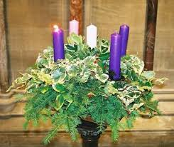The Advent Wreath Candle Holder was placed in the sanctuary by Mrs. Marcia H. Bonds and family in memory of Berry Bonds.

Around the Community
Fairfield World War II Memorial Monument Committee is seeking donations in creating a monument to those 36 young men from Fairfield County who gave their lives in the conflict. Fairfield county and the Town of Winnsboro have pledged $15,000 in matching funds for the monument. The monument will be placed on the Green at Mt. Zion where the Town will be developing a park with walkway with all the other war memorials. Pledges are $100 to $225 for engraved brick and text. Please see www.brickmarkers.com/donoar/fairfield.html. The deadline for raising funds to be matched is December 14, 2014. Don’t hesitate as time is short to make your commitment. See Donnie Laird for more info.
********
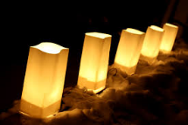 The Young Adults will be selling Luminaries again this year. The cost will be $5.00 and each luminary will be placed outside the church on Christmas Eve. Watch for order forms to be placed in the bulletin beginning December 7th. All proceeds will go to the Young Adults to be used for their programs and outreach ministries.

********
If you would like to purchase a Poinsettia for the sanctuary, the cost will be $12.50. Please call the church office (803)635-4087 and let us know the sentiment you wish to be expressed in the bulletin. Thank you.

*******

Memorials

In Memory of In Memory of
Carl Douglas Mary McCormac

Betty Jo Peay Ryan, Amy, Caleb and
Win McMaster Elaine Sheffield
Jack and Martha Wilkes
Cecelia Shaw and Family
Mary D. Douglass
Larry and Nancy Stevenson
Fred and Cindy Douglas
Linda G. Williams
Emerson and Dottie Couch
Art and Rosa Jane Brown
“Skip” and Margie Clarkson
Richard and Janice Talley Treuling
Peggy H. Ayers

Have Yourself a Merry Little Advent
Expectation. Anticipation. Wonder. All of these words describe the season of Advent, those weeks that lead up to Christmas. Advent is more than a countdown to December 25th – it is a season in and of itself. Center yourself in this wonderful season with some of these ideas for rituals that can be used year after year
Advent Wreath Many people identify the Advent wreath as a symbol of the season and it is a lovely and meaningful one. Create your own Advent wreath for your family. It doesn’t need to be elaborate or complicated – just five candles in a circle or even in a row will do the job. Here at First Church, we use three purple and one pink candle for the Sundays of Advent. In many Methodist churches, the color blue is becoming popular as it is the color of expectation. A fifth candle in white is used to symbolize the birth of Christ. If you can’t find colored candles, don’t worry about it. Any color will do. Light your wreath on Sunday evenings, along with a short devotional. Or light them every night of the week as you gather as a family. Dedicate even just 5 minutes out of your day to gather, light a candle, and pray.
Advent Calendars Now often called “Countdown to Christmas” calendars, these can be found in stores. The ones with little chocolates in them are great. Or perhaps invest in a re-usable one that you can fill with your own candy. Another idea is to put in a strip of paper with the candy and on these strips you could have either an activity to do as a family or a question to talk about as you eat together. I have included the one I will be using this year in our newsletter.
Experiences Create wonderful experiences for your family for they will be treasured long after the last toy has broken. Go to a Christmas tree farm to cut down a tree. Make some homemade ornaments (popcorn garland perhaps?) to string on the tree. Spend the afternoon baking cookies with children and grandchildren. Find some Christmas story books at the library and read them together as a family. Take out your favorite Christmas DVDs and curl up together on a chilly night to watch as a family. Travis and I always watch our favorites including “Elf”, “The Muppets Christmas Carol”, and “The Grinch Who Stole Christmas.”
Nativity Set Display your nativity set in a place where your family can interact with it and discuss the different characters in the Christmas story. If you have lots of little ones in your family, invest in a set that can be handled by small hands and that is impossible to break. “Little Peoples” makes a fabulous one that I have in my office year round!
Devotions Find an Advent devotional to read through as a family or individual. There are print versions available in stores and even free ones online that can be emailed right to your inbox every day. Ground yourself in prayer and scripture during this season.
Participate Our church is offering opportunities each week to fellowship and experience the joy of the season! Join us for our Hanging of the Greens, Service of Remembrance, Holy Communion, Messiah concert at Bethel ARP, Christmas Caroling and Chili dinner, Children’s Christmas Program and Choir Cantata! Make plans to join us for worship on Sunday morning and seasonal activities on Sunday afternoons.
May one or a few of these suggestions help you and your family to rest into God’s presence during this special season and throughout the year

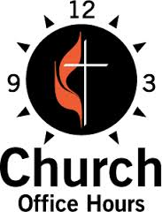
Monday, Wednesday, Thursday and Friday
8:00 a.m. until Noon (Julie Barfield)
Tuesday
9:00 a.m. until 12:30 (Peggy Ayers)
Friday
10:00 a.m. until Noon (Peggy Ayers)
******************************
To bring a Christmas ornament on Sunday, Nov. 30th for the Young Adult’s Ornament Exchange. Place your ornament on the tree in the Fellowship Hall. You can pick up another ornament on Sunday, Dec. 21.
Christmas Caroling will be the Sunday, December 14 at 4:00 p.m. followed by a Chili/Soup Supper at 6:00 p.m.


Sunday, November 30th
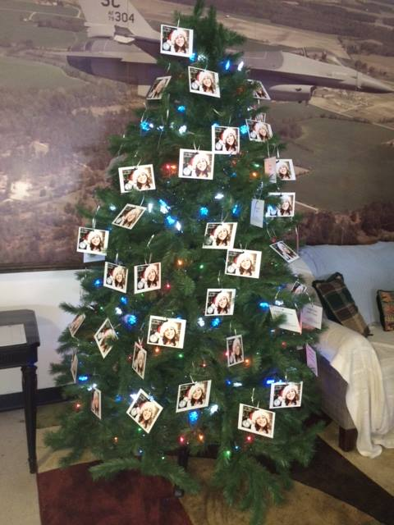 A special thank you to all who took an Epworth Christmas Tree Angel card. All cards were picked up. Gifts are due back to the church office by December 7. On behalf of Epworth, thank you!
Jane Hinnant

Mary Jim Gunter, Patsy Black, Sallie Kate Watford, Donnie Laird, Alex Rabb, Jay Lucas, Roy Barnett and Jim Baughman rotate Tuesday mornings coming to the church to count the offerings of the previous Sunday.
Win McMaster picks up the donated food every week and takes it to the Fairfield County Food Bank.
Milton Hinnant takes care of needed repairs around the church.
A special thanks to each of these dedicated members for their service in preparation of worship each week.

