Order of Worship
November 23, 2014
Last Sunday after Pentecost

PRELUDE

WELCOME AND ANNOUNCEMENTS

INTROIT Surely the Presence Of the Lord CHOIR
Is In This Place
Lanny Wolfe

PRAYER:
Almighty God, we long to rest in your gentle arms. We need your compassion as we face the challenges and disappointments of life. When our hearts are hard, and our concern is only for ourselves, turn us back to you. Remind us of your saving love and keep us close to you, Lord. Love us as only you can love, in Jesus’ name. Amen.

*HYMN: #463 Lord, Speak to Me

PASTORAL PRAYER

LORD’S PRAYER WITH CHORAL RESPONSE

Our Father, who art in heaven,
Hallowed be thy Name.
Thy Kingdom come.
Thy will be done on earth,
As it is in heaven.
Give us this day our daily bread.
And forgive us our trespasses,
As we forgive those who trespass against us.
And lead us not into temptation,
But deliver us from evil.
For thine is the kingdom,
The power, and the glory, forever.
Amen.

ANTHEM Hiding in Thee CHOIR
Sankey/Berry

*PSALTER #809 Psalm 90

*GLORIA PATRI # 71 Greatorex

*AFFIRMATION OF FAITH #881

The Apostles’ Creed

I believe in God the Father Almighty,
maker of heaven and earth;
And in Jesus Christ his only Son our Lord:
who was conceived by the Holy Spirit,
born of the Virgin Mary,
suffered under Pontius Pilate,
was crucified, dead, and buried;
the third day he rose from the dead;
he ascended into heaven,
and sitteth at the right hand of God the Father Almighty;
from thence he shall come to judge the quick and the dead.
I believe in the Holy Spirit,
the holy catholic church,
the communion of saints,
the forgiveness of sins
the resurrection of the body,
and the life everlasting. Amen

CHILDREN’S TIME

OFFERTORY

*DOXOLOGY #95 Old 100th

*HYMN 129 Give to the Winds Thy Fears

SCRIPTURE LESSON Matthew 25:1-13

This is the Word of God, for the people of God
Thanks be to God

SERMON “8 Words That Can Change Your Life!” Rev. Belman

*HYMN: #88 Maker, in Whom We Live

During the singing of the closing hymn, you are invited to the altar for prayer, to unite with the church, or for other responses to God's love.

*BENEDICTION God Be With You CHOIR
‘Till We Meet Again
Ralph Vaughan Williams

*POSTLUDE

WELCOME VISITORS!

Welcome to our church family, we're glad that you could come. We're honored to share this day with you as we worship God's risen Son. We hope that God will touch your life as we worship side by side and that you leave this place today with the peace of God inside.

THOSE WHO SERVE THIS WEEK

Ushers: Ed Gates and Heath Caldwell
Counters: Jay Lucas and Alex Rabb
Acolyte: Berkley Derrick

Announcements

Thank you to all who make the Epworth Angel gifts possible.

Food Pantry Sunday. Please bring food for the Food Pantry each Sunday to the boxes in the Narthex and we will commit this food to the glory of God on the 3rd Sunday of each month.

First Church will have a float in the Christmas Parade today, Nov. 23rd. If you would like to participate, please meet us at the church this afternoon.

The office will be closed on Thursday and Friday of this week. Happy Thanksgiving!

The altar flowers are given to the glory of God and in honor of Brad and Sallie Williams on the birth of their first son, Brady by Kay, Doug, Brock and Brice.

If you would like to provide altar flowers, please sign up on the flower calendar in the hall behind the sanctuary.

Prayer List

The family of Carl Douglas, Forest Hughes, Paul Cramer, Sara Duncan, Rev. Don McKinney, Billy Boulware, Jr., Betty Coleman, Chip, Julie and Madeline Fischesser, Brent Dorrier, Frank Martin, Taylor Novinger, Lynne Moore, Mabel Ward, Mary Thomas, Rosetta Watson, Julie Reese, Russ Pearson, Stewart Goudelock, Merrill J. Wood, Maudie Douglas, Vicky Melvin, Annette Clowney, Scott Vanvick, Becky McAlister, Albertia Bundy, Gary Brown, Blaine Riley

Please remember in prayer those serving our country in our armed forces both at home and overseas.

When you can, remember to send a card, call or visit

Doris Myfelt 3195 Rio Dosa Drive #2103, Lexington, KY 40509 (859)309-9284
Susan Jackson, Harbor Chase, 1611 Constitution Blvd., Rock Hill, SC 29732. Phone (803) 366-7431

Dot Yon Goodwin House Apt. #401, 3440 S. Jefferson Street
Falls Church, VA 22041

Elise Williams 9423 Old Douglass Road, Blackstock, SC 29014

Edith McAlister 110 Summit Hills Drive, Apt. #317,
Spartanburg, SC 29307

Becky McMaster NHC Room 311, 7601 Parkland (PO Box 25548), Columbia SC 29223

Forest Hughes Fairfield Health Care, 117 Bellfield Road
Ridgeway, SC 29130

Katherine Rabb 1330 India Hook Road, Westminister Towers, Apt. 108 Rock Hill, SC 29732

Lisa Lewis Meyer The Heritage at Lowman, PO Box 444
White Rock, SC 29177

Mabel Ward 9370 Windsor Lake Blvd. Apt. #206 Columbia, SC 29223

Stewardship Report for November 16 2014

Sunday School Attendance | 29
Worship Attendance | 99
Sunday School Offering | 19.00
Worship Offering | 3m820.24
Needed Each Week | 3,714.75
Received Year to Date | 176,728.56
Needed Year to Date | 170,878.50

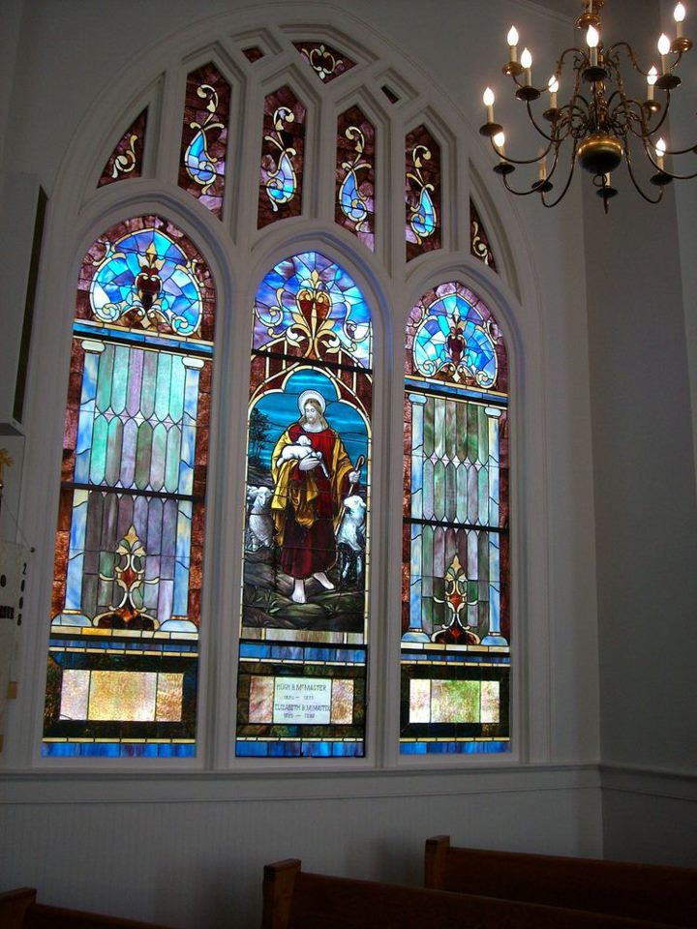

Seek God. Love All People.
Change the World.

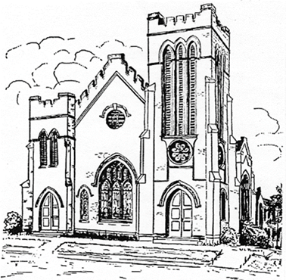
First United Methodist Church
109 W. College Street
Winnsboro, SC 29180

firstumc@hotmail.com (office)
FCWpastor@hotmail.com (pastor)
www.firstmethodistwinnsboro.com

Pastor: Rev. Julie Songer Belman
Choir Director: Wanda Neese
Organist: Esther J. Baughman
Lay Leader: Marcia Bonds
Church Secretary: Julie Barfield
Financial Secretary: Peggy H. Ayers
Treasurer: Paul Dove
Pastor Emeritus: Rev. F. Bundy Bynum

