Order of Worship
November 30, 2014
1st Sunday of Advent

PRELUDE

WELCOME AND ANNOUNCEMENTS

INTROIT O Come, O Come, Emanuel CHOIR
9C Latin/15C French

Call to Worship:
We gather together to welcome in the season of Advent.
We gather together to welcome the coming of the King.
John the Baptist prepared a way in the wilderness for the Messiah.
John cried out, “Prepare the way for the Lord, make straight paths for him.”
We cry out, “O come, o come, Emmanuel. God be with us.”
God is with us. Our Lord has come and is coming. We are here to prepare the way.

*HYMN: #196 Come, Thou Long-Expected Jesus

LIGHTING OF THE ADVENT CANDLE
Blackwelder Family

PASTORAL PRAYER:

LORD’S PRAYER WITH CHORAL RESPONSE

Our Father, who art in heaven,
Hallowed be thy Name.
Thy Kingdom come.
Thy will be done on earth,
As it is in heaven.
Give us this day our daily bread.
And forgive us our trespasses,
As we forgive those who trespass against us.
And lead us not into temptation,
But deliver us from evil.
For thine is the kingdom,
The power, and the glory, forever.
Amen.

ANTHEM Will We Know Him? CHOIR
Price/Besig

*PSALTER #807 Psalm 89

*GLORIA PATRI # 71 Greatorex

*AFFIRMATION OF FAITH #881

The Apostles’ Creed

I believe in God the Father Almighty,
maker of heaven and earth;
And in Jesus Christ his only Son our Lord:
who was conceived by the Holy Spirit,
born of the Virgin Mary,
suffered under Pontius Pilate,
was crucified, dead, and buried;
the third day he rose from the dead;
he ascended into heaven,
and sitteth at the right hand of God the Father Almighty;
from thence he shall come to judge the quick and the dead.
I believe in the Holy Spirit,
the holy catholic church,
the communion of saints,
the forgiveness of sins
the resurrection of the body,
and the life everlasting. Amen

CHILDREN’S TIME

OFFERTORY

*DOXOLOGY #95 Old 100th

HANGING OF THE GREENS

*HYMN #158 Come, Christians, Join to Sing

SCRIPTURE LESSON Luke 1:26-38

This is the Word of God, for the people of God
Thanks be to God

SERMON “Godly People” Doug Williams

*HYMN: #238 Angels We Have Heard on High

During the singing of the closing hymn, you are invited to the altar for prayer, to unite with the church, or for other responses to God's love.

*BENEDICTION Go My Children With My Blessing CHOIR
Traditional Welch

*POSTLUDE

WELCOME VISITORS!

Welcome to our church family, we're glad that you could come. We're honored to share this day with you as we worship God's risen Son. We hope that God will touch your life as we worship side by side and that you leave this place today with the peace of God inside.

THOSE WHO SERVE THIS WEEK

Ushers: Ed Gates and Heath Caldwell
Counters: Roy Barnett and Jim Baughman
Acolyte: Berkley Derrick

Announcements

Service of Remembrance – Tonight at 6:00 p.m. in the Sanctuary. Hosted by Pope Funeral Home. Service by Rev. Julie Belman. A memorial service for those who have gone before us as we enter the holiday season. Everyone is invited to attend.

Please drop off an ornament for our first annual Ornament Exchange in the Fellowship Hall. You can pick up another ornament of your choice on December 21st.

The altar flowers are given to the glory of God and in memory of Mr. Bob Caldwell by Bob and Sarah McMaster.

If you would like to provide altar flowers, please sign up on the flower calendar in the hall behind the sanctuary.

Prayer List

The family of Robert Caldwell, Forest Hughes, Katherine Douglas, Paul Cramer, Sara Duncan, Rev. Don McKinney, Billy Boulware, Jr., Betty Coleman, Chip, Julie and Madeline Fischesser, Brent Dorrier, Frank Martin, Taylor Novinger, Lynne Moore, Mabel Ward, Mary Thomas, Rosetta Watson, Julie Reese, Russ Pearson, Stewart Goudelock, Merrill J. Wood, Maudie Douglas, Vicky Melvin, Annette Clowney, Scott Vanvick, Becky McAlister, Albertia Bundy, Gary Brown, Blaine Riley

Please remember in prayer those serving our country in our armed forces both at home and overseas.

When you can, remember to send a card, call or visit

Doris Myfelt 3195 Rio Dosa Drive #2103, Lexington, KY 40509 (859)309-9284
Susan Jackson, Harbor Chase, 1611 Constitution Blvd., Rock Hill, SC 29732. Phone (803) 366-7431

Dot Yon Goodwin House Apt. #401, 3440 S. Jefferson Street
Falls Church, VA 22041

Elise Williams 9423 Old Douglass Road, Blackstock, SC 29014

Edith McAlister 110 Summit Hills Drive, Apt. #317,
Spartanburg, SC 29307

Becky McMaster NHC Room 311, 7601 Parkland (PO Box 25548), Columbia SC 29223

Forest Hughes Fairfield Health Care, 117 Bellfield Road
Ridgeway, SC 29130

Katherine Rabb 1330 India Hook Road, Westminister Towers, Apt. 108 Rock Hill, SC 29732

Lisa Lewis Meyer The Heritage at Lowman, PO Box 444
White Rock, SC 29177

Mabel Ward 9370 Windsor Lake Blvd. Apt. #206 Columbia, SC 29223

Stewardship Report for November 23 2014

Sunday School Attendance | 28
Worship Attendance | 86
Sunday School Offering | 24.00
Worship Offering | 2,757.54
Needed Each Week | 3,714.75
Received Year to Date | 179,480.10
Needed Year to Date | 174,593.25

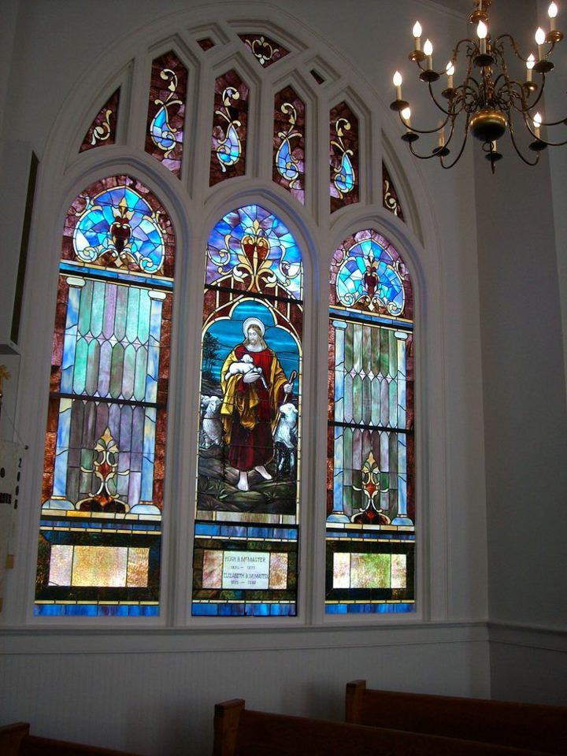

Seek God. Love All People.
Change the World.

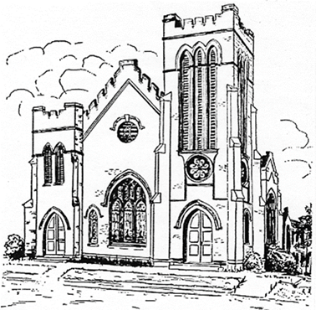
First United Methodist Church
109 W. College Street
Winnsboro, SC 29180

firstumc@hotmail.com (office)
FCWpastor@hotmail.com (pastor)
www.firstmethodistwinnsboro.com

Pastor: Rev. Julie Songer Belman
Choir Director: Wanda Neese
Organist: Esther J. Baughman
Lay Leader: Marcia Bonds
Church Secretary: Julie Barfield
Financial Secretary: Peggy H. Ayers
Treasurer: Paul Dove
Pastor Emeritus: Rev. F. Bundy Bynum

