THE FIRST WORD

2015 - 02 First United Methodist Church – 109 West College Street – Winnsboro, SC 02 - 2015

“When Jesus came to Nazareth, where he had been brought up, he went to the synagogue on the sabbath day, as was his custom. He stood up to read, and the scroll of the prophet Isaiah was given to him. He unrolled the scroll and found the place where it was written: “The Spirit of the Lord is upon me, because he has anointed me to bring good news to the poor. He has sent me to proclaim release to the captives and recovery of sight to the blind, to let the oppressed go free, to proclaim the year of the Lord’s favor.” When they heard this, all in the synagogue were filled with rage. They got up, drove him out of the town, and led him to the brow of the hill on which their town was built, so that they might hurl him off the cliff. But he passed through the midst of them and went on his way.” Luke 4, selected verses
In this text, Jesus has read the scripture and preached publicly for the first time in his home town synagogue. At first they are excited, talking about how he is one of their own. And then our text takes a wild twist: the congregation offers to take Jesus cliff diving!! And that’s when Jesus does the most bold thing of all! Here he is with people who are filled with rage, who drive him out of town, who lead him out on a cliff, who are ready to declare him forgotten, dead, worthless… they are about to “hurl him off the cliff”
And Luke says, “But Jesus passed through the midst of them and went on his way.” What?! How did Jesus do this? So often we think boldness is about what we say or how we say it. Jesus said bold things, but mostly his boldness was to remind them of God’s word. His boldness called to mind the prophets who refused to be limited. His boldness came through is demeanor, his presence, his refusal to submit to a pressure to be less than who he is. Jesus is the Savior for the world and he will not hold back.
Are YOU holding back somewhere? Can you see all the possibilities of what God is wanting for you? Where God is calling you? How God is equipping you? But in these possibilities, the world says “No!” Christ’s boldness was revealed in the calm way in which he stepped from the cliff, and simply walked through the crowd.
Where are you being pushed so far that you can see the cliff?
Where may God be calling you to pass through and go on your way boldly?
Where is the truth needing to be spoken?
Where are people needing to be reached?
Where are WE called to GO boldly?

For wherever you go, wherever you are pushed, Christ has already passed through! Jesus has already made the way clear. There is no where we go where Christ has not already gone boldly. ‘He passed through the midst of them and went on his way.’ Jesus went on his way: to be The Way for all.
My friends, in 2015 I pray we all get a FRESH START to our faith. May we move through this year boldly following Jesus Christ!


OUR MINISTRY FOR
February

USHERS:
Bob McMaster and Johnny Porter

COUNTERS:
Mary Jim Gunter and Patsy Black
Sallie Kate and Donnie Laird
Alex Rabb and Kenny Martin
Roy Barnett and Jim Baughman

Acolyte:
Berkley Derrick

PRAYER LIST

The family of Jay Lucas and the family of Billy Boulware, Jr. , Bill Bundy, Jim Baughman, Caroline Montgomery, Sara Duncan, Rev. Don McKinney, Betty Coleman, Chip, Julie and Madeline Fischesser, Brent Dorrier, Frank Martin, Taylor Novinger, Lynne Moore, Mary Thomas, Julie Reese, Tam Lark, Merrill J. Wood, Annette Clowney, Scott Vanvick, Becky McAlister, Albertia Bundy, Martha Branham Robinson, and Blaine Riley

Please, remember in prayer those serving our country in our armed forces both at home and overseas.

When you can, remember to send a card, call or visit

Doris Myfelt 3195 Rio Dosa Drive #2103, Lexington, KY 40509 (859)309-9284

Susan Jackson, Harbor Chase, 1611 Constitution Blvd., Rock Hill, SC 29732. Phone (803) 366-7431

Dot Yon Goodwin House Apt. #401, 3440 S. Jefferson Street
Falls Church, VA 22041

Elise Williams 9423 Old Douglass Road, Blackstock, SC 29014

Edith McAlister 110 Summit Hills Drive, Apt. #317,
Spartanburg, SC 29307

Becky McMaster NHC Room 311, 7601 Parkland (PO Box 25548), Columbia SC 29223

Katherine Rabb 1330 India Hook Road, Westminister Towers, Apt. 108 Rock Hill, SC 29732

Lisa Lewis Meyer The Heritage at Lowman, PO Box 444
White Rock, SC 29177

Mabel Ward 200 River Landing Unit #209, Charleston, SC 29492

Happy Valentine’s Day!

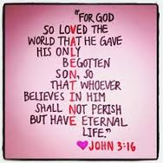

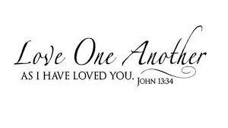

A special thank you to Doug Williams, Sarah McMaster and Jena Johnson for leading the services with our visiting ministers while Pastor Julie is on maternity leave.

 Easy Decadent Truffles

Ingredients
1 (8 ounce) package cream cheese, softened
3 cups confectioners' sugar, sifted
3 cups semisweet chocolate chips, melted
1 1/2 teaspoons vanilla

Directions
In a large bowl, beat cream cheese until smooth. Gradually beat in confectioners' sugar until well blended. Stir in melted chocolate and vanilla until no streaks remain. Refrigerate for about 1 hour. Shape into 1 inch balls.

Footnotes
Roll truffles in ground walnuts (or any ground nuts), cocoa, coconut, confectioners' sugar, candy sprinkles, etc.
To flavor truffles with liqueurs or other flavorings, omit vanilla. Divide truffle mixture into thirds. Add 1 tablespoon liqueur (almond, coffee, orange) to each mixture; mix well.

In Concert
Wanda Neese will be performing a piano concert at the Newberry Opera House on Thursday, February 12, 2015 at 8:00 p.m.


TO MEMBERS OF OUR CHURCH FAMILY WITH BIRTHDAYS IN
February

Feb. 1 Sandi Humphries
Feb 2 DeeDee Ruth
Feb. 2 Mabel Ward
Feb 5 Bobby Lee Estes
Feb. 13 Emily Raley
Feb. 20 ‘Mutt’ Stevenson
Feb. 25 Jane Lucas

************************

Altar Flower Schedule

FEBRUARY FLOWER CALENDAR

February 1 Bill & Linda Haslett

February 8 Virgil Porter

February 15

February 22

If you would like to provide altar flowers, please sign up on the flower calendar in the hall behind the sanctuary.

***************
Missing
Does anyone know where the white monogrammed aprons are? They were monogrammed by Kerri Martin and have been missing for some time. Please call if you know where they are!

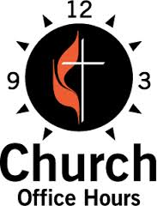
Monday, Wednesday, Thursday and Friday
8:00 a.m. until Noon (Julie Barfield)
Tuesday
9:00 a.m. until 12:30 (Peggy Ayers)
Friday
10:00 a.m. until Noon (Peggy Ayers)
******************************
If you do not receive Robo Calls from Pastor Julie, please call the church office so we can include your phone number. In the event of inclement weather, you will receive a Robo call if church is cancelled.

Sunday School offerings are an important part of our ministry to Epworth Children’s Home. Did you know that money collected the first Sunday of each month is sent directly to Epworth Children’s Home? Also, the remainder of the monies collected from Sunday School offerings is used to purchase the curriculum for all classes.
 Keyless Entry
Thank you to the Trustees for the installation of a keyless entry to the backdoor of the church. The keyless entry utilizes a code on a numeric keypad. Anyone who needs a code must see Julie Barfield. For those of you who come in and out of the church on a regular basis during the week, you will no longer need a key to enter the church. Once you are given a code for entrance into the building, you will be responsible for insuring the door closes properly upon your exit. The side door will remain locked at all times and entrance and exit into the church will be through the backdoor only (except on Sunday!) The front doors and side door will always be open on Sunday! This system will ensure the safety of the staff and the church and all things and people inside, as well as, update our existing system. We hope you find this new system convenient.

Also, a big thank you to the Trustees for having fire extinguishers installed in the sanctuary. The safety and security of our church and all who attend it is very important to us.


The Church Choir under the leadership of Wanda Neese and Esther Baughman provide our musical ministry every week. They provide music to special occasions such as Holy Week, Christmas Cantata, funerals, and weddings just to name a few.
We are blessed and fortunate to have such a powerful music ministry in this church. 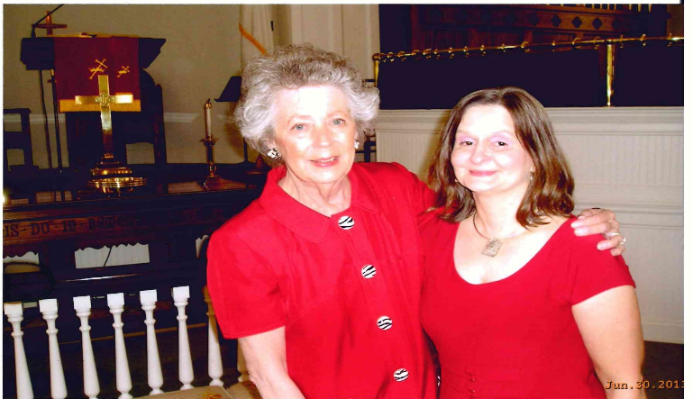
A special thanks to each of these dedicated members for their service in preparation of worship each week.

****************************
First United Methodist PreSchool
Please read this very important update on the First United Methodist PreSchool. We need your help. In order for us to start this very important ministry in this church, we need startup funds. The facility is in need of updating. We need to update the existing fire system, exit signs, handicap access, a door in one of the classrooms and several other state code enforced requirements. The cost to complete the updates and the cost of the salaries to start this program require funds that are not budgeted. We need contributions from you in order to make this ministry happen. We believe the need is so great that once we start the PreSchool, the number of children enrolled will enable the program to sustain itself. Please donate to this worthy cause. It will help the community and it will help this church move forward in a positive way. If you feel compelled to help with this ministry through a donation, please contact the church office if you need additional information. Thank you in advance.

Stewardship Report
Needed Each Week: $4,495.80
Received Year to Date: $14,543.35
Needed Year to Date: $17,983.20

In Loving Memory of
Addison Jay Lucas
February 8, 1935 – January 21, 2015

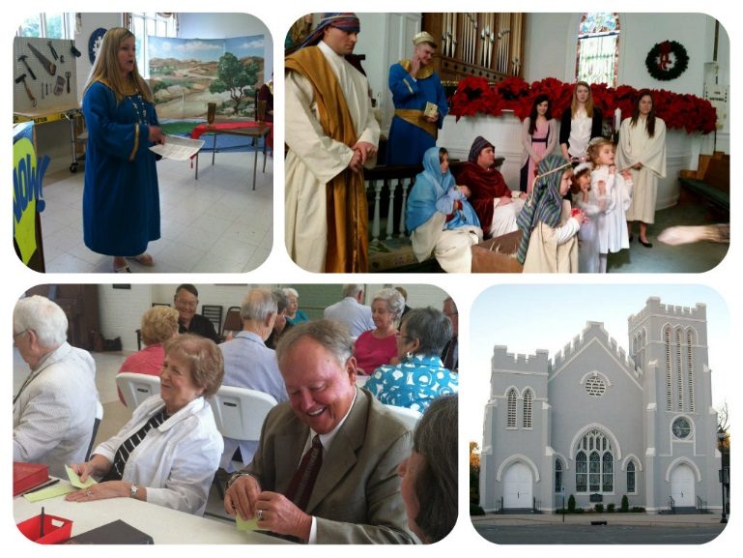

Winnsboro Lion’s Club
Pancake Supper
Monday, February 2, 2015 5:30 – 7:30 p.m.
Fairfield Elementary School
Adults $5.00/Children under 12 $4.00
Dine In or Take Out
See the Lairds, Hasletts or Doves for tickets!

 We welcome the following visiting pastors while Rev. Julie Belman is out on maternity leave:
Chaplain Clyde Scott – February 1
John Adams – February 8

Chaplain Clyde Scott – February 15
Rev. Larry Hayes – February 22
Please make every effort to attend!

Rev. Julie Maternity Leave On Call Schedule
These pastors are on call for emergencies and pastoral needs each week.
February 1-7
Rev. Steve McCormick
smmccormick@umcsc.org
cell number: 803-968-0345

February 8-14
Rev. Todd Davis
todd@bethelmethodistcolumbia.com
cell number: 803-351-1245

February 15-21
Rev. John Jordan
jkajordansc@aol.com
cell number: 805-351-0975

February 22-28
Rev. Meg Cook
mcook@epworthsc.org
cell number: 828-442-6032

March 1-7
Rev. Ally Deal
aldeal@att.net
cell number 828-551-5259

March 8-14
Rev. Mike Bruce
pastor@ashlandumc.com
cell number: 843-206-5283

March 15-21
Rev. Kathy Griffin
kgriffin@trinityblythewood.com
cell number 803-609-4412

March 22-28
Rev. Christopher Greene
jcgreene@umcsc.org
cell number: 864-316-3212

March 29 - April 4 (Holy Week)
Rev. Bundy Bynum
bbbynum@truvista.net
cell: 803-718-0224

April 5-11
Rev. Carly Wicklund
cwicklund@shandon-umc.org
cell number: 803-417-7154

April 12-18
Rev. Frank Copeland
fecopeland@umcsc.org
cell number: 864-993-6273

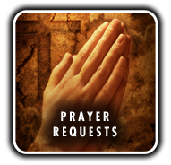 Please let us know if you have any special needs, prayer requests, or concerns. Call us 803 635 4087.

A word from the Church Office about Baby Belman:
Pastor Julie and Travis have asked the church office to send an announcement about their baby’s arrival to share the exciting news with everyone at FUMC. We will let you know when Baby Boy Belman arrives. After the Belmans come home from the hospital and have BB all settled in, you are welcome to visit! Please call Pastor Julie before you go to the parsonage (319-6169).

Memorials
In Memory of Forest Hughes
By
Jim and Esther Baughman
Paul and Bobbie Dove
Wilson Chevrolet, Inc.
Milton and Jane Hinnant
Bob and Tricia Drake
Ruby Teal
Katherine Rabb
Kathy McKinney
Martha M. Westbook-Conder
Bill and Margaret DuBard
Charles and Mazie Atkinson
Henry E. Johnson
Carroll Pope
Wilbur and Barbara Douglas
Tommy and Martha Huquenin
Fred and Lea Weed

A special gift has been given to our church in memory of Ed Teal

In Memory of Carl Douglas
By
David and Doris Barr
Ruby Teal
Tony and Beth Caulder
Milton and Jane Hinnant
Fred and Lea Weed

In Memory of Bill Boulware, Jr.
By
Bill and Linda Haslett
Bill and Margaret DuBard
Peggy H. Ayers
Win McMaster
Bo and Beth Harwell
Wilbur and Barbara Douglas
The Melvin Families
Tony and Beth Caulder
Fred and Lea Weed
Eddie and Sallie Kate Watford
Milton and Jane Hinnant
Brad and Sallie Williams

In Memory of Bob Caldwell
By
Roy and Frances Barnett
Tony and Beth Caulder
Fred and Lea Weed

In Memory of Alita Stephenson
By
Ruby Teal

In Memory of Ralph Boys
By
Ruby Teal

In Memory of Margaret McNeely
By
Bill and Linda Haslett
Eddie and Sallie Kate Watford

In Memory of Harvey Branham, Jr.
By
David and Doris Barr
Fred and Lea Weed

In Memory of Jay Lucas
By
Glenn and Jusanita Hendrix
Dean and Ann Lee and Jack Melvin
Wilbur and Barbara Douglas
Peggy H. Ayers
Jim and Esther Baughman
Tony and Beth Caulder
Paul and Bobbie Dove
David and Doris Barr
W.G. and Betsy Stevenson



