Order of Worship
March 16, 2014
Second Sunday in Lent

PRELUDE

Welcome Announcements
Congregational Greeting

INTROIT If Thou But Suffer God to Guide Thee CHOIR
Winkworth/Neumark

*Prayer

O God, you so loved the world as to give your only begotten Son, that whosoever believes in him should not perish, but have everlasting life. Grant to us the precious gift of faith, that we may know that the Son of God is come, and may have power to overcome the world and gain a blessed immortality; through Jesus Christ our Lord. Amen.

*Hymn : #98 To God Be TheGlory

Morning Prayer

Lord’s Prayer with Choral Response

Anthem Be Still CHOIR
Frombach/McDonald

RESPONSIVE READING PSALM 121 Page 844

*Gloria Patri # 71 Greatorex

*Affirmation of Faith #881 The Apostles’ Creed

Children’s Time

Offertory

*Doxology #95 Praise God from Whom All Blessings Flow Old 100th

*Hymn: #292 What Wondrous Love Is This

GOSPEL John 3: 1-17 Page:93

Sermon Where It Wills Bart Sistare

*Hymn:#297 Beneath the Cross of Jesus

*Benediction May the Mind of Christ My Saviour CHOIR
Wilkerson
*Postlude

During the singing of the closing hymn, you are invited to the altar for prayer, to unite with the church, or for other responses to God's love.

WELCOME VISITORS!

Welcome to our church family, we're glad that you could come.
We're honored to share this day with you as we worship God's risen Son. We hope that God has touched your life as we worshipped side by side and that you left this place today with the peace of God inside.

THOSE WHO SERVE THIS WEEK

Ushers: Adam Swearingen and Justin Blackwelder
Counters: Alex Rabb and Jay Lucas
Acolyte: Berkley Derrick

Announcements

- Wednesday, March 19 – Finance Committee Meeting 6:30 pm

- Wednesday, March 19 – Choir Practice 7:30 pm

*** The Bible Study; Miracles of Jesus, will be postponed until after Easter.

**** The Methodist Men will have a special guest speaker on March 25. Derial Ogburn has traveled throughout the world speading God’s message and work. He will speak to the group on Methodist missionary work focusing on his latest mission in Cuba. Please make plans to attend and invite a friend.

 The flowers in the sanctuary this morning are placed to the Glory of God and in honor of Berkley’s 14th birthday and in memory of Louis Boulware and Charlie Beach by Wanda Neese.

Prayer List

Marcia Bonds | Ann Bailey | Doris Barr
Billy Boulware, Jr. | Betty Coleman | Becky McAlister
Brent Dorrier | Frank Martin | Rev. Don McKinney
Lynne Moore | Carl Douglas | Julie Reese
Stewart Goudelock | Russ Pearson | Taylor Novinger
Rosetta Watson | Merrill Jennings Wood | Mary Thomas
Maudie Douglas | Vicky Melvin | Chip, Julie and Madeline Fischesser
Scott Vanvick

Please remember in prayer those serving our country in our armed forces both at home and overseas

When you can, remember to send a card, call or visit

Mabel Ward: The Waterford, Columbia,
Katherine Rabb: Rock Hill,
Lisa Lewis Meyer, Lowman White Rock,
Dot Yon, Falls Church, Va
Elise Williams and Edith McAlister Spartanburg,
Becky McMaster NHC, Columbia

Please remember those serving our country here and abroad.

The 2014 Flower Calendar is available if you are interested in providing flowers for worship. Please sign up in the hallway between the Fellowship Hall and Sanctuary.

STEWARDSHIP REPORT FOR MARCH 9, 2014
Sunday School Attendance 31

Worship Attendance 96
Sunday School Offering $28.00

Worship Offering $3,898.04
Needed Each Week 3,714.75

Received Year-to-Date $34,497.00 $6,789.61

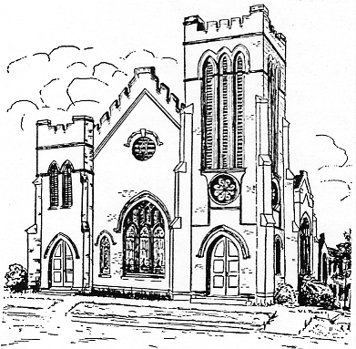
First United Methodist Church
109 W. College Street
Winnsboro, SC 29180
firstumc@hotmail.com
www.firstmethodistwinnsboro.com

Pastor: Rev. J. Bart Sistare
Choir Director: Wanda Neese
Organist: Esther J. Baughman
Lay Leader: Marcia Bonds
Church Secretary: Julie Barfield
Financial Secretary: Peggy H. Ayers
Treasurer: Paul Dove
Pastor Emeritus: Rev. F. Bundy Bynum

