THE FIRST WORD

2014 - 8 First United Methodist Church – 109 West College Street – Winnsboro, SC 8 - 2014

Showing Up
Woody Allen is famous for claiming 90% of life is just showing up!
But this begs a question: is 'just showing up' as easy as it sounds??? Woody Allen obviously never had my college professors! The ones who assigned a mere 10% of our grade to class participation and then insisted, as one of them told me pointedly, "You gotta do more for that than just show up!" (I didn't think that was fair. It was an 8 a.m. class, uphill from where I should have been still asleep. Just showing up was huge!)
So, back to the question. Showing up might not be everything, but it's the first thing. Think about exercise. Exercise is not all you need to do to be a healthy person. But it's a start. It's showing up. Exercise is sort of like prayer. It's easy to think prayer doesn't make a difference, until you start doing it regularly, and you begin to feel connected; you start to feel a part of something much bigger than you.
That's what participation means, literally: 'being a part.' It means, "I'm part of this, and it is a part of me, too." As your new pastor, one of my main job responsibilities is to help church members get engaged in the greater life of our church. As your new pastor - just showing up - even when I don’t know what I’m supposed to be doing or how to quite do it yet is a vital part of ministry.
As I meet with different committees in our church, it is clear that participation is just as important as the physical and financial concerns of our ministries. And “showing up” is something all of us can do! We can be present: physically, spiritually, and emotionally to journey together with our fellow disciples of Jesus Christ.
I have learned that participation, being a part of something we believe in, is very important to us. We who find a home in the body of Christ have a lofty goal: transforming the world into the Ways of God through the power of the gospel of love. That's huge! It's a reach. But just showing up is a start.
God can do amazing things. So can we. But we can't do it without YOU. So, I hope you will commit to showing up at First UMC Winnsboro in the coming weeks as we Seek God, Love All People, and Change the World!
Rev. Julie Belman

“The only kinds of fights worth fighting for are those you are going to lose, because somebody has to fight them and lose and lose and lose until someday, somebody who believes as you do wins. In order for somebody to win an important, major fight 100 years hence, a lot of other people have got to be willing-for the sheer fun and joy of it-to go right ahead an fight, knowing you're going to lose. You mustn't feel like a martyr. You've got to enjoy it.” I. F. Stone

OUR MINISTRY FOR
October

USHERS:
Terry Melvin and Jackie Wilkes

COUNTERS:
Mary Jim Gunter and Patsy Black
Sallie Kate and Donnie Laird
Alex Rabb and Jay Lucas
Roy Barnett and Jim Baughman

Acolyte:
Berkley Derrick

PRAYER LIST

Susan Jackson, Sara Duncan, Billy Boulware, Jr., Betty Coleman, Becky McAlister, Brent Dorrier, Vicky Melvin, Stewart Goudelock, Frank Martin, Rev. Don McKinney, Lynne Moore, Julie Reese, Maudie Douglas, Taylor Novinger, Rosetta Watson, Merrill Jennings Wood, Mary Thomas, Chip Julie and Madeline Fischesser, Scott VanVick and Russ Pearson, Carl and Katherine Douglas, Albertia Bundy, Annette Clowney, and Paul Cramer

Please, remember in prayer those serving our country in our armed forces both at home and overseas.

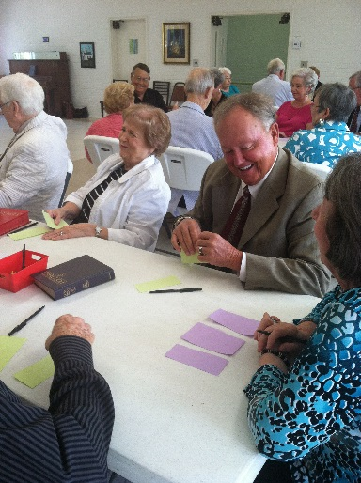

5th Sunday interactive lesson with Rev. Julie Belman

When you can, remember to send a card, call or visit

Mabel Ward 9370 Windsor Lake Blvd. Apt. #206 Columbia, SC 29223
Katherine Rabb 1330 India Hook Road, Apt. 108 Rock Hill, SC 29732
Lisa Lewis Meyer The Heritage at Lowman, PO Box 444
White Rock, SC 29177
Dot Yon Goodwin House Apt. #401, 3440 S. Jefferson St.
Falls Church, VA 22041
Elise Williams 9423 Old Douglass Road, Blackstock, SC 29014
Edith McAlister 110 Summit Hills Drive, Apt. #317,
Spartanburg, SC 29307
Becky McMaster NHC Room 228, 7601 Parkland (PO Box 25548), Columbia SC 29223
Forest Hughes Fairfield Health Care, 117 Bellfield Road
Ridgeway, SC 29130

*****************************



TO MEMBERS OF OUR CHURCH FAMILY WITH BIRTHDAYS IN
October

Dargan Broome 1 (90th)
Jef Raley 6
Betsy Boulware 7
Grey Brendle 7
Blair Hemlepp 10
Michael Hemlepp 14
Maudie Douglas 15
JoAnn Futrell 22
Heath Caldwell 24
Esther Baughman 28
Kemper McMaster 31

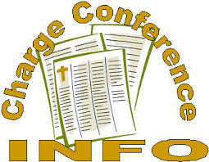

It’s time for Charge Conference. Committee Chair’s and anyone with an item to be included in the report to the District Superintendent on October 29th, please write it up and drop it in the mailbox at the church or give it to Bill DuBard.

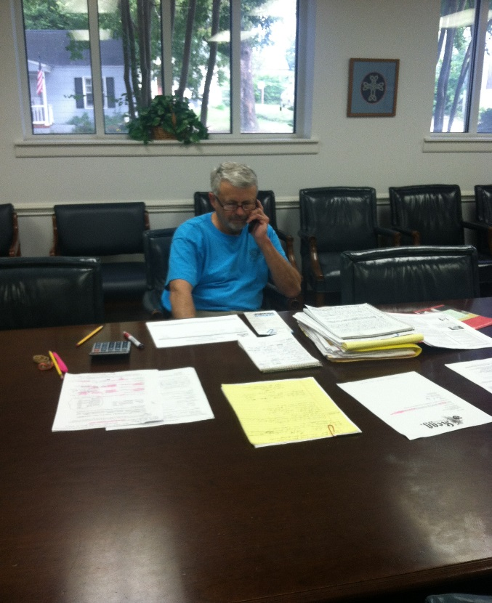
Milton Hinnant works on the Trustees budget items in preparation for the Charge Conference.

Important Announcement

Cemetary plots at the First United Methodist Cemetary are now $300.00.



Join us on Thursday, October 23 at 7:00 pm for a Family Night Supper. There will be plenty of fun and fellowship. Bring a dish and be a part of something great. See you there!

******************************


The Big Grab Yard sale was a huge success for the First United Methodist Church. The UMW made over $4500. The 2 day yard sale was a lot of hard work and a special thanks goes out to the United Methodist Women. Some notable women who worked extremely hard for days and days include Frances Porter, Barbara Martin, Beth Caulder, and Barbara Douglas. A special thanks for Paul and Bobbie Dove who served lunch to the workers on the second day! The women are already planning for next year. If you have anything you would like to donate, please bring it to the church and we will store it in the church house for next year’s event.

“Seek God, Love All People.
Change the World”

United Methodist Response to the Ebola Crisis
The Ebola crisis is especially heart-wrenching for United Methodists, because of the long-standing presence of The United Methodist Church in Liberia and Sierra Leone. Churches in the United States have strong partnerships with churches in West Africa. The missionaries are deeply thankful to their partners throughout the United Methodist connection who continue to offer prayers and support to UMCOR’s response to the Ebola crisis. United Methodist churches that want to respond to the Ebola crisis in West Africa are encouraged to:
· Pray for the people who live under the fear of this disease, the families of those who have died, and the health professionals who are caring for people who have Ebola.
· Give to UMCOR International Disaster Response, Advance #982450, so that UMCOR can continue to partner with United Methodist health boards and other organizations working to respond to this and other disasters.
· Raise awareness about Ebola and about the importance, generally, of good healthcare systems and hygiene practices.
******************************************
Altar Flower Schedule

OCTOBER FLOWER CALENDAR

October 5 – Jane and Milton Hinnant

October 12 – Sarah and Bob McMaster

October 19 – Open

October 26 – Win McMaster



Summary of Committee Meetings:

** You are invited to attend all committee meeting with the exception of the SPRC (personnel related matters).

Daycare Feasibility Committee – Met September 10. The group is on a fact finding mission. We are in the process of researching costs to open a preschool. The “assignments” include a survey for insurance costs, upgrade of the fire system, cost for personnel, inspection by the state Fire Marshall, cost for cribs and other necessities. After the State Fire Marshall visits, we will have a better outlook on the needs that will be associated with this project. Will meet again October 22 to bring information back to committee.

Finance Committee – The Finance Committee met on September 16. The committee received reports from the Treasurer and Financial Secretary for the year-to- date which indicate contributions are approximately equal to the budget. The committee is preparing the budget for 2015 to be submitted to the Administrative Council and Charge Conference for approval in October. In other actions, the committee approved a realignment of responsibilities and duties consistent with The Book of Discipline of The United Methodist Church.

Nominations Committee - Met September 25. The committee recommendations and placed calls to fill leadership roles in the various committees of the church. A list will be provided to the congregation at the next newsletter.

Memorials
In Memory of
Carol Berthold
By
Edith McAlister
In Memory of
J.B. Hegler
And
John Atkinson
By
Paul and Bobbie Dove
*************************




A trip to the hospital was not how I expected to spend my weekend. Yet, as I ordered my Sunday Supper from the hospital cafeteria, with my sweet hubby sitting beside me, all I could do was give thanks to God. The weekend was horrible in some ways and wonderful in others. I rejoice that even in the midst of pain and uncertainty, I have a family who loves me, friends who take care of me, a church who prays for me, and a God whose Holy Spirit surrounds me through all of life's storms. I am okay, and most importantly, Baby Belman is okay. Thanks to each of you for your calls, texts, prayers and support. A very special thank you to Jimmy Gladden for stepping in to the pulpit during my absence. Please continue to pray for us.
Pastor Julie
******************************
Important Dates
World Communion Sunday – Oct. 5
Blessing of the Animals – Oct. 5
Finance Committee – Oct. 21
Daycare Feasibility – Oct. 22
Shepherd Committee – Oct. 23
Family Night Supper – Oct. 23
Halloween Carnival – Oct. 25
Charge Conference – Oct. 29

What’s Happening at First United Methodist

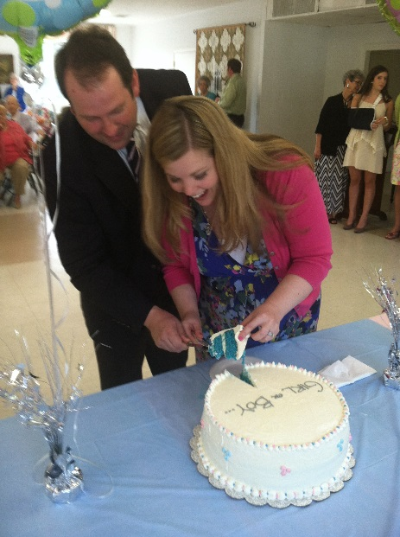
It’s a boy! We are so excited for Pastor Julie and Travis on the upcoming birth of Baby Boy Belman!

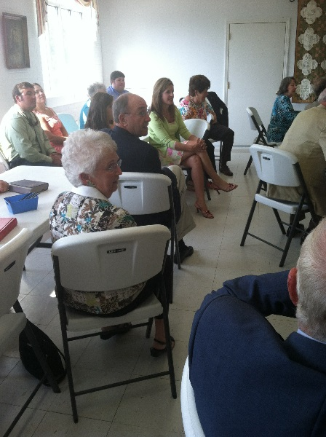
The 5th Sunday devotional and lesson.

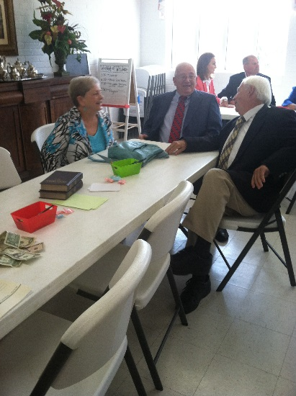
An interactive lesson. Fun was had by all!
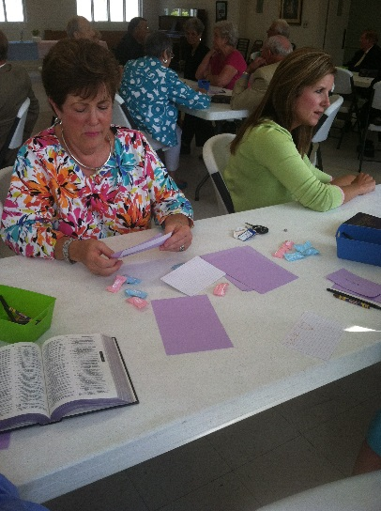
Doing her assignment!
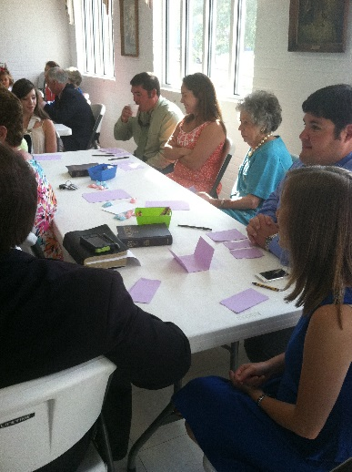
Everyone participates.

