Order of Worship
January 4, 2015
Epiphany Sunday

PRELUDE

WELCOME AND ANNOUNCEMENTS

INTROIT Once in Royal David’s City CHOIR

PRAYER:

Holy God of glory and majesty, you have called us by name. We pray in this moment for the courage and the strength to answer your call. As we open our ears to hear the story of your Son’s baptism, open our hearts also, that we may experience again the renewing power of rebirth in the Holy Spirit. Inspire us in this time of worship, that we may claim our own identity as your beloved children. We pray in the name of our brother, Jesus Christ. Amen

*HYMN: #145 Morning Has Broken

PASTORAL PRAYER

LORD’S PRAYER WITH CHORAL RESPONSE

Our Father, who art in heaven,
Hallowed be thy Name.
Thy Kingdom come.
Thy will be done on earth,
As it is in heaven.
Give us this day our daily bread.
And forgive us our trespasses,
As we forgive those who trespass against us.
And lead us not into temptation,
But deliver us from evil.
For thine is the kingdom,
The power, and the glory, forever.
Amen.

ANTHEM Gesu’ Babmino Mrs. Kerry Matthews, Soloist
Marters/Yon

*PSALTER #761 Psalm 29

*GLORIA PATRI # 71 Greatorex

*AFFIRMATION OF FAITH #881 The Apostles’ Creed

I believe in God the Father Almighty,
maker of heaven and earth;
And in Jesus Christ his only Son our Lord:
who was conceived by the Holy Spirit,
born of the Virgin Mary,
suffered under Pontius Pilate,
was crucified, dead, and buried;
the third day he rose from the dead;
he ascended into heaven,
and sitteth at the right hand of God the Father Almighty;
from thence he shall come to judge the quick and the dead.
I believe in the Holy Spirit,
the holy catholic church,
the communion of saints,
the forgiveness of sins
the resurrection of the body,
and the life everlasting. Amen

CHILDREN’S TIME

OFFERTORY

*DOXOLOGY #95 Old 100th

*HYMN #420 Breathe on Me, Breath of God

SCRIPTURE LESSON Luke 3:15-22

This is the Word of God, for the people of God
Thanks be to God

SERMON “Who Am I?  series #1 Rev. Belman

*HYMN: #400 Come, Thou Fount of Every Blessing

During the singing of the closing hymn, you are invited to the altar for prayer, to unite with the church, or for other responses to God's love.

*BENEDICTION Go My Children With My Blessing CHOIR

*POSTLUDE

WELCOME VISITORS!

Welcome to our church family, we're glad that you could come. We're honored to share this day with you as we worship God's risen Son. We hope that God will touch your life as we worship side by side and that you leave this place today with the peace of God inside.

THOSE WHO SERVE THIS WEEK

Ushers: Tony Caulder and Johnny Caldwell
Counters: Mary Jim Gunter and Patsy Black

Announcements

***Choir Party – Sunday, Jan. 4 at Esther and Jim’s, 6:00 p.m.

Women’s Winter/Spring Bible Study at Honeysuckle Acres, beginning January 5&6 at 9:30 a.m. Identical sessions each Monday and Tuesday morning. We will end on March 23&24. RSVP to Pat Frish at 635-7583 or e-mail hpfrish@yahoo.com

Daniel – Lives of Integrity Words of Prophecy by Beth Moore

Just as the prophet Daniel faced unbelievable pressure to compromise his faith in a hostile culture and was constantly confronted by temptations and threats, todays believers face similar trials.

The class consists of twelve sessions ending on March 23 & 24, 2015. Cost of the workbook is $16.00 payable the first week. You may reuse your Daniel study guide if you can find it). The classes are non-denominational. Because we all have a saving knowledge of Jesus Christ we are all one body-the body of Christ. Eschatology (end-time events) will be studied and all interpretations will be discussed. Please feel free to invite your friends.

The altar flowers are given to the glory of God and in memory of loved ones by Marcia Bonds.

If you would like to provide altar flowers, please sign up on the flower calendar in the hall behind the sanctuary.

Prayer List

Jim Baughman, Bill Bundy, Jay Lucas, Caroline Montgomery, Sara Duncan, Rev. Don McKinney, Billy Boulware, Jr., Betty Coleman, Chip, Julie and Madeline Fischesser, Brent Dorrier, Frank Martin, Taylor Novinger, Lynne Moore, Mary Thomas, Julie Reese, Tam Lark, Merrill J. Wood, Maudie Douglas, Annette Clowney, Scott Vanvick, Becky McAlister, Albertia Bundy, Martha Branham Robinson, and Blaine Riley

Please remember in prayer those serving our country in our armed forces both at home and overseas.

When you can, remember to send a card, call or visit

Doris Myfelt 3195 Rio Dosa Drive #2103, Lexington, KY 40509 (859)309-9284

Susan Jackson, Harbor Chase, 1611 Constitution Blvd., Rock Hill, SC 29732. Phone (803) 366-7431

Dot Yon Goodwin House Apt. #401, 3440 S. Jefferson Street
Falls Church, VA 22041

Elise Williams 9423 Old Douglass Road, Blackstock, SC 29014

Edith McAlister 110 Summit Hills Drive, Apt. #317,
Spartanburg, SC 29307

Becky McMaster NHC Room 311, 7601 Parkland (PO Box 25548), Columbia SC 29223

Katherine Rabb 1330 India Hook Road, Westminister Towers, Apt. 108 Rock Hill, SC 29732

Lisa Lewis Meyer The Heritage at Lowman, PO Box 444
White Rock, SC 29177

Mabel Ward 200 River Landing Unit #209, Charleston, SC 29492

Stewardship Report for December 28 2014

Sunday School Attendance | 25
Worship Attendance | 86
Sunday School Offering | 20.00
Worship Offering | 4,542.54
Needed Each Week | 3,714.75
Received Year to Date | 203,936.07
Needed Year to Date | 193,167.00

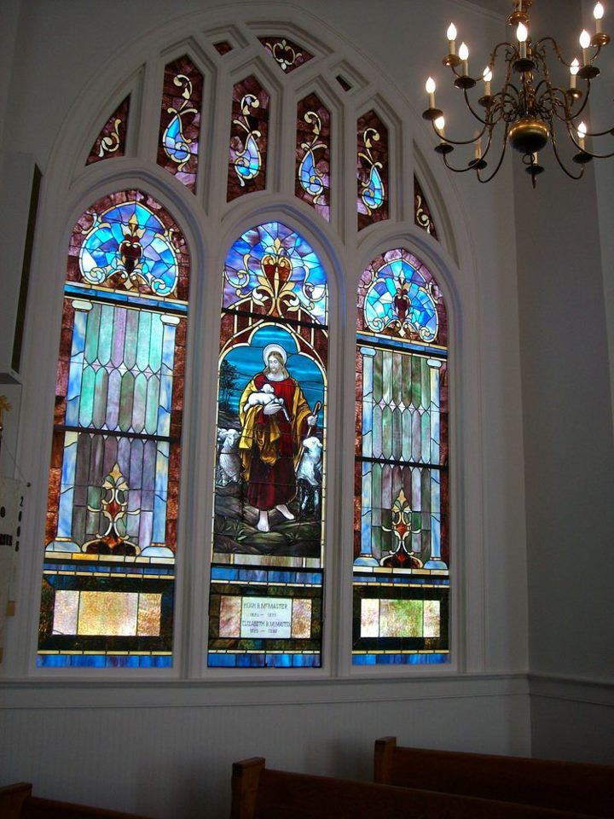

Seek God. Love All People.
Change the World.

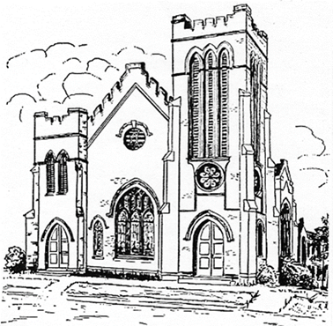
First United Methodist Church
109 W. College Street
Winnsboro, SC 29180

firstumc@hotmail.com (office)
FCWpastor@hotmail.com (pastor)
www.firstmethodistwinnsboro.com

Pastor: Rev. Julie Songer Belman
Choir Director: Wanda Neese
Organist: Esther J. Baughman
Lay Leader: Doug Williams
Church Secretary: Julie Barfield
Financial Secretary: Peggy H. Ayers
Treasurer: Paul Dove
Pastor Emeritus: Rev. F. Bundy Bynum

