THE FIRST WORD

2014 - 9 First United Methodist Church – 109 West College Street – Winnsboro, SC 9 - 2014

“Each should use whatever gift you have received to serve others, as faithful stewards of God’s grace.” 1 Peter 4:10
Fall is my favorite season: leaves changing colors, the crisp air, football, pumpkins (and pumpkin pie!) the State Fair… what's not to love?! A beloved book of mine is The Fall of Freddie the Leaf by Leo Buscalgia. It's a story about life and death, beginnings and endings, the seasons of our lives. The book was written to help children understand the difficult nature of death, but it has a great deal of hope and resurrection in its pages.
Freddie is part of a huge tree and is surrounded by hundreds of other leaves just like him. His best friend Daniel is the oldest and wisest leaf on their branch. Freddie asks Daniel why the leaves turn different colors in the fall even though they are on the same tree. Daniel replies, "Each of us is different. We have had different experiences. We have faced the sun differently. We have cast shade differently. Why should we not have different colors?"
This month, as you re-commitment yourself to upholding the church with your prayers, your presence, your gifts, your service and your witness, I invite you to consider what First Methodist Winnsboro means to you. How the ministries of our church have brought about change and transformation in your heart, and along your faith journey. How First Methodist Winnsboro has encouraged and challenged you to grow as a disciple; how it has embraced and supported you in your struggles; how it has shone the light of God's love into dark corners of the world.
Members of a church are like leaves with different colors on the same tree - we may experience church differently, but we are all part of the Body of Christ. We gather around the table and are fed with food and fellowship at Family Night Suppers. Through Sunday School we challenge one another to dig deeper in faith. Through the music, prayers, and proclamation, we engage in worship that is relevant and uplifting. We offer healing and hope through our caring outreach and in-reach with visits, prayers, telephone calls, rides, meals and on and on. We spread the good news of God's love through impressive mission work, both hands on and financially - far too numerous to list.
Think about commonalities that ground us and differences that make us unique in our own colors and symbols and understandings of life and how we relate to the world. We all have different resources and talents, but we are all called to share what we have. May your faith grow and blossom as you commit yourself anew to the mission and ministries of First United Methodist Church of Winnsboro in the coming year.
Peace and love,
Rev. Julie Belman

OUR MINISTRY FOR
November

USHERS:
Ed Gates and Heath Caldwell

COUNTERS:
Mary Jim Gunter and Patsy Black
Sallie Kate and Donnie Laird
Alex Rabb and Jay Lucas
Roy Barnett and Jim Baughman

Acolyte:
Berkley Derrick

PRAYER LIST

Susan Jackson, Sara Duncan, Billy Boulware, Jr., Betty Coleman, Becky McAlister, Brent Dorrier, Vicky Melvin, Stewart Goudelock, Frank Martin, Rev. Don McKinney, Lynne Moore, Julie Reese, Maudie Douglas, Taylor Novinger, Rosetta Watson, Merrill Jennings Wood, Mary Thomas, Chip Julie and Madeline Fischesser, Scott VanVick and Russ Pearson, Carl and Katherine Douglas, Albertia Bundy, Annette Clowney, Paul Cramer, and
Blaine Riley

Please, remember in prayer those serving our country in our armed forces both at home and overseas.

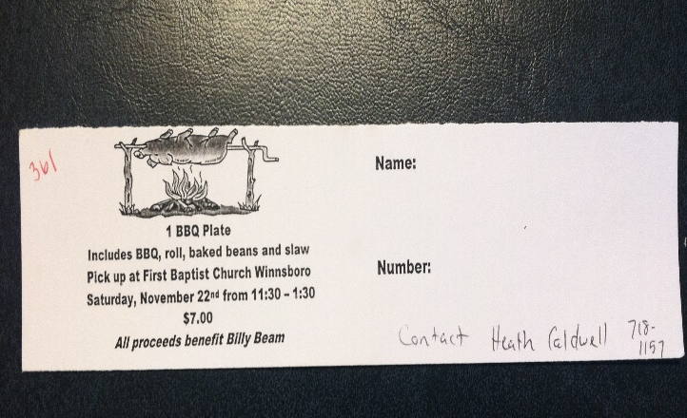

Please see Heath Caldwell or call him at

718-1157 for a ticket to a BBQ plate to benefit Billy Beam. Tickets are $7.00.

When you can, remember to send a card, call or visit

Mabel Ward 9370 Windsor Lake Blvd. Apt. #206 Columbia, SC 29223
Katherine Rabb 1330 India Hook Road, Westminister Towers Apt. 511
Rock Hill, SC 29732
Lisa Lewis Meyer The Heritage at Lowman, PO Box 444
White Rock, SC 29177
Dot Yon Goodwin House Apt. #401, 3440 S. Jefferson St.
Falls Church, VA 22041
Elise Williams 9423 Old Douglass Road, Blackstock, SC 29014
Edith McAlister 110 Summit Hills Drive, Apt. #317,
Spartanburg, SC 29307
Becky McMaster NHC Room 228, 7601 Parkland (PO Box 25548), Columbia SC 29223
Forest Hughes Fairfield Health Care, 117 Bellfield Road
Ridgeway, SC 29130
Doris Myfelt 2195 Rio Dosa Drive #2103 Lexington, KY 40509
(859) 309-9284
Susan Jackson Harbor Chase, 1611 Constitution Blvd., Rock Hill SC 29732 (803) 366-7431
*****************************



Congratulations to Emily and Jason Baccomo! We expect another First United Methodist member in 2015!
Calling All Singers!!!
Winnsboro Choral Society to Perform Handel’s Messiah

There will be a performance of George Frideric Handel’s Messiah on Sunday, December 7th at 3:00 at Bethel Associate Reformed Presbyterian Church in Winnsboro. There is no charge for admission but an offering will be accepted during “The Pastoral Symphony.”
Rev. Lane Keister, the minister at Lebanon Presbyterian Church will be conducting rehearsals and the performance. Rev. Eddie Huss, Minister of Music and Arts at Shandon United Methodist Church in Columbia will serve as organist.
Rehearsals will be held Sunday afternoons from 3:00 to 5:00 at Bethel Associate Reformed Presbyterian Church October 26, November 9, November 16, and November 30. No rehearsal will be held November 23.
Winnsboro has had a tradition of singing Messiah since the 1950’s when Walter Graham and Nelle Sprott taught high school students in Fairfield County the 1742 masterpiece. For many years after Walter Graham moved away, Nelle Sprott and Ellen Nicholson have provided the community with the opportunity to learn and perform the Christmas section of Messiah. Take advantage of the chance to participate in this musical classic, to enrich your community and your own understanding and meaning of the season.

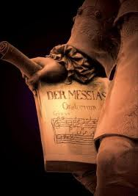

Memorials

In memory of J.B. Hegler
By
Edith McAllister

*********************

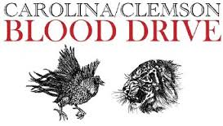
Red Cross Blood Drive
Clemson/Carolina Competition – November 13, 2014
First United Methodist Church
(Does your blood run orange or garnet?)
First United Methodist Church is hosting an American Red Cross Blood Drive on November 13 from 2:00 – 7:00. This will be the 4nd Annual Clemson/Carolina Blood Drive. Last year was very successful with over forty people offering to donate. Please call the church office at 635-4087 from 9:00-12:00 during the week to schedule your donation time to donate blood. You may leave a message. Last year Carolina won the battle and Clemson fans hope to show that the blood collected this day “runs garnet instead of orange”. Door prizes will be given. If you would like to contribute a door prize, or if you have any questions, contact Barbara Martin at 635-2273. Plan to donate blood on Thursday, November 13th to support the American Red Cross and your favorite team.

My Hope-2014
Heaven: A new message from Billy Graham to help reach your community
What do you think Heaven is like? Who will be there? As my father said (written by Franklin Graham), "First, there must be a decision here and now, in this life." Don't miss the new film "Heaven" from Billy Graham - My Hope Project, with a message for you and your community. Order the DVD now for your church, campus group, youth group or any other gathering where you can share the love of Jesus Christ. https://myhopewithbillygraham.org
“Heaven…but first there must be a decision here and now in this life.”
Billy Graham
Don’t miss the new film and message from Billy Graham this November, which you and your church can use to share the Gospel in your community. For more information or to get your church involved, visit www.myhopewithBillyGraham.org today.
John 14:6
Jesus answered, “I am the way and the truth and the life. No one comes to the Father except through me.
Are you absolutely sure you would go to heaven if you were to die tonight? Are you sure your significant others would as well? Attending church does not guarantee this. Nor does your baptism or confirmation or anything else that we bring to the table to justify ourselves to God. Only a personal relationship and trust in the blood of Jesus Christ, shed on the cross for atonement of our sins guarantees a future in heaven. If you are not sure or if you want to talk about this with someone please call Pat & Hal Frish, Jim Futrell, or Martha Martin. Any of us can walk you through this.
Matthew 7:21-23
²¹ “Not everyone who says to me, ‘Lord, Lord,’ will enter the kingdom of heaven, but only the one who does the will of my Father who is in heaven. ²² Many will say to me on that day, ‘Lord, Lord, did we not prophesy in your name and in your name drive out demons and in your name perform many miracles?’ ²³ Then I will tell them plainly, ‘I never knew you. Away from me, you evildoers!’

As a church we will be showing the new video at Honeysuckle Acres on November 6 at 6:30 P.m. RSVP 635-7583 Dessert will be served. Please invite friends and family.

We will also show this film on the fifth Sunday in November during Sunday School.

Pat & Hal Frish, Jim Futrell, Martha Martin
******************************************
Altar Flower Schedule

NOVEMBER FLOWER CALENDAR

November 2 – Open

November 9 – Open

November 16 – Open

November 23 – Kay Williams

November 30 - Open




Summary of Committee Meetings:

** You are invited to attend all committee meeting with the exception of the SPRC (personnel related matters).

Daycare Feasibility Committee –

Met October 22. The group has reached a point in the feasibility study that we need to move forward with some infrastructure updates (wired smoke detectors, fire extinguishers, fire door). Also the study has determined that we need to acquire monies to ensure the start-up costs are covered (salary, supplies, electricity, water, insurance). If you are interested in helping get this very important ministry started in this church, please see Pastor Julie.

FUMC Shepherding Committee Update
Due to a few changes in membership the Shepherding Committee has revised its lists of shepherds and those being shepherded. Members of First UMC Winnsboro who do not know who their shepherd is should contact Lea Weed or Bobbie Dove. The Committee wants to ensure that everyone in the church receives shepherding care, especially during illness, bereavement, birthdays, and other special or needy occasions.
Also, shepherds who are unsure of who is on their list should also contact Lea or Bobbie for a copy of the updated listings. The Committee is eager to contact every church member as often as needed.
In operation now for about a year, the Committee has been active and response has been excellent. “We have been very pleased with how well this program has been received and how well it appears to be working,” a member of the committee said.
Finance Committee Receives Extensive Input on FY 2015 Church Budget
One of the main parts of the annual Charge Conference is the adopting of the church’s budget for the upcoming fiscal year. Finance Chair Bob Drake asked committee member Marcia Bonds to compile a listing of budgetary askings from all church committees, programs, and services. Mrs. Bonds presented the list at a Finance Committee meeting, and the Committee was then able to build a proposed budget reflecting needs identified by the various line item entities.
The Administrative Council endorsed the proposed FY 2015 budget and voted to forward it to the Charge Conference for adoption.

FUMC Statistics Improving
Statistics for the third quarter of FY 2014 are showing substantial growth over previous quarters. Attendance and collections are both improving, according to Church bulletin reports. “Our weekly collections are on the average above weekly budget needs and should enable us to end the year on target,” according to church treasurer Paul Dove. However, unanticipated expenses have caused some depletion of special funds accounts, when available for these expenses. “This quarter we have reached our weekly budgetary needs more frequently than in the past, but we will need to continue this trend through the fourth quarter to meet the FY budget,” Treasurer Dove said.
Average Sunday attendance this quarter has also posted improved numbers, by some twenty to twenty-five percent on the average. “We can see the growth in church attendance from our perch in the choir,” a choir member said.
Vision Committee
The Vision Committee had a planning session on Sunday, September 14, 2014. Much of the meeting was devoted to program planning for the remainder of 2014. The committee then discussed Pastor Julie’s mission statement: “Seek God. Love All People. Change the World.” A motion to recommend to the Administrative Council that we formally adopt this as the church mission statement was made and approved. The group then began to use the three statements as organizing principles for evaluating the various programs and projects of our church. For example, we seek God through our worship services, Sunday School, Bible studies, and other small group activities. We love all people through our various service programs and projects such as the Shepherd and Bereavement committees, contributions to the Food Bank, and support of programs likes Salkehatchie. We help to change the world through our apportionment giving to the programs of the United Methodist Church as well as smaller efforts like Milk Money for Haiti and Samaritan’s Purse Christmas boxes. The Vision Committee plans to use this framework as we examine our programming and begin planning for 2015. The Committee will meet again on Monday, November 3, at 7:00 p.m.

If you have a pastoral need or know of a church member sick or in the hospital, please let Pastor Julie know immediately. You may reach her after hours by cell (803)319-6169

Report of the Committee on Lay Leadership for 2015

The Administrative Council
Chairperson Bill DuBard
Vice Chair Jena Johnson
Recording Secretary Betsy Stevenson
Financial Secretary Peggy Ayers
Treasurer Paul Dove
Historian Betty Bynum
L.M.A.C. Bobbie Dove
Atl. L.M.A.C. Paul Dove
Lay Leader Doug Williams
Vision Committee Sarah McMaster
Pres. UMM Heath Caldwell
Pres. UMW Beth Caulder
Pres. UMYF N/A
Pastor Emeritus Bundy Bynum
At Large Members
Jay Ayers Clyde Sanders
Eric Johnson Brice Porter
Bill Bundy Martha Martin
OutReach Lea Weed (Chair)
Missions Cheryl Caldwell
Epworth Child. Home Jane Hinnant
Evangelism Kitty Rabb, Pat Frish
Rel. and Race Nat. Amer. Beth Caulder
Church and Society Susan Dove, Bill Bittinger
Disaster Relief Callie Bell, Eddie Watford

Nurture
Health & Welfare Barbara Martin
Worship Kitty Rabb, Lea Weed, Jane Lucas, Jack Ivester, Mary Jim Gunter, Patsy Black, Julie Barfield
Age Level Coordinators
Children Frances Porter
Youth Frances Porter
Young Adult Mary Swearingen
Adult and Family Mary Jim Gunter
Higher Ed Campus Coleman and Justin Blackwelder
Sunday School Supt. Jena Johnson
Library Margaret DuBard

Trustees
Class of 2017 Johnny Caldwell
Sallie Williams
Jimmy Gladden
Class of 2016 Tony Barfield
Bobbie Dove
Kitty Rabb
Class of 2015 Milton Hinnant (Chair)
Lenora Bundy
Jackie Wilkes
Tony Caulder



Staff Parish Relations
Class of 2017 Tricia Drake
Mary Swearingen
Jack Ivester
Class of 2016 Dean Lee
Linda Haslett
Eddie Watford
Class of 2015 Jimmie Douglas
Martha Wilkes
Vickie Robinson (Chair)
Clyde Sanders
Lay Leader Doug Williams
Lay Me.A.C. Bobbie Dove

Committee on Lay Leadership
Class of 2017 Grayson Caulder
Kay Williams
Class of 2016 Martha Martin
Nancy Blair Gonzalez
Class of 2015 Barbara Martin
Bobbie Dove
Lay Leader Doug Williams
Chair Julie Belman
Committee on Finance
Bob Drake (Chair) Betsy Boulware
Roy Barnett Dean Lee
Joe Sanders Alex Rabb
Heath Caldwell Kenny Martin
Marcia Bonds Don Gunter

Ex-Officio (Finance)
SPRC (Chair) Vicky Robinson
Lay Leader Doug Williams
L.M.A.C. Bobbie Dove
Administrative Council Bill DuBard
Financial Secretary Peggy Ayers
Treasurer Paul Dove

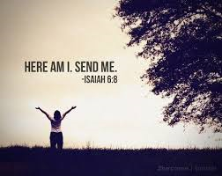
How is God calling me to uphold the church with my prayers, presence, gifts, service, and witness

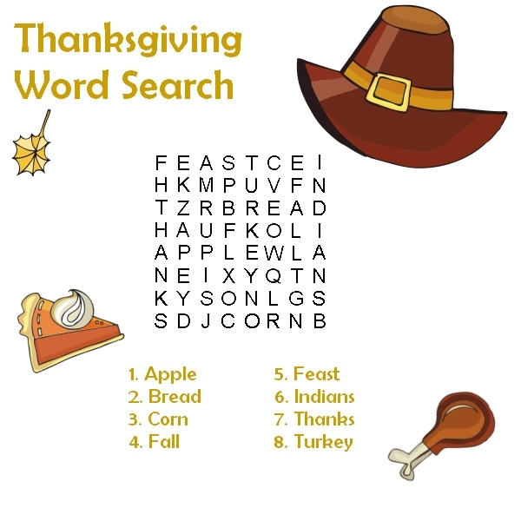

TO MEMBERS OF OUR CHURCH FAMILY WITH BIRTHDAYS IN
November

Beth Caulder 4
Martin Caulder 6
Jena Johnson 7
Terry Melvin 7
Bob McMaster 8
Fred Weed 8
Linda Haslett 8
Wyatt Raley 10
Carl Startsman 12
Tutta Startsman 16
Cheryl Caldwell 18
Emily Baccomo 18
Johnny Caldwell 25


Vision Committee – November 3
Operation Christmas Child boxes due to church – November 7
Carolina Clemson Blood Drive – November 13
Finance Committee – November 18
Men’s Club – November 25
Hanging of the Greens – November 29
5th Sunday - Billy Graham Heaven video shown during Sunday School – November 30
Community Memorial Service – November 30

The Annual Blessing of the Animals
Our human ties with our friends of other species is a wonderful and special gift from God. Pastor Julie blessed these special friends and we are thankful!
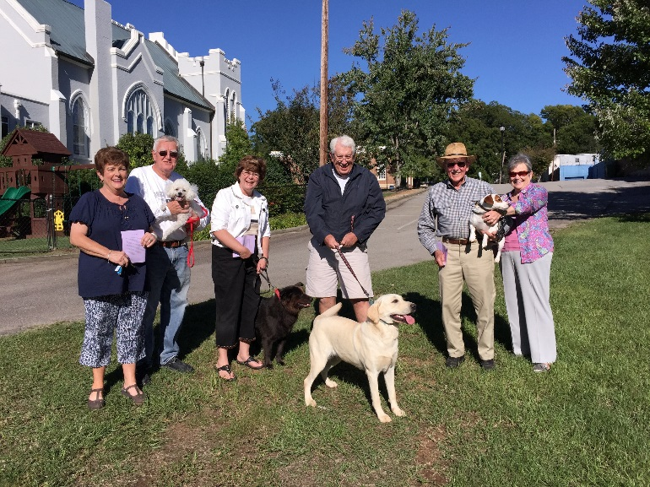

 Betty and Bundy Bynum for providing a beautiful entrance at the back door of the church . It is always such a treat to see what beautiful treasure is on the table!
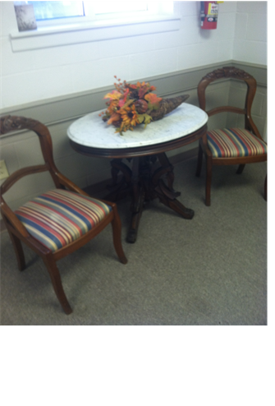

Halloween Carnival at First United Methodist
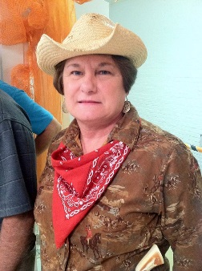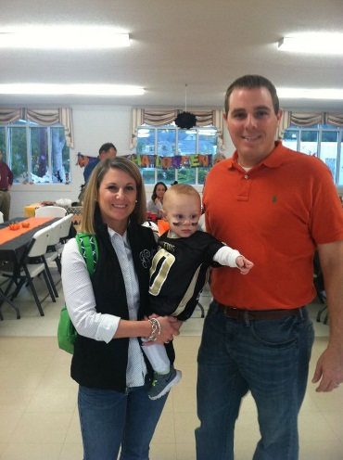

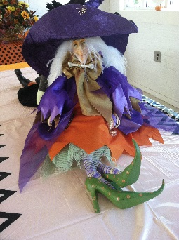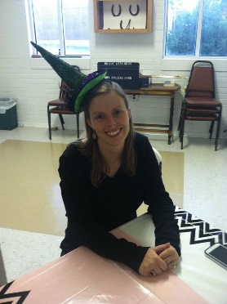
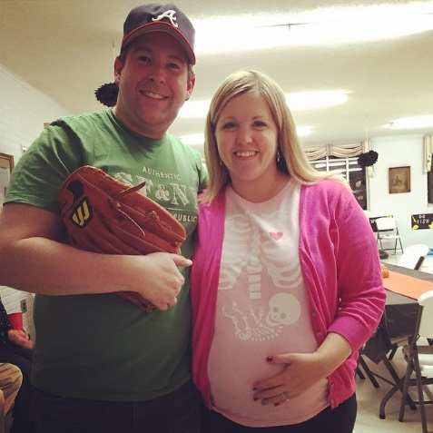
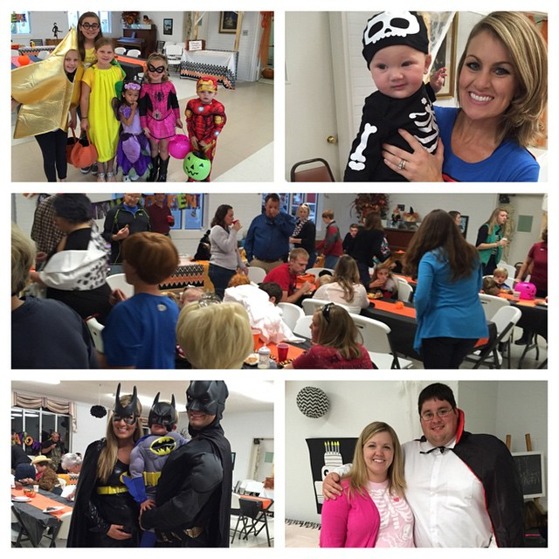

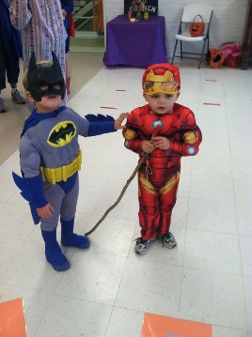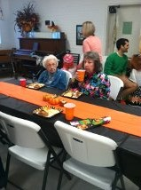
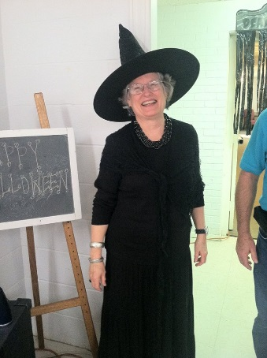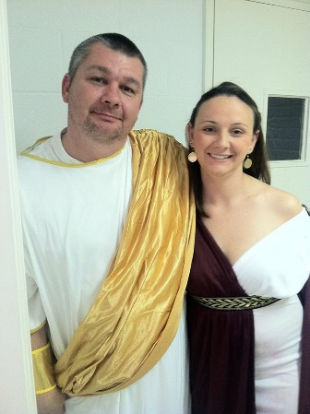

Everyone had a spooktacular good time!
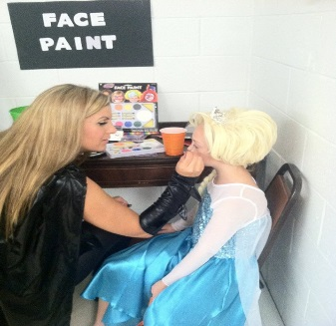

Please join us on November 30th for the

Hanging of the Greens
during our morning service.
*****************

First United Methodist Church will host a
Service of Remembrance
for community members who passed away this past year. This event is prepared by Pope Funeral Home. Reverend Julie Belman will perform the service. Please join us on November 30th at 6:00 p.m. as we remember family and friends who have gone ahead of us as we enter into the coming holiday season.

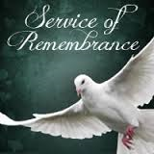


Jack Ivester opens the doors, turns on the lights and cuts on the heat/air before every Sunday service.
Lea Weed polishes the cross and candles before service.
Jane and Jay Lucas polish the brass railing around the choir loft.
Mary Jim Gunter changes the paraments and fills the candles with oil.
Patsy Black prepares the communion table by filling the glasses with juice and the plates with bread.
A special thanks to each of these dedicated members for their service in preparation of worship each week.

