Order of Worship
February 9, 2014
Fifth Sunday after Epiphany

Prelude

Welcome Announcements
Congregational Greeting

Introit “Surely The Presence Of The Lord Is In This Place" Choir
Lanny Wolfe

*Collect

Our heavenly Father,

we your humble children invoke your blessing on us. We adore you, whose name is love, whose nature is compassion, whose presence is joy, whose word is truth, whose spirit is goodness, whose holiness is beauty, whose will is peace, whose service is perfect freedom, and in knowledge of whom stands our eternal life. Unto you be all honor and all glory; through Jesus Christ our Lord. Amen.

*Hymn # 98 To God Be the Glory TO GOD BE THE GLORY

Morning Prayer

Lord’s Prayer with Choral Response

Anthem "Set Me As a Seal Upon Your Heart” CHOIR
Page/Williams

Responsive Reading #833 Psalm 112

*Gloria Patri # 71 Greatorex

*Affirmation of Faith #881 The Apostles’ Creed

Children’s Time

Offertory

*Doxology #95 Praise God from Whom All Blessings Flow Old 100th

*Hymn #175 Jesus, the Very Thought of Thee ST. AGNES

Scripture Lesson Matthew 5: 13-20 Page:4

Sermon Salt and Light Pastor Sistare

*Hymn # 571 Go, Make of All Disciples LANCASHIRE

*Benediction “Go, My Children, With My Blessings”
Traditional Welsh
*Postlude
During the singing of the closing hymn, you are invited to the altar for prayer, to unite with the church, or for other responses to God's love.

WELCOME VISITORS!

Welcome to our church family, we're glad that you could come.
We're honored to share this day with you as we worship God's risen Son. We hope that God has touched your life as we worshipped side by side and that you left this place today with the peace of God inside.

THIS WEEK AT FIRST CHURCH

Wednesday February 12 7:30 p.m. Choir Practice

THOSE WHO SERVE THIS WEEK

Ushers: Bob McMaster and Johnny Porter
Acolyte: Berkley Derrick
Counters: Sallie Kate Watford and Donnie Laird

ANNOUNCEMENTS

Family Night – Thursday, February 13, in the Fellowship Hall

Men’s Spiritual Weekend February 28 – March 2, 2014 at Springmaid Beach, South Carolina “Take the Plunge: Deeper Prayer, Passion, Purpose, and Power”. Register online at www.umcsc.org or get a brochure from the church office.

The 2014 Flower Calendar is available if you are interested in providing flowers for worship please sign up in the hallway between the Fellowship Hall and Sanctuary.

 The flowers in the sanctuary this morning are placed to the Glory of God and in honor of the Young Adults of our church who have breathed new life into it by Bundy and Betty Bynum

PRAYER LIST

Frank Martin
Rev. Don McKinney
Lynne Moore
Carl Douglas
Julie Reese
Stewart Goudelock

Taylor Novinger
Alvin Raley
Rosetta Watson
Merrill Jennings Wood
Mary Thomas
Maudie Douglas
Vicky Melvin

Marcia Bonds
Ann Bailey
Doris Barr
Billy Boulware, Jr. Betty Coleman
Becky McAlister
Brent Dorrier

Please remember in prayer those serving our country in our armed forces both at home and overseas

When you can, remember to send a card, call or visit

Mabel Ward: The Waterford, Columbia,
Katherine Rabb: Rock Hill,
Lisa Lewis Meyer, Lowman White Rock,
Dot Yon, Falls Church, Va
Elise Williams and Edith McAlister Spartanburg,
Becky McMaster NHC, Columbia

STEWARDSHIP REPORT FOR FEBRUARY 2, 2014
Sunday School Attendance 26

Worship Attendance 88
Sunday School Offering $20.00

Worship Offering $3818.54
Needed Each Week 3,714.75

Received Year-to-Date $15,382.23 $6,789.61

WELCOME VISITORS!

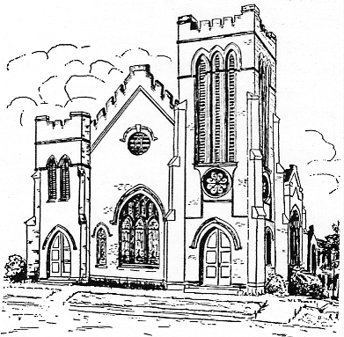
First United Methodist Church
109 W. College Street
Winnsboro, SC 29180
firstumc@hotmail.com
www.firstmethodistwinnsboro.com

Pastor: Rev. J. Bart Sistare
Choir Director: Wanda Neese
Organist: Esther J. Baughman
Lay Leader: Marcia Bonds
Church Secretary: Julie Barfield
Financial Secretary: Peggy H. Ayers
Treasurer: Paul Dove
Pastor Emeritus: Rev. F. Bundy Bynum

