Order of Worship
October 12, 2014
18th Sunday after Pentecost

PRELUDE

WELCOME AND ANNOUNCEMENTS

INTROIT All Creatures of our God and King CHOIR
Traditional German

PRAYER

O God our loving Father, you have given your Son to save us, and sent your Holy Spirit to guide us. Receive now our praise and thanksgiving. May our hearts be open to your presence in this hour to the end that we may seek and be found by you, love people, and change the world. AMEN.

*HYMN: #158 Come, Christians, Join and Sing

MORNING PRAYER

LORD’S PRAYER WITH CHORAL RESPONSE

Our Father, who art in heaven,
Hallowed be thy Name.
Thy Kingdom come.
Thy will be done on earth,
As it is in heaven.
Give us this day our daily bread.
And forgive us our trespasses,
As we forgive those who trespass against us.
And lead us not into temptation,
But deliver us from evil.
For thine is the kingdom,
The power, and the glory, forever.
Amen.

ANTHEM Rejoice in the Lord Always CHOIR
Henry Purcell

*RESPONSIVE READING #821 Psalm 100

*GLORIA PATRI # 71 Greatorex

*AFFIRMATION OF FAITH #881

The Apostles’ Creed

I believe in God the Father Almighty,
maker of heaven and earth;
And in Jesus Christ his only Son our Lord:
who was conceived by the Holy Spirit,
born of the Virgin Mary,
suffered under Pontius Pilate,
was crucified, dead, and buried;
the third day he rose from the dead;
he ascended into heaven,
and sitteth at the right hand of God the Father Almighty;
from thence he shall come to judge the quick and the dead.
I believe in the Holy Spirit,
the holy catholic church,
the communion of saints,
the forgiveness of sins
the resurrection of the body,
and the life everlasting. Amen

CHILDREN’S TIME

OFFERTORY

*DOXOLOGY #95 Old 100th

*HYMN: #334 Sweet, Sweet Spirit

SCRIPTURE LESSON Philippians 4:1, 4-9

This is the Word of God, for the people of God
Thanks be to God

SERMON “Rejoice, and Pass It On!” Rev. Bynum

*HYMN: #572 Pass It On

During the singing of the closing hymn, you are invited to the altar for prayer, to unite with the church, or for other responses to God's love.

*BENEDICTION May the Road Rise to Meet You CHOIR
Lee Turner

*POSTLUDE

WELCOME VISITORS!

Welcome to our church family, we're glad that you could come. We're honored to share this day with you as we worship God's risen Son. We hope that God will touch your life as we worship side by side and that you leave this place today with the peace of God inside.

THOSE WHO SERVE THIS WEEK

Ushers: Terry Melvin and Jackie Wilkes
Counters: Sallie Kate Watford and Donnie Laird

Announcements

- Trustees meeting, Monday, October 13, 6:30 pm,

Conference Room
- Curlee McMaster Douglas Jennings Circle, Monday, October 13, 4:00 p.m., Fellowship Hall
- Administrative Council – Wednesday, October 15, 6:30 pm.,

Conference Room
- Susanna Wesley Circle, Thursday, October 16, 7:00 pm, Conference Room
- Operation Christmas Child (Samaritan’s Purse). Shoeboxes available in Conference Room – Due back to Church by Monday, November 17
- Halloween Carnival – Saturday, Oct. 25. 6:00 pm-8:00 pm. If you would like to volunteer, please see any of the Young Adults.

The altar flowers are given to the glory of God and in memory of our fathers, Jim Dorrier and Col. Bob McMaster by Bob and Sarah McMaster.

If you would like to provide altar flowers, please sign up on the flower calendar in the hall behind the sanctuary.

Prayer List

Sara Duncan, Rev. Don McKinney, Billy Boulware, Jr., Betty Coleman, Chip, Julie and Madeline Fischesser, Brent Dorrier, Frank Martin, Taylor Novinger, Lynne Moore, Mabel Ward, Mary Thomas, Rosetta Watson, Julie Reese, Russ Pearson, Stewart Goudelock, Merrill J. Wood, Carl and Katherine Douglas, Maudie Douglas, Vicky Melvin, Annette Clowney, Scott Vanvick, Becky McAlister, Albertia Bundy, Gary Brown, Blaine Riley

Please remember in prayer those serving our country in our armed forces both at home and overseas.

When you can, remember to send a card, call or visit

Dot Yon Goodwin House Apt. #401, 3440 S. Jefferson Street
Falls Church, VA 22041

Elise Williams 9423 Old Douglass Road, Blackstock, SC 29014

Edith McAlister 110 Summit Hills Drive, Apt. #317,
Spartanburg, SC 29307

Becky McMaster NHC Room 311, 7601 Parkland (PO Box 25548), Columbia SC 29223

Forest Hughes Fairfield Health Care, 117 Bellfield Road
Ridgeway, SC 29130

Katherine Rabb 1330 India Hook Road, Apt. 108 Rock Hill, SC 29732
Lisa Lewis Meyer The Heritage at Lowman, PO Box 444
White Rock, SC 29177

Mabel Ward 9370 Windsor Lake Blvd. Apt. #206 Columbia, SC 29223

Stewardship Report for October 5, 2014

Sunday School Attendance | 34
Worship Attendance | 96
Sunday School Offering | 36.00
Worship Offering | 6,688.63
Needed Each Week | 3,714.75
Received Year to Date | 152,387.32
Needed Year to Date | 148,590.00

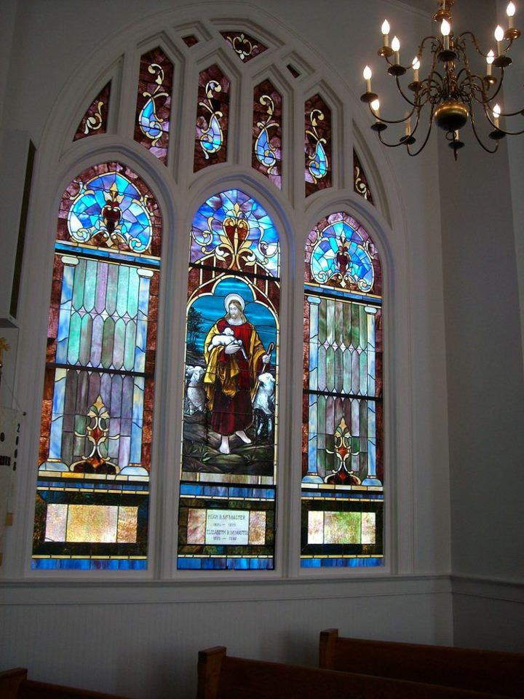

Seek God. Love All People.
Change the World.

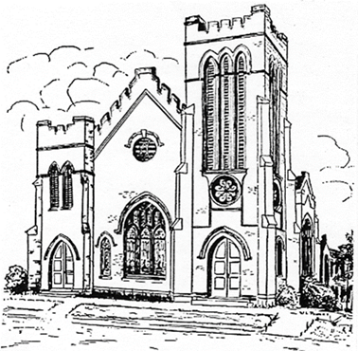
First United Methodist Church
109 W. College Street
Winnsboro, SC 29180

firstumc@hotmail.com (office)
FCWpastor@hotmail.com (pastor)
www.firstmethodistwinnsboro.com

Pastor: Rev. Julie Songer Belman
Choir Director: Wanda Neese
Organist: Esther J. Baughman
Lay Leader: Marcia Bonds
Church Secretary: Julie Barfield
Financial Secretary: Peggy H. Ayers
Treasurer: Paul Dove
Pastor Emeritus: Rev. F. Bundy Bynum

