THE FIRST WORD

2014 - 10 First United Methodist Church – 109 West College Street – Winnsboro, SC 10 - 2014


Looking for a Fresh Start in 2015?
The Bible says that God’s mercies are new every morning. Wow!! We have the potential for a fresh start every day! How would you like a new beginning? Or how about breaking a pattern or cycle that continues to wreak havoc in your life? Fresh starts don’t begin with a change of circumstances – a new job, new location, or new relationship – or even a new year… they begin with a change of heart.
We learn on TV how to make over homes, wardrobes, bodies and even faces. Seems we all want a “New Me” at some level. A tuck here, a pinch there, a little less, a little more.
Something within us insists “I can do better,” “I can do more,” “I can be a different me.” We try to reinvent ourselves physically, mentally and spiritually.
But trying harder to be better, do more, or live differently doesn’t always create the Fresh Start we hope is possible. Is there really a spiritual plan that can help each of us discover or rediscover a Fresh Start?
This January we begin a journey with God that’s uncluttered from the cycle of “try harder” and the guilt of failure. God offers us each a Fresh Start. In fact, God offers many of them.
It’s a new year, and at First United Methodist Church in Winnsboro, we invite you to join us as we talk about how to make the rest of our lives, the very best of our lives.
1/4/15 “Who Am I?”
1/11/15 “Who is God?”
1/18/15 “What God does!”

Watch for follow up in February newsletter: “How we Live NOW”

OUR MINISTRY FOR
January

USHERS:
Tony Caulder and Johnny Caldwell

COUNTERS:
Mary Jim Gunter and Patsy Black
Sallie Kate and Donnie Laird
Alex Rabb and Jay Lucas
Roy Barnett and Jim Baughman

Acolyte:
Berkley Derrick

PRAYER LIST

The family of Forest Hughes, Bill Bundy, Jay Lucas, Wilbur Douglas, Jay Baughman, Caroline Montgomery, Sara Duncan, Rev. Don McKinney, Billy Boulware, Jr., Betty Coleman, Chip, Julie and Madeline Fischesser, Brent Dorrier, Frank Martin, Taylor Novinger, Lynne Moore, Mary Thomas, Julie Reese, Tam Lark, Merrill J. Wood, Maudie Douglas, Annette Clowney, Scott Vanvick, Becky McAlister, Albertia Bundy, Martha Branham Robinson, and Blaine Riley

Please, remember in prayer those serving our country in our armed forces both at home and overseas.

When you can, remember to send a card, call or visit

Doris Myfelt 3195 Rio Dosa Drive #2103, Lexington, KY 40509 (859)309-9284

Susan Jackson, Harbor Chase, 1611 Constitution Blvd., Rock Hill, SC 29732. Phone (803) 366-7431

Dot Yon Goodwin House Apt. #401, 3440 S. Jefferson Street
Falls Church, VA 22041

Elise Williams 9423 Old Douglass Road, Blackstock, SC 29014

Edith McAlister 110 Summit Hills Drive, Apt. #317,
Spartanburg, SC 29307

Becky McMaster NHC Room 311, 7601 Parkland (PO Box 25548), Columbia SC 29223

Katherine Rabb 1330 India Hook Road, Westminister Towers, Apt. 108 Rock Hill, SC 29732

Lisa Lewis Meyer The Heritage at Lowman, PO Box 444
White Rock, SC 29177

Mabel Ward 200 River Landing Unit #209, Charleston, SC 29492

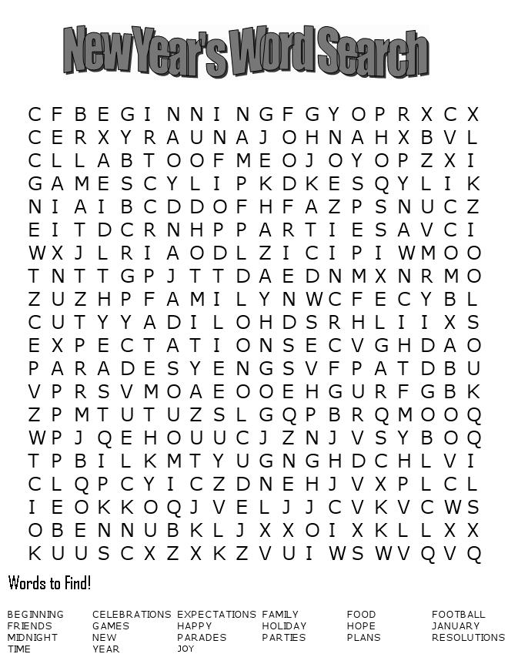



Summary of Committee Meetings:

** You are invited to attend all committee meeting with the exception of the SPRC (personnel related matters).

Treasurer’s Report (Updated 12/16/14)
Fourth quarter collections continue to show significant growth. As of December 7, we are $7,538 ahead of our FY 2014 budget and should end the year in the black for the first time in several years, provided current giving levels continue through December. Since we—our church---have accepted an ambitious budget for FY 2015, this bodes well for our step of faith and indicates that we will also meet our next year’s projected financial needs.
Deadline for FY 2014 Contributions
Please note that all contributions for FY 2014 should be in the church office no later than 9:30 AM, Tuesday, December 30, 2014, when we make our year-end deposit.
More Information about Our Funding
In addition to budgeted items, which are funded from FY receipts (collections), our checking account contains designated or restricted funds for specified use only in the amount of $29,802.95 as of November 30. These funds have accumulated over a period of time and cannot be used for purposes other than for which they were given. For example, there is $4,681.28 in this account under “Organ Fund” and must be used for maintenance or repair of our pipe organ.
Also, unless the donor specifies otherwise, all monies received as memorials are credited to the “Cemetery Fund,” which maintains our cemetery.
Some funding line items have been eliminated as the project or purpose no longer exists. For example, the “Chair Fund” fulfilled its mission some time ago, so the small balance remaining in that fund was transferred into the Hearing Aid Fund. Any actions affecting designated (or restricted) funds must be approved by our Finance Committee and forwarded to our Administrative Council for their action. This applies also to any alterations to the approved FY budget and to any transfers from Certificates of Deposit or Money Market funds. Current low interest rates have affected significantly income earned from these investments.
We have over the years been given stock bequests, and most of these carry restrictions on the dividends. Certain income goes to the cemetery fund, for example.
A basic tenet of the booklet on Methodist Church finance is transparency. A second tenet is creating and maintaining written policies and procedures for financial matters. Your Finance Committee, Treasurer and Financial Secretary are working to meet these mandates and appreciate the assistance given to us from members of the congregation who have accepted responsibilities for various duties associated with church financial accountability.


TO MEMBERS OF OUR CHURCH FAMILY WITH BIRTHDAYS IN
January

Jan. 10, Bradley Mincey
Jan. 17, Susan Jackson
Jan. 19, Kay Williams
Jan. 20, Win McMaster
Jan. 21 Jacob McDonald
Jan. 22, Ed Gates
Jan. 23, Gini McDonald
Jan. 26, Jan Trent
Jan. 26, Bill Bundy
Jan 28, Lawrence Haynes
Jan. 30, Susan Hindall

************************

Altar Flower Schedule

JANUARY FLOWER CALENDAR

January 4 Marcia Bonds

January 11

January 18

January 25

If you would like to provide altar flowers, please sign up on the flower calendar in the hall behind the sanctuary.

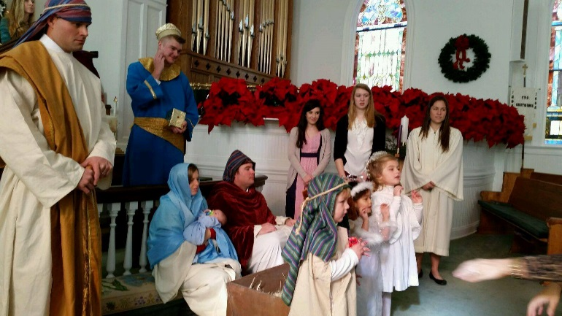


Happy New Year!

In Memory of Carl Macy Douglas
April 3, 1929 – November 7, 2014
and
In Memory of Forest Earl Hughes, Jr.
September 29, 1924 – December 7, 2014

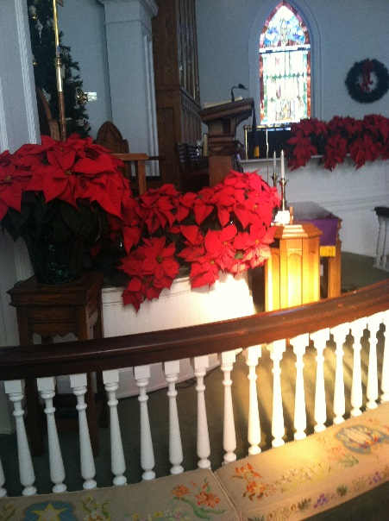
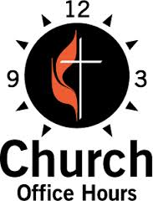
Monday, Wednesday, Thursday and Friday
8:00 a.m. until Noon (Julie Barfield)
Tuesday
9:00 a.m. until 12:30 (Peggy Ayers)
Friday
10:00 a.m. until Noon (Peggy Ayers)
******************************
If you do not receive Robo Calls from Pastor Julie, please call the church office so we can include your phone number. In the event of inclement weather, you will receive a Robo call if church is cancelled.

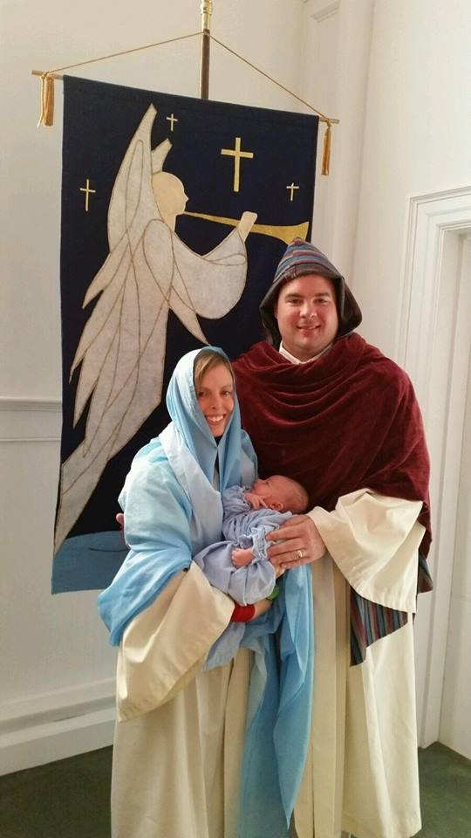
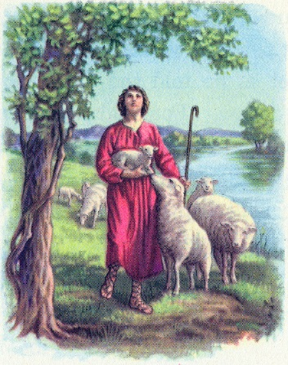The Shepherd Committee welcomes Joe Sanders to the program. If you would like to be involved with this ministry, please get in touch with Lea Weed.

Kitty Rabb ordered and arranged the poinsettias in the sanctuary. She had help from her assistant, Alex Rabb! Also, Kitty makes sure that flowers are in the sanctuary every Sunday. If there is a Sunday that no one signs up, Kitty makes sure flowers are there in time for the worship service.
Alex Rabb coordinates the ushers for every Sunday of the year and for special services.
The Young Adults put up the Chrismon tree and decorated it, as well as, put up the wreaths inside and outside the church.
A special thanks to each of these dedicated members for their service in preparation of worship each week.

First United Methodist PreSchool
Please read this very important update on the First United Methodist PreSchool. We need your help. In order for us to start this very important ministry in this church, we need startup funds. The facility is in need of updating. We need to update the existing fire system, exit signs, handicap access, a door in one of the classrooms and several other state code enforced requirements. The cost to complete the updates and the cost of the salaries to start this program require funds that are not budgeted. We need contributions from you in order to make this ministry happen. We believe the need is so great that once we start the PreSchool, the number of children enrolled will enable the program to sustain itself. Please donate to this worthy cause. It will help the community and it will help this church move forward in a positive way. If you feel compelled to help with this ministry through a donation, please contact Pastor Julie or the church office if you need additional information. Thank you in advance.

Memorials and Adulations

In Memory of Carl Douglas
Jay and Jane Lucas
Kathy Davis
Maynard Davies
Mike and Barbara Watson
Danny and Lily Caldwell
Trent and Vonnie Purcell
James and Joanna Kraus
Jim and Esther Baughman
Roy and Frances Barnett
Paul and Bobbie Dove
Billy and Callie Bell
Bill and Margaret DuBard
Henry E. Johnson, Jr.
Wilbur and Barbara Douglas
Don and Mary Jim Gunter
Dean and Ann Lee and Families
Jack and Joyce Carroll Pope Currie
Eddie and Sallie Kate Watford
Marion and Vickie Robinson
William G. and Betsy Stevenson

In Memory of Bob Caldwell
Paul and Bobbie Dove
Jack and Martha Wilkes
Billy and Callie Bell
Carl and Tutta Startsman
Peggy H. Ayers
The Wesley Melvin Families
Bill and Margaret DuBard
Win McMaster
Don and MaryJim Gunter
Marcia Bonds
William G. and Betsy Stevenson

In Memory of Ralph Boys
Bill and Margaret DuBard
Don and Mary Jim Gunter
Dean and Ann Lee and Jack Melvin
Eddie and Sallie Kate Watford

In Memory of Alita Stephenson
Bill and Margaret DuBard
Don and Mary Jim Gunter
Marion and Vickie Robinson
Eddie and Sallie Kate Watford

In Memory of George Bender
Marcia Bonds
Roy and Frances Barnett

In Honor of Billy and Callie Bell
Duke, Sharon, Taylor and Kala Bell

In Honor of Bob and Sarah McMaster
Michael and Carol Doyle



In Memory of Forest Hughes
Don and Mary Jim Gunter
The Wesley Melvin Families
Marcia Bonds
Peggy H. Ayers
David and Doris Barr
Tom and Roberta Ketchin
Andrea D. Hudson
Hubert and Bonnie Brice
Bill and Kim Porter
Steve and Eleanor Mann
Anne McMaster
Lunceford and Diane Bass
Brent Dorrier
Herndon Chevrolet
Marion and Vickie Robinson
Ernest and Betty Ann Ferguson
The Melton Family
Roy and Frances Barnett
Win McMaster
Amy R. Adams
John and Emily Turner
Genia Pope Tyson
William and Patricia Barnett
Lucy Coleman
Marjorie Dove
David and Melinda Brown
Shirley Parrish
John and Mary Coleman Johnson
Larry and Nancy Stevenson
Sarah Boulware
William G. and Betsy Stevenson

In Memory of Mary McMaster McCormac
Kitty Rice McMaster
Laurens Livings

In Memory of Fritz Williams
Eddie and Sallie Kate Watford



 Please remember that every 3rd Sunday we will dedicate the food that is brought to the church for the Fairfield Community Food Bank.

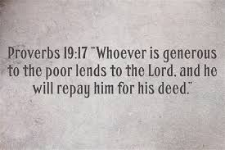

Women’s Winter/Spring Bible Study
At Honeysuckle Acres, beginning January 5&6 at 9:30 a.m.. We will have identical sessions each Monday and Tuesday morning. We will end on March 23&24.
RSVP to Pat Frish at 635-7583 or e-mail hpfrish@yahoo.com

Daniel – Lives of Integrity Words of Prophecy by Beth Moore

Just as the prophet Daniel faced unbelievable pressure to compromise his faith in a hostile culture and was constantly confronted by temptations and threats, todays believers face similar trials.

The class consists of twelve sessions ending on March 23 & 24, 2015. Cost of the workbook is $16.00 payable the first week. You may reuse your Daniel study guide if you can find it). The classes are non-denominational. Because we all have a saving knowledge of Jesus Christ we are all one body-the body of Christ. Eschatology (end-time events) will be studied and all interpretations will be discussed. Please post this announcement at your church and feel free to invite your friends.

