A Service of Lessons and Carols
December 21, 2014
Fourth Sunday in Advent

Prelude

Welcome and Announcements

Music and Meditation

O Come All Ye Faithful Choir

Adeste Fideles/John Wade/Joel Raney

*Hymn #245 The First Noel The First Noel

Lighting the Advent Wreath Caulder Family

The Bidding Prayer and Lord’s Prayer

Our Father, who art in heaven,
Hallowed be thy Name.
Thy Kingdom come.
Thy will be done on earth,
As it is in heaven.
Give us this day our daily bread.
And forgive us our trespasses,
As we forgive those who trespass against us.
And lead us not into temptation,
But deliver us from evil.
For thine is the kingdom,
The power, and the glory, forever.
Amen.

READING

Star of Bethlehem Choir
Leslie Bricusse/John Williams/Tom Fettke

Comfort Ye (from Messiah) Jimmy Gladden, Tenor
George F. Handel

Angel’s Carol Choir
John Rutter

Offertory – Silent Night (Clair de Lune)
Franz gruber/claude debussy/carolyne taylor

*Doxology #95 Old 100th
*Hymn # 246 Joy to the World

Bethlehem Procession Choir
Choplin

READING

Child of Peace CHOIR
Nancy Price/Don Besig

Star Carol CHOIR
Alfred Burt/Wihla Hutson

READING

The Child Grew Strong CHOIR
Louis Benson/Joseph Martin

Benediction Fourfold Amen choir
Ann Gates

Postlude

*Stand as you are able

A special thanks to Chuck Herrin

for assisting with Cello

WELCOME VISITORS!

Welcome to our church family, we're glad that you could come. We're honored to share this day with you as we worship God's risen Son. We hope that God will touch your life as we worship side by side and that you leave this place today with the peace of God inside.

THOSE WHO SERVE THIS WEEK

Ushers: Joe Sanders and Kenny Martin
Counters: Alex Rabb and Jay Lucas
Acolyte: Berkley Derrick

ANNOUNCEMENTS

First Baptist Church will present a Live Nativity on Monday, December 22nd and Tuesday, December 23rd between 6:30 pm and 8:30 p.m. All are invited to come.

The Candlelight Service will be held on Wednesday, Dec. 24 at 7:00 p.m.

The Church Office will be closed on Thursday, Dec. 25 and Friday, Dec. 26. Merry Christmas!

The deadline for all 2014 financial contributions should be in the church office no later than 9:30 a.m. on Tuesday, December 30th.

The altar flowers are given to the glory of God and in memory of Berry Bonds by Marcia Bonds.

If you would like to provide altar flowers, please sign up on the flower calendar in the hall behind the sanctuary.

Prayer List

The family of Forest Hughes, Bill Bundy, Jay Lucas, Wilbur Douglas, Caroline Montgomery, Sara Duncan, Rev. Don Mckinney, Billy Boulware, Jr., Betty Coleman, Chip, Julie and Madeline Fischesser, Brent Dorrier, Frank Martin, Taylor Novinger, Lynne Moore, Mary Thomas, Julie Reese, Tam Lark, Merrill J. Wood, Maudie Douglas, Annette Clowney, Scott Vanvick, Becky McAlister, Albertia Bundy, Martha Branham Robinson, and Blaine Riley

Please remember in prayer those serving our country in our armed forces both at home and overseas.

When you can, remember to send a card, call or visit

Doris Myfelt 3195 Rio Dosa Drive #2103, Lexington, KY 40509 (859)309-9284

Susan Jackson, Harbor Chase, 1611 Constitution Blvd., Rock Hill, SC 29732. Phone (803) 366-7431

Dot Yon Goodwin House Apt. #401, 3440 S. Jefferson Street
Falls Church, VA 22041

Elise Williams 9423 Old Douglass Road, Blackstock, SC 29014

Edith mcalister 110 Summit Hills Drive, Apt. #317,
Spartanburg, SC 29307

Becky mcmaster NHC Room 311, 7601 Parkland (PO Box 25548), Columbia SC 29223

Katherine Rabb 1330 India Hook Road, Westminister Towers, Apt. 108 Rock Hill, SC 29732

Lisa Lewis Meyer The Heritage at Lowman, PO Box 444
White Rock, SC 29177

Mabel Ward 200 River Landing Unit #209, Charleston, SC 29492

Stewardship Report for December 14 2014

Sunday School Attendance | 19
Worship Attendance | 123
Sunday School Offering | 26.00
Worship Offering | 4,985.88
Needed Each Week | 3,714.75
Received Year to Date | 194,547.06
Needed Year to Date | 185,737.50

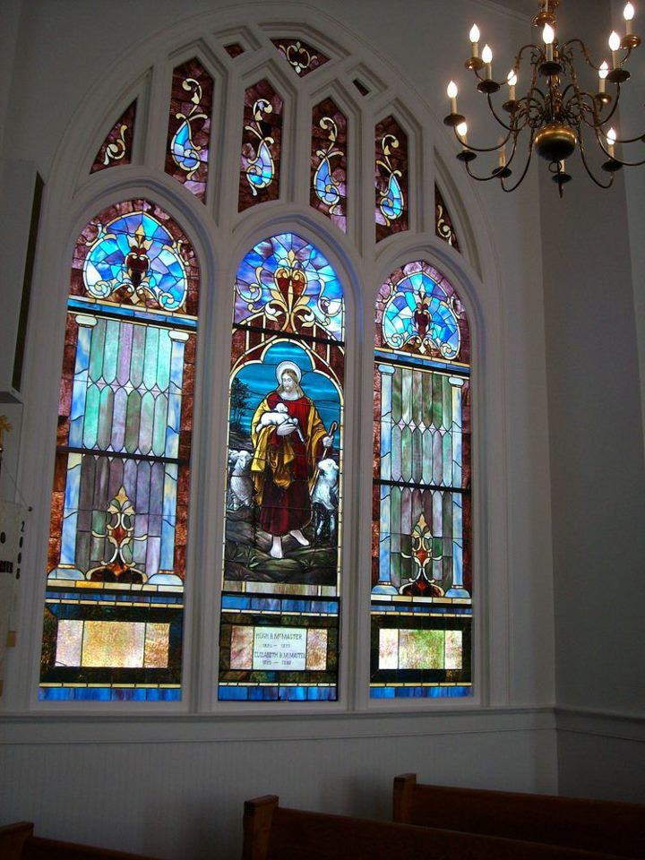

Seek God. Love All People.
Change the World.

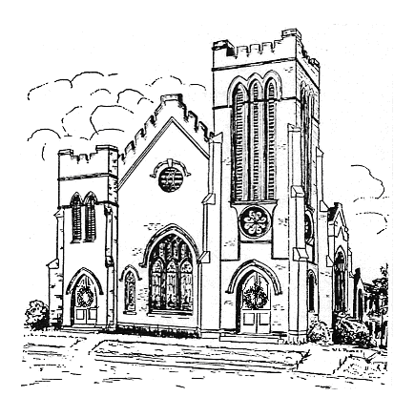

First United Methodist Church
109 W. College Street
Winnsboro, SC 29180
(803)635-4087

Firstumc@hotmail.com (office)
Fcwpastor@hotmail.com (pastor)
www.firstmethodistwinnsboro.com

Pastor: Rev. Julie Songer Belman
Church Secretary Julie Barfield
Choir Director: Wanda Neese
Organist: Esther J. Baughman
Lay Leader: Marcia Bonds
Financial Secretary: Peggy H. Ayers
Treasurer: Paul Dove
Pastor Emeritus: Rev. F. Bundy Bynum

