Order of Worship
March 23, 2014
3rd Sunday in Lent

PRELUDE

Welcome Announcements
Congregational Greeting

INTROIT May the Mind of Christ My Saviour CHOIR
Mary Wilkinson

*Prayer
O Lord our God, you are always more ready to bestow your good gifts on us than we are to seek them, and are willing to give more than we desire or deserve. Help us so to seek that we may truly find, so to ask that we may joyfully receive, so to knock that the door of your mercy may be opened to us; through Jesus Christ our Savior. Amen.

*Hymn : 715 Rejoice, the Lord is King

Morning Prayer

Lord’s Prayer with Choral Response

Anthem Whispering Hope – Septimus Winner CHOIR
Ruth Elaine Schram

RESPONSIVE READING PSALM 95 Page 814

*Gloria Patri # 71 Greatorex

*Affirmation of Faith #881 The Apostles’ Creed

Children’s Time

Offertory

*Doxology #95 Praise God from Whom All Blessings Flow Old 100th

*Hymn: #465 Holy Spirit, Truth Divine

GOSPEL John 4:5-42 Page:94

Sermon Are You Thirsty? Bart Sistare

*Hymn:#175 Jesus, the Very Thought of Thee

*Benediction A Clare Benediction CHOIR
John Rutter
*Postlude

During the singing of the closing hymn, you are invited to the altar for prayer, to unite with the church, or for other responses to God's love.

WELCOME VISITORS!

Welcome to our church family, we're glad that you could come.
We're honored to share this day with you as we worship God's risen Son. We hope that God will touch your life as we worship side by side and that you leave this place today with the peace of God inside.

THOSE WHO SERVE THIS WEEK

Ushers: Adam Swearingen and Justin Blackwelder
Counters: Alex Rabb and Jay Lucas
Acolyte: Berkley Derrick

Announcements

- Tuesday, March 25 – Men’s Club with guest speaker, Derial Ogburn 7:00 p.m.

- Wednesday, March 26 – Trustees Meeting 6:30 pm

- Wednesday, March 26 – Choir Practice 7:30 pm

Please make plans to attend the First United Methodist Church Easter Egg Hunt at Honeysuckle Acres on Good Friday, April 18, 2014 beginning at 10:00 a.m. Bring your Easter Basket and 20 plastic eggs. We expect a special appearance from Peter Cottontail.

 The flowers in the sanctuary this morning are placed to the Glory of God and in memory of Neill Judson Hines, III by Jim and Jo Ann Futrell.

Prayer List

Marcia Bonds | Ann Bailey | Rev. Don McKinney
Billy Boulware, Jr. | Betty Coleman | Julie Reese
Brent Dorrier | Frank Martin | Taylor Novinger
Lynne Moore | Carl Douglas | Mary Thomas
Stewart Goudelock | Russ Pearson | Chip, Julie and Madeline Fischesser
Rosetta Watson | Merrill Jennings Wood
Maudie Douglas | Vicky Melvin
Scott Vanvick | Becky McAlister

Please remember in prayer those serving our country in our armed forces both at home and overseas

When you can, remember to send a card, call or visit

Mabel Ward: The Waterford, Columbia,
Katherine Rabb: Rock Hill,
Lisa Lewis Meyer, Lowman White Rock,
Dot Yon, Falls Church, Va
Elise Williams and Edith McAlister Spartanburg,
Becky McMaster NHC, Columbia

The 2014 Flower Calendar is available if you are interested in providing flowers for worship. Please sign up in the hallway between the Fellowship Hall and Sanctuary.

STEWARDSHIP REPORT FOR MARCH 16, 2014
Sunday School Attendance 24

Worship Attendance 74
Sunday School Offering $16.00

Worship Offering $2,816.54
Needed Each Week 3,714.75

Received Year-to-Date $37,313.54 $6,789.61

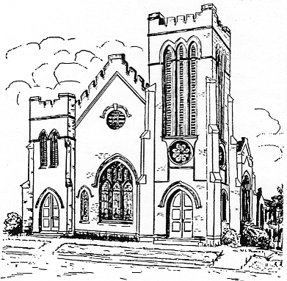
First United Methodist Church
109 W. College Street
Winnsboro, SC 29180
firstumc@hotmail.com
www.firstmethodistwinnsboro.com

Pastor: Rev. J. Bart Sistare
Choir Director: Wanda Neese
Organist: Esther J. Baughman
Lay Leader: Marcia Bonds
Church Secretary: Julie Barfield
Financial Secretary: Peggy H. Ayers
Treasurer: Paul Dove
Pastor Emeritus: Rev. F. Bundy Bynum

