THE FIRST WORD

2014 - 5 First United Methodist Church – 109 West College Street – Winnsboro, SC 5 - 2014

This year’s Holy Week Services were an outstanding success with great crowds and two new congregations participating with the Church of The Nazarene and St. Mark Baptist Church taking part. Added to that, we raised $439 for the local Food Bank plus a number of bags of non-perishable food items.

The preaching was good, the singing robust, and the meals extraordinary. My thanks go out to all who participated, all who prepared our lunch on Friday (considering that our Maundy Thursday Family Night came just hours before means many of you were plenty busy), and all who made sure the sanctuary was comfortable and clean for each day. My sincerest thanks also go to Esther Baughman who arranged all the music for the week. It was all outstanding but especially Friday’s music from the joint choirs of First Church and Lebanon Presbyterian.

These services each year consistently set the proper tone for the Easter celebration that follows and gives Christians of all denominations the chance to remember once again our unity in Christ.

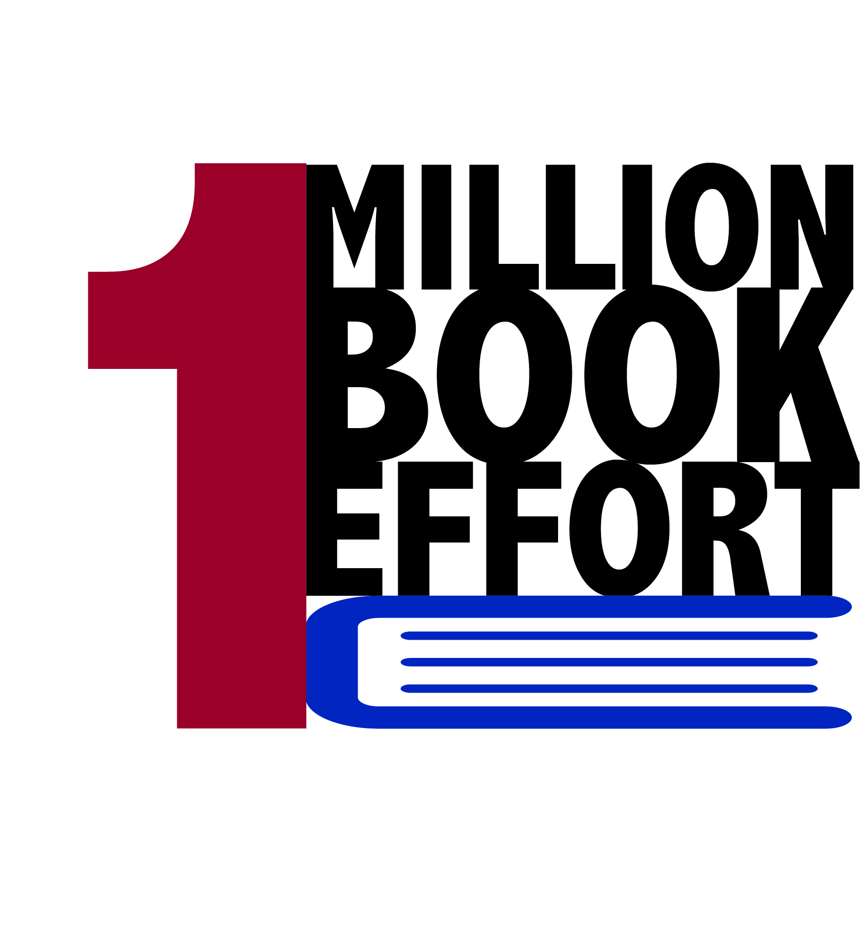
We are progressing in our South Carolina Conference’s Million Book Effort. A number of you have contributed new books to our collection and others have made a financial contribution. Anna Sistare went door-to-door to all of our downtown businesses and received over $100 in contributions as well. We have been in contact with Educational Wonderland about purchasing new books for Kids 5 Years-old up to Grade 6. Scholastic has a website that will prove productive for us as well. There will also be a Scholastic Warehouse sale the week of May 7. Please give generously to this effort. Poverty and Illiteracy go hand-in-hand. When we combat illiteracy we necessarily affect the other. The old saying goes, “Give a man a fish and you feed him for a day. Teach him to fish and you feed him for a lifetime.” The Million Book Effort is one way the United Methodist Church in South Carolina is attempting to teach fishing.

Bart

OUR MINISTRY FOR
MAY

USHERS:
Eric Johnson and Reid Johnson

COUNTERS:
Mary Jim Gunter and Patsy Black
Sallie Kate and Donnie Laird
Alex Rabb and Jay Lucas
Roy Barnett and Jim Baughman

PRAYER LIST

Betsy Stevenson, Susan Jackson, Marcia Bonds, Ann Bailey, Billy Boulware, Jr., Betty Coleman, Becky McAlister, Brent Dorrier, Vicky Melvin, Stewart Goudelock, Frank Martin, Rev. Don McKinney, Lynne Moore, Julie Reese, Maudie Douglas, Taylor Novinger, Rosetta Watson, Merrill Jennings Wood, Mary Thomas, Chip Julie and Madeline Fischesser, Pat Curlee, Scott VanVick and Russ Pearson

Please, remember in prayer those serving our country in our armed forces both at home and overseas.

When you can, remember to send a card, call or visit:

Mabel Ward: The Waterford,
Katherine Rabb:, Rock Hill,
Lisa Lewis Meyer: Lowman,
Becky McMaster: NHC, Columbia

Elise Williams and Edith McAlister: Spartanburg, Dot Yon, Falls Church, VA, Forrest Hughes, Fairfield Health Care, Ridgeway.


Interested in what’s happening throughout the church? You have an open invitation to attend any committee meeting with the exception of the PPRC (due to personnel related issues). Come to an Administrative Council, Trustee, Vision or Finance meeting to see how things are going and to see how you can help our church grow and develop. Watch the Sunday church bulletin for dates and times. Be a part of First United Methodist Church!



TO MEMBERS OF OUR CHURCH FAMILY WITH BIRTHDAYS IN
MAY

Frances Barnett 2
Brent Dorrier 4 Marion Robinson 9 Brock Williams 10 Catherine Boulware 15
Barbara Martin 15
Tony Barfield 16 Brenda McMaster 16 Dean Lee 22
Jay Ayers 23
Anne Lee 24
Reid Johnson 29
Edith McAlister 30

(Please call the church office if you would like your birthday to be mentioned in our monthly tribute.)

Thanks again to the generous donation of Frank and Frances Lyles, we were able to help 4 families this past month. In their spirit of giving, we are committed to helping families in need as the Lyles requested.
If you are interested in leaving a legacy to First United Methodist Church, please call the church office or make arrangements by remembering those in need.

Church Contact Information
CHURCH: 635-4087
PARSONAGE: 815-0414
FAX: 635-4496
www.firstmethodistwinnsboro.com
E-mail: Firstumc@hotmail.com

UNITED METHODIST WOMEN

The FUMC Women have started collecting items for the upcoming yard sale, to be held in September 2014. The collection point will be the "yellow door" Sunday School room downstairs - the same room used this year. Please bring your items to the church during the normal church hours. If you need assistance in getting the items to the church or have any other questions, please call Frances Porter at 718-6293.

A big shout out to Berkley Derrick for always volunteering to serve as acolyte when needed! Thank you!

There is a new Sunday School class of college students and young adults. They meet in the Lucy Way classroom and welcome all young adults to join them at 10 am every Sunday for refreshments and study of “The Purpose Driven Life.”



MAY FLOWER CALENDAR

May 4

Bill and Lenora Bundy

May 11

Mother’s Day

May 18

May 25

If you would like to put flowers in the sanctuary, please call the church office or sign up on the flower calendar located in the hallway between the fellowship hall and the sanctuary.

A special Congratulations to Mary Jim Gunter who received the Meta Sullivan Service Award. Thank you for all the work you provide to First United Methodist!

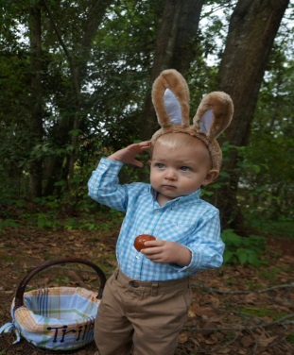 The Young Adults would like to thank Honeysuckle Acres for hosting the Annual Easter Egg Hunt! It was a huge success and fun was had by all!

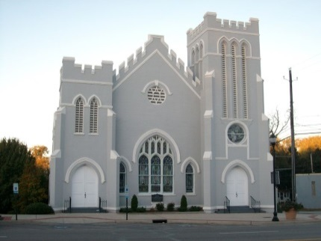
Visit our website:
www.firstmethodistwinnsboro.com
and
Like us on Facebook!

Fairfield Council on Aging needs volunteers to deliver Meals on Wheels. Delivery times are between 11 am and Noon. Please call Beth Bonds at 635-3015 if you are interested.

1st Annual United Fellowship Outdoor Cookout

Music…Games…Fun…

Saturday, May 31st 5 pm – 8 pm

**Bring a book or 2 or a Donation for the 1 Million Book Effort**

Any questions, contact “The Young Adults” (Coleman, Mary, Brice, Sallie, Doug)

BYOB
(Bring Your Own Book)


Heavenly Humor

An elderly couple was shipwrecked on an island and the husband, concerned about unpaid bills, asked his wife: “Dear, did you pay our VISA bill?” “I’m sorry, I forgot.” she replied. “The MasterCard bill?” “I forgot that too.” She said. “Did you make the IRS installment?” “Sorry, dear, I didn’t send that one either.” “What about the monthly check for our church tithe?” “Forgive me, honey,” she said, “I forgot that, too.” “Don’t worry, dear,” the husband said, giving her a big hug. “If VISA, MasterCard, and the IRS can’t find us, our pastor will.”

Congratulations to the Men’s Club on raising $$$$$ selling Boston Butt roasts. All proceeds will go to local missionary work. Thank you for supporting the First United Methodist Men’s Club!

Christianity is not a theory or speculation, but a life; not a philosophy of life, but a living presence. ~ Samuel Taylor Coleridge

Treasurer’s Report

There will only be 1 newsletter for June, July and August. If you have any news or information for the summer months, please send it to the office no later than May 23, 2014. Thanks!
Memorials

In Memory

Emily Busbee

By

Marion and Vickie Robinson
Don and Mary Jim Gunter

Danny Burley

By

Don and Mary Jim Gunter

Johnny Martin

By

Marion and Vickie Robinson

Alvin Raley

By

Richard and Gail Bonds

Berry Bonds

By

Richard and Gail Bonds

News from Our Church Family

On May 3, 2014 Peter Frish (Aaron’s dad), will receive his Master of Arts in Christian Apologetics from Southern Evangelical Seminary in Charlotte, NC. Following graduation Peter and Aaron plan travel to Israel where they will volunteer at the Beit Bracha Prayer and Retreat Center described below. Aaron will have an opportunity to play his trumpet and have daily devotions in addition to his duties and Peter may have an opportunity to lead devotions and teach classes. Peter will use his handyman skills at the center and Aaron will improve on his skills in the kitchen and as a waiter. They will stay for a three month stint after which Peter will return to Southern Evangelical Seminary to begin his Master of Divinity degree.

Beit Bracha Prayer and Retreat Center
Beit Bracha (the House of Blessing) is a Christian guesthouse near the Sea of Galilee with a peaceful, prayerful vibe. Beit Bracha is situated close to many major historical sites, including the Mt. of Beatitudes, Tabgha, and Capernaum. Single and twin rooms are available, as well as rooms large enough for a family. Prices are reasonable, and breakfast is included. Perfectly situated close to the Sea of Galilee, Beit Bracha is a wonderful place to rest at the end of a long day visiting the sights in Northern Israel, or as a retreat center for prayer and meditation.

This House of Blessing, as it is called, is literally ministering peace to Christians from around the world, people who come to trace the steps of the Master and discover within a short distance the very places where Jesus walked and taught: The Mount of Beatitudes, Capernaum, Tabgha...and much more.
Likewise, local residents often divided by religion and ethnicity flocks to the House of Blessing because they are welcomed. One day it is an army commander seeking brief refuge from a war. Another, it is a Messianic Jewish couple celebrating their wedding; yet another, a group of young Arab believers there for Bible study and discipleship. Day after day, individuals, families and groups arrive from near and far for retreats, prayer tours, local gatherings and fellowship in this place that ministers the love of Jesus and fosters peace and reconciliation.

Because of the pioneering work of English church reformers such as Wycliffe and Tyndale who translated the Bible into vernacular English, Christians in England became familiar with the Bible, its teachings, and the special role God planned for His covenant people Israel. It was no coincidence that CMJ was established in England in 1809 by prominent Christians.
From the beginning CMJ was aware that God had promised to bring Israel back to its God, Messiah and land. Seeing the oppression and persecution of the Jewish people, CMJ began a ministry to relieve the suffering of the Jewish people through charity at local levels, political activism in the highest echelons of the British government, and proclaiming the Gospel of God's Kingdom. The Good News of His love for mankind and the ultimate consummation of His reign on the earth included the promised restoration of His covenant people to their calling.

CMJ set up mission stations throughout the world. Schools, churches, clinics, hospitals, printing presses and bookshops were established primarily in Europe and the Middle East to help alleviate the suffering of the Jewish people. CMJ staff was instrumental in combating anti-Semitism, and Christians in the British government (many involved with CMJ such as Wilberforce and Shaftesbury) played a key role in the Jewish return to the Land of Israel. CMJ not only built the first Protestant church in the Middle East, Christ Church Jerusalem, but also the first schools, the first houses of industry for job training, and the first hospital with state-of-the-art equipment and medicine, all of which helped bring modern standards of health, welfare, and education to the area.

CMJ in Israel continues its ministry of being a witness to both Jews and Gentiles of God's love and faithfulness as found in Jesus the Messiah. Today we express this in many practical ways: supporting and educating local believers, praying for the peace of Jerusalem, combating anti-Semitism, teaching Christians about their Jewish Roots, and proclaiming the return of the King.

Entering the Computer Age



A special thank you to Bob Drake and Kenny Martin for their work in auditing the financial records of the church. Sarah McMaster, Paul Dove, Bob Drake and Kenny Martin have been instrumental in providing leadership and organization to the vision to computerize the financial records. We are working hard to safeguard information and computerizing these records is a big step forward. We have already begun the process of computerizing other important data such as maps, cemetery information, and historical records.
Holy Week Services 

We had another successful week of Holy Week Services. Attendance was outstanding and we were able to give a generous donation of $439.00 and food to the Fairfield County Food Bank.

A special thanks to all the churches that participated, First Baptist Church, St. Mark Baptist Church, Gordon Memorial UMC, Bethel UMC, Church of the Nazarene, Bethel ARP, Sion Presbyterian Church, Washington Street Baptist Church, and First United Methodist Church.

Our thanks also to the following ushers: Jack Ivester. Jay Lucas and Roy Barnett

Thanks to our guest musicians: Mr. Chuck Herrin, Mrs. Karen Chapman, Mr. John Hartness, Mrs. Ginny McKinney, The Johnson String Trio, Campbell, Patrick and Evan, Mrs. Kerry Matthews, The Combined Choirs of Lebanon Presbyterian and First United Methodist Churches, Organist, Mrs. Esther J. Baughman and Choir Director, Wanda Neese. A special thanks to: Reverend J. Bart Sistare, III for providing leadership through the week, and to Mary Jim Gunter and Jack Ivester for taking care of all the extra “behind the scenes” things that no one ever sees.

This has become a great tradition at First United Methodist Church!

