Order of Worship
September 21, 2014
15th Sunday after Pentecost

PRELUDE

WELCOME AND ANNOUNCEMENTS

INTROIT A Mighty Fortress is Our God CHOIR
Martin Luther

PRAYER

Lord of mystery and community, you have called us here this day to remind us of the mission journey you set before us. Whether we have come to you from long ago, or have just come to you now, you reach out with love and blessing for each one of us. Help us remember your love and offer blessings to each other in your name. Enable us to truly be your disciples in this world. In Jesus’ name, we pray, Amen.

*HYMN: #698 God of the Ages

MORNING PRAYER

LORD’S PRAYER WITH CHORAL RESPONSE

Our Father, who art in heaven,
Hallowed be thy Name.
Thy Kingdom come.
Thy will be done on earth,
As it is in heaven.
Give us this day our daily bread.
And forgive us our trespasses,
As we forgive those who trespass against us.
And lead us not into temptation,
But deliver us from evil.
For thine is the kingdom,
The power, and the glory, forever.
Amen.

ANTHEM Holy, Holy, Holy, We Worship You CHOIR
Arr. By Benjamin Harlan

*RESPONSIVE READING #782 Psalm 48

*GLORIA PATRI # 71 Greatorex

*AFFIRMATION OF FAITH #881

The Apostles’ Creed

I believe in God the Father Almighty,
maker of heaven and earth;
And in Jesus Christ his only Son our Lord:
who was conceived by the Holy Spirit,
born of the Virgin Mary,
suffered under Pontius Pilate,
was crucified, dead, and buried;
the third day he rose from the dead;
he ascended into heaven,
and sitteth at the right hand of God the Father Almighty;
from thence he shall come to judge the quick and the dead.
I believe in the Holy Spirit,
the holy catholic church,
the communion of saints,
the forgiveness of sins
the resurrection of the body,
and the life everlasting. Amen

CHILDREN’S TIME

OFFERTORY

*DOXOLOGY #95 Old 100th

*HYMN: #472 Near to the Heart of God

SCRIPTURE LESSON Mark 6:1-6

This is the Word of God, for the people of God
Thanks be to God

SERMON “Faith in God’s Voice” Rev. Belman

*HYMN: #398 Jesus Calls Us

During the singing of the closing hymn, you are invited to the altar for prayer, to unite with the church, or for other responses to God's love.

*BENEDICTION A Gaelic Benediction CHOIR
Jerry Ulrich

*POSTLUDE

WELCOME VISITORS!

Welcome to our church family, we're glad that you could come. We're honored to share this day with you as we worship God's risen Son. We hope that God will touch your life as we worship side by side and that you leave this place today with the peace of God inside.

THOSE WHO SERVE THIS WEEK

Ushers: Bob Drake and Brock Williams
Counters: Jay Lucas and Alex Rabb
Acolyte – Berkley Derrick

Announcements
- Tuesday, September 23 – Men’s Club, 7:00 p.m. Fellowship Hall
- Thursday, September 25 – Nominations Committee, 6:00 p.m. Conference Room
- If you are interested in attending the Fun Day (see insert) please fill out registration and place in offering plate. We need the registration fee and commitment no later than Friday, October 3rd so transportation can be arranged.
- *Committee chairs or anyone with an item for the report to the District Superintendent, see Bill DuBard. Charge Conference, October 29th.

The altar flowers are given in loving memory of H. Paul Dove, Sr., Rev. Guy Cecil Hinson, Sr., and Guy Cecil Hinson, Jr., fathers and grandfather birthdays by Paul and Bobbie Dove.

There are many openings in the flower calendar. If you would like to provide altar flowers, please sign up.

Prayer List

Sara Duncan, Rev. Don McKinney, Billy Boulware, Jr., Betty Coleman, Chip, Julie and Madeline Fischesser, Brent Dorrier, Frank Martin, Taylor Novinger, Lynne Moore, Mabel Ward, Mary Thomas, Rosetta Watson, Julie Reese, Russ Pearson, Stewart Goudelock, Merrill J. Wood, Carl and Katherine Douglas, Maudie Douglas, Vicky Melvin, Annette Clowney, Scott Vanvick, Becky McAlister, Albertia Bundy, Gary Brown, Blaine Riley

Please remember in prayer those serving our country in our armed forces both at home and overseas.

When you can, remember to send a card, call or visit

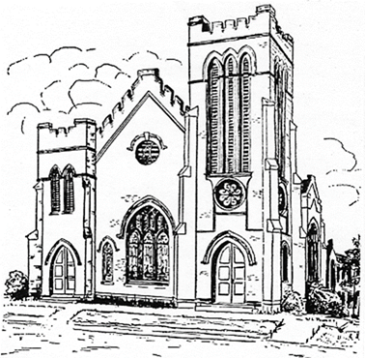

Dot Yon Goodwin House Apt. #401, 3440 S. Jefferson Street
Falls Church, VA 22041

Elise Williams 9423 Old Douglass Road, Blackstock, SC 29014

Edith McAlister 110 Summit Hills Drive, Apt. #317,
Spartanburg, SC 29307

Becky McMaster NHC Room 311, 7601 Parkland (PO Box 25548), Columbia SC 29223

Forest Hughes Fairfield Health Care, 117 Bellfield Road
Ridgeway, SC 29130

Katherine Rabb 1330 India Hook Road, Apt. 108 Rock Hill, SC 29732
Lisa Lewis Meyer The Heritage at Lowman, PO Box 444
White Rock, SC 29177

Mabel Ward 9370 Windsor Lake Blvd. Apt. #206 Columbia, SC 29223

Stewardship Report for September 14, 2014

Sunday School Attendance | 31
Worship Attendance | 86
Sunday School Offering | 21.00
Worship Offering | 3,686.54
Needed Each Week | 3,714.75
Received Year to Date | 138,270.23
Needed Year to Date | 137,445.75

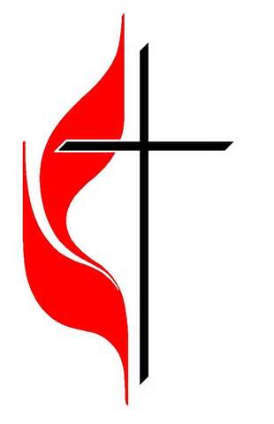

“Seek God. Love People. Change the World.”

First United Methodist Church
109 W. College Street
Winnsboro, SC 29180

firstumc@hotmail.com (office)
FCWpastor@hotmail.com (pastor)
www.firstmethodistwinnsboro.com

Pastor: Rev. Julie Songer Belman
Choir Director: Wanda Neese
Organist: Esther J. Baughman
Lay Leader: Marcia Bonds
Church Secretary: Julie Barfield
Financial Secretary: Peggy H. Ayers
Treasurer: Paul Dove
Pastor Emeritus: Rev. F. Bundy Bynum

