Order of Worship
May 4, 2014
3nd Sunday of Easter

PRELUDE

Welcome Announcements
Congregational Greeting

INTROIT All Creatures of Our God and King CHOIR
Traditional German

*Prayer

O Lord, your wondrous birth means nothing unless we are born again, your death and sacrifice mean nothing unless we die to sin, your resurrection means nothing if you be risen alone. Raise and exalt us, O Savior, both now to the estate of grace and hereafter to the estate of glory; where with the Father and the Holy Spirit you live and reign, God forever and ever. Amen.

*Hymn : 139 Praise to the Lord, the Almighty

Morning Prayer

Lord’s Prayer with Choral Response

Anthem Hiding In Thee CHOIR
Cushing/Sankey/Berry

RESPONSIVE READING PSALM 116 Page 837

*Gloria Patri # 71 Greatorex

*Affirmation of Faith #881 The Apostles’ Creed

Children’s Time

Offertory

*Doxology #95 Praise God from Whom All Blessings Flow Old 100th

*Hymn: #454 Open My Eyes, That I May See

GOSPEL Luke 24:13-35 Page: 90

Sermon Did You Miss It? Bart Sistare

*Hymn:#700 Abide With Me

*Benediction Go Now in Peace CHOIR
Price/Besig
*Postlude

During the singing of the closing hymn, you are invited to the altar for prayer, to unite with the church, or for other responses to God's love.

WELCOME VISITORS!

Welcome to our church family, we're glad that you could come.
We're honored to share this day with you as we worship God's risen Son. We hope that God will touch your life as we worship side by side and that you leave this place today with the peace of God inside.

THOSE WHO SERVE THIS WEEK

Ushers: Eric Johnson and Reid Johnson
Counters: Mary Jim Gunter and Patsy Black

Announcements

- Tonight at 6:00 pm join us in the Fellowship Hall to hear Sarah Junkin Woodard speak on her 20 year missionary work in Nicaragua. Hotdog supper to follow. All are invited.

- Wednesday, May 7 at 7:00 pm. Vision Committee in the Conference Room.

- Thursday, May 8 at 4:00 pm, Mary Clare Johnson will perform in a violin recital at the ARP Church. All are invited.

- Choir Practice: Wednesday 7:30 pm

 The flowers in the sanctuary this morning are placed to the Glory of God and in honor of our mothers, Annette Clowney and Albertia Bundy by Bill and Lenora Bundy.

The 2014 Flower Calendar is available if you are interested in providing flowers for worship. Please sign up in the hallway between the Fellowship Hall and Sanctuary

Prayer List

Marcia Bonds | Ann Bailey | Rev. Don McKinney
Billy Boulware, Jr. | Betty Coleman | Julie Reese
Brent Dorrier | Frank Martin | Taylor Novinger
Lynne Moore | Carl Douglas | Mary Thomas
Stewart Goudelock | Russ Pearson | Chip, Julie and Madeline Fischesser
Rosetta Watson | Merrill Jennings Wood | Betsy Stevenson
Maudie Douglas | Vicky Melvin | Susan Jackson
Scott Vanvick | Becky McAlister | Pat Curlee

Please remember in prayer those serving our country in our armed forces both at home and overseas

When you can, remember to send a card, call or visit

Mabel Ward: The Waterford, Columbia,
Katherine Rabb: Rock Hill,
Lisa Lewis Meyer, Lowman White Rock,
Dot Yon, Falls Church, Va
Elise Williams and Edith McAlister Spartanburg,
Becky McMaster NHC, Columbia
Forrest Hughes, Fairfield Health Care

STEWARDSHIP REPORT FOR APRIL 27, 2014
Sunday School Attendance 29

Worship Attendance 86
Sunday School Offering 24.65

Worship Offering $3,330.54
Needed Each Week 3,714.75

Received Year-to-Date $58,818.31 $6,789.61

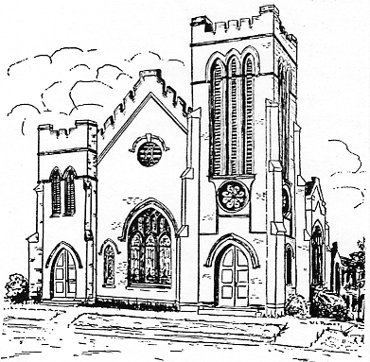
First United Methodist Church
109 W. College Street
Winnsboro, SC 29180
firstumc@hotmail.com
www.firstmethodistwinnsboro.com

Pastor: Rev. J. Bart Sistare
Choir Director: Wanda Neese
Organist: Esther J. Baughman
Lay Leader: Marcia Bonds
Church Secretary: Julie Barfield
Financial Secretary: Peggy H. Ayers
Treasurer: Paul Dove
Pastor Emeritus: Rev. F. Bundy Bynum

