Order of Worship
December 28, 2014
1st Sunday after Christmas Day

PRELUDE

WELCOME AND ANNOUNCEMENTS

INTROIT Good Christian Men Rejoice CHOIR
Christina Rossetti/Gustav Holst

PRAYER:

God of mystery, in the darkness of our world your light shines with grace and truth. Open the eyes of our hearts to the glory of your love. Speak your word of truth and joy. May the mystery revealed in Jesus draw us closer to you. May the wonder of your love fill us with wisdom and peace. As we rejoice in your presence, teach us to seek justice and righteousness. Fill our hearts to overflowing with your joy, your glory, your hope. Amen.

*HYMN: #249 There’s A Song in the Air

PASTORAL PRAYER

LORD’S PRAYER WITH CHORAL RESPONSE

Our Father, who art in heaven,
Hallowed be thy Name.
Thy Kingdom come.
Thy will be done on earth,
As it is in heaven.
Give us this day our daily bread.
And forgive us our trespasses,
As we forgive those who trespass against us.
And lead us not into temptation,
But deliver us from evil.
For thine is the kingdom,
The power, and the glory, forever.
Amen.

ANTHEM Sing, O Sing This Blessed Morn CHOIR
Christopher Wordsworth/Eugene Butler

*PSALTER #795 Psalm 72

*GLORIA PATRI # 71 Greatorex

*AFFIRMATION OF FAITH #881

The Apostles’ Creed

I believe in God the Father Almighty,
maker of heaven and earth;
And in Jesus Christ his only Son our Lord:
who was conceived by the Holy Spirit,
born of the Virgin Mary,
suffered under Pontius Pilate,
was crucified, dead, and buried;
the third day he rose from the dead;
he ascended into heaven,
and sitteth at the right hand of God the Father Almighty;
from thence he shall come to judge the quick and the dead.
I believe in the Holy Spirit,
the holy catholic church,
the communion of saints,
the forgiveness of sins
the resurrection of the body,
and the life everlasting. Amen

CHILDREN’S TIME

OFFERTORY

*DOXOLOGY #95 Old 100th

*HYMN #219 What Child Is This

SCRIPTURE LESSON Isaiah 60:1-5, 17b-22

This is the Word of God, for the people of God
Thanks be to God

SERMON “Arise! Shine! Give God the Glory!”
Rev. Belman

*HYMN: #251 Go, Tell It On the Mountain

During the singing of the closing hymn, you are invited to the altar for prayer, to unite with the church, or for other responses to God's love.

*BENEDICTION Father, Give Thy Benediction CHOIR
Samuel Longfellow

*POSTLUDE

WELCOME VISITORS!

Welcome to our church family, we're glad that you could come. We're honored to share this day with you as we worship God's risen Son. We hope that God will touch your life as we worship side by side and that you leave this place today with the peace of God inside.

THOSE WHO SERVE THIS WEEK

Ushers: Joe Sanders and Kenny Martin
Counters: Sallie Kate Watford and Donnie Laird
Acolyte: Berkley Derrick

Announcements

The church office will be closed on New Year’s Day.

The altar flowers are given to the glory of God by Bill and Margaret DuBard.

If you would like to provide altar flowers, please sign up on the flower calendar in the hall behind the sanctuary.

Prayer List

The family of Forest Hughes, Bill Bundy, Jay Lucas, Wilbur Douglas, Caroline Montgomery, Sara Duncan, Rev. Don McKinney, Billy Boulware, Jr., Betty Coleman, Chip, Julie and Madeline Fischesser, Brent Dorrier, Frank Martin, Taylor Novinger, Lynne Moore, Mary Thomas, Julie Reese, Tam Lark, Merrill J. Wood, Maudie Douglas, Annette Clowney, Scott Vanvick, Becky McAlister, Albertia Bundy, Martha Branham Robinson, and Blaine Riley

Please remember in prayer those serving our country in our armed forces both at home and overseas.

When you can, remember to send a card, call or visit

Doris Myfelt 3195 Rio Dosa Drive #2103, Lexington, KY 40509 (859)309-9284
Susan Jackson, Harbor Chase, 1611 Constitution Blvd., Rock Hill, SC 29732. Phone (803) 366-7431

Dot Yon Goodwin House Apt. #401, 3440 S. Jefferson Street
Falls Church, VA 22041

Elise Williams 9423 Old Douglass Road, Blackstock, SC 29014

Edith McAlister 110 Summit Hills Drive, Apt. #317,
Spartanburg, SC 29307

Becky McMaster NHC Room 311, 7601 Parkland (PO Box 25548), Columbia SC 29223

Katherine Rabb 1330 India Hook Road, Westminister Towers, Apt. 108 Rock Hill, SC 29732

Lisa Lewis Meyer The Heritage at Lowman, PO Box 444
White Rock, SC 29177

Mabel Ward 200 River Landing Unit #209, Charleston, SC 29492

Stewardship Report for December 21 2014

Sunday School Attendance | 26
Worship Attendance | 86
Sunday School Offering | 25.00
Worship Offering | 4,837.54
Needed Each Week | 3,714.75
Received Year to Date | 189,561.18
Needed Year to Date | 182,022.75

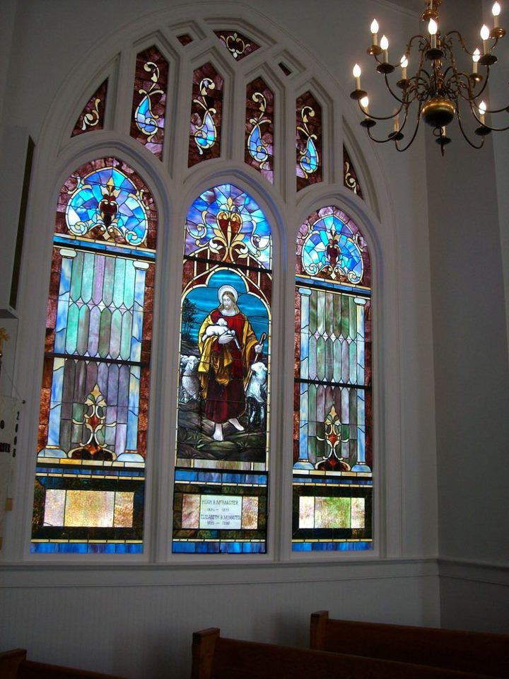

Seek God. Love All People.
Change the World.

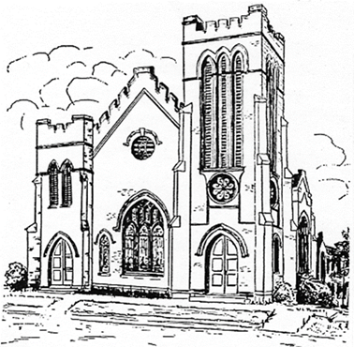
First United Methodist Church
109 W. College Street
Winnsboro, SC 29180

firstumc@hotmail.com (office)
FCWpastor@hotmail.com (pastor)
www.firstmethodistwinnsboro.com

Pastor: Rev. Julie Songer Belman
Choir Director: Wanda Neese
Organist: Esther J. Baughman
Lay Leader: Marcia Bonds
Church Secretary: Julie Barfield
Financial Secretary: Peggy H. Ayers
Treasurer: Paul Dove
Pastor Emeritus: Rev. F. Bundy Bynum

