THE FIRST WORD

2014 - 6 First United Methodist Church – 109 West College Street – Winnsboro, SC 6 - 2014

This is the last time I will be writing an article for the newsletter here at First Church, moving day will be June 25; and, since I have always been awful at goodbyes, it will be necessarily short. I just want to say thank you to all of you for the last 5 years spent here in Winnsboro. Personally, it has been an eventful time in my life and that of my family. It has been a time that has seen my daughter begin and complete her college education, the birth of my grandchildren, and of course, my heart by-pass surgery. (Could’ve done without that last one). Professionally, I’ve had the opportunity to work with some wonderful people at a great church, to get to know and enjoy Bundy and Betty Bynum, and to appreciate Winnsboro, a place I had only briefly visited twice prior to my moving here in 2009. I am grateful for my years here and for all that I have learned and I know that Julie Belman will be blessed to be a part of this community. I wish her and all of you the very best as together you serve God in the years ahead.

Bart

OUR MINISTRY FOR
June

USHERS:
Bill Bundy and Tony Barfield

COUNTERS:
Mary Jim Gunter and Patsy Black
Sallie Kate and Donnie Laird
Alex Rabb and Jay Lucas
Roy Barnett and Jim Baughman


TO MEMBERS OF OUR CHURCH FAMILY WITH BIRTHDAYS IN
JUNE

Laura Derrick 2
Nancy Blair Gonzalez 2
Jack Melvin 2
Will Hemlepp 4
Lauren Cooke 5
Julie Barfield 7
Sam Barfield 9
Frances Ann Porter 13
Tony Caulder 14
Amy Adams 19
Wanda Derrick 19
Callie Bell 20
Lewis Humphries 24
Martha Wilkes 24
Betsy Hemlepp 28

PRAYER LIST

Betsy Stevenson, Susan Jackson, Marcia Bonds, Ann Bailey, Billy Boulware, Jr., Betty Coleman, Becky McAlister, Brent Dorrier, Vicky Melvin, Stewart Goudelock, Frank Martin, Rev. Don McKinney, Lynne Moore, Julie Reese, Maudie Douglas, Taylor Novinger, Rosetta Watson, Merrill Jennings Wood, Mary Thomas, Chip Julie and Madeline Fischesser, Scott VanVick and Russ Pearson, Sara Duncan

Please, remember in prayer those serving our country in our armed forces both at home and overseas.

When you can, remember to send a card, call or visit

Mabel Ward 9370 Windsor Lake Blvd. Apt. #206 Columbia, SC 29223
Katherine Rabb 1330 India Hook Road, Apt. 108 Rock Hill, SC 29732
Lisa Lewis Meyer The Heritage at Lowman, PO Box 444
White Rock, SC 29177
Dot Yon Goodwin House Apt. #401, 3440 S. Jefferson St.
Falls Church, VA 22041
Elise Williams Skylyn Place Nursing Center Room #12, 1705 Skylyn Drive, Spartanburg, SC 29307
Edith McAlister 110 Summit Hills Drive, Apt. #317,
Spartanburg, SC 29307
Becky McMaster NHC Room 228, 7601 Parkland (PO Box 25548), Columbia SC 29223
Forest Hughes Fairfield Health Care, 117 Bellfield Road
Ridgeway, SC 29130

.
(Please call the church office if you would like your birthday to be mentioned in our monthly tribute.)

Church Contact Information
CHURCH: 635-4087
PARSONAGE: 815-0414
FAX: 635-4496
www.firstmethodistwinnsboro.com
E-mail: Firstumc@hotmail.com

 Stay tuned for pictures and details from the 1st Annual Fellowship Outdoor Cookout which was sponsored by the Young Adults.

UNITED METHODIST WOMEN

The FUMC Women have started collecting items for the upcoming yard sale, to be held in September 2014. The collection point will be the "yellow door" Sunday School room downstairs - the same room used this year. Please bring your items to the church during the normal church hours. If you need assistance in getting the items to the church or have any other questions, please call Frances Porter at 718-6293.

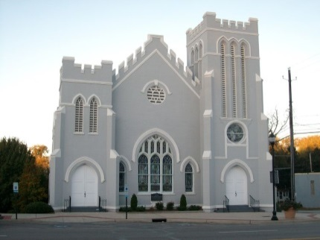

Visit our website:

www.firstmethodistwinnsboro.com

and Like us on Facebook!

Fairfield Council on Aging needs volunteers to deliver Meals on Wheels. Delivery times are between 11 am and Noon. Please call Beth Bonds at 635-3015 if you are interested.



Treasurer’s Report (Through May 25)

Collected: $72,842.47
Needed: $78,009.75

Vial of Life
The Vial of Life is a smart way to have your medical information on hand just in case of an emergency. Seniors need this because of their constant medical changes and medications… It’s the right thing to do.

Put one in your wallet, in your glove compartment, and especially on your refrigerator door- even put one in your child’s pocket. It’s FREE.
Go to www.vialoflife.com and print the forms or fill them out online. This is an easy way to keep track of your current medications and your current medical information. Be prepared! And did we mention, it’s FREE!

************

 First United Methodist would like to welcome Mary Margaret and Stevenson's baby brother - Sullivan Glenn! Congratulations to Mary and Adam Swearingen.
*******************


When you can, please make donations to the Fairfield County Food Bank. We have a container at the back door or you can leave food items in the Narthex. Cash or checks are always welcome!

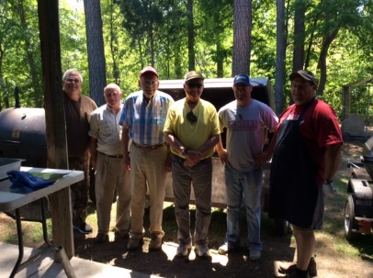

Methodist Men had a successful fundraiser. The Boston Butt roasts brought in more than $3,600 to be used throughout the community for local charities. Special thanks to John Martin for his cooking expertise!

Summer Altar Flower Schedule

JUNE FLOWER CALENDAR

June 1 – Wanda Neese

June 8

June 15 – Father’s Day

June 22 – Tony and Beth Caulder

June 29 – Bill and Margaret DuBard

JULY FLOWER CALENDAR

July 6

July 13 – Esther Baughman and Barbara Douglas

July 20

July 27 – Bill and Linda Haslett

AUGUST FLOWER CALENDAR

August 3 – Peggy Ayers

August 10

August 17

August 24

August 31

If you would like to put flowers in the sanctuary, please call the church office or sign up on the flower calendar located in the hallway between the fellowship hall and the sanctuary.



In Memory of Mrs. Audrey Pope. This is a quick and easy summer salad found in our Methodist cookbook.

Mandarin Orange Salad

1 (6 oz. ) orange Jello
1 lg. Cool Whip
1 (12 oz.) cottage cheese
1 (No. 3) crushed pineapple, drained
1 (11 oz.) mandarin oranges, drained and chopped

Make Jello using juices from mandarin oranges and pineapple and only ½ of water called for on package of Jello. Blend in other ingredients. Chill until set. Serve on lettuce. Makes 12 to 14 sevings.

 If you would like to purchase a copy of “A Taste of Tradition”, a collection of recipes by First United Methodist Church, please call the office 635-4087.

************************



To a Block Party to
Meet the New Neighbors!

Sarah Bryant’s Home
200 Evans Street

Saturday, June 8, 2014
4:00 p.m. – Until

Bring a Covered Dish
Drinks and Ice Provided

Swimming Pool
Music Provided by a D.J.

Call 803 960-9098 for more details!


************************************

An Old Fashioned Pounding!

A pounding is an old fashioned tradition celebrated in many churches where a new pastor is welcomed to the church with gifts of food and household items. Traditionally, a pounding would provide a pastor and his family with a pound of staples, such as a pound of flour, a pound of sugar, a pound of butter and a pound of other basic items. Please welcome Rev. Belman into First Church with a pounding of household items that can be dropped off at the office or in the boxes provided in the Conference Room.
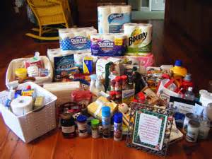

Thank you to Justin Blackwelder and his helper, Joe Blackwelder for installing the new playground equipment!

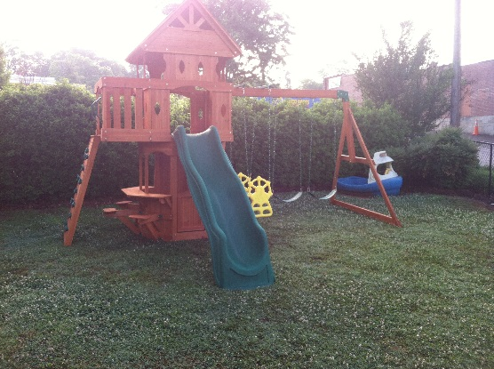
And whatever you do, in word or deed, do everything in the name of the Lord Jesus, giving thanks to God the Father through him. Colossians 3:17
*****************
Thank you to Paul and Bobbie Dove for putting the American flag on the graves of those who served in the Armed Forces in honor of their service for Memorial Day.
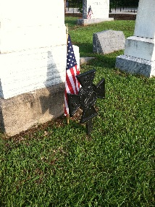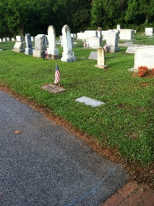
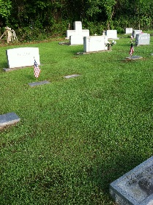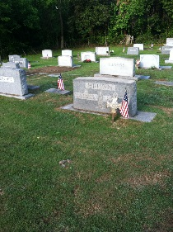

 The 1Million Book Effort was a huge success. This project was initiated by the South Carolina Conference to collect 1,000,000 new age-appropriate books for children throughout the state. First United Methodist Church provided more than $450 and numerous books to the cause. Thank you to all who participated in this very important project. Children are our future and every child deserves the tools to succeed.

************

 Please join us on June 29th as we welcome Rev. Julie Songer Belman to the pulpit. We welcome Rev. Belman and her husband, Travis to First United Methodist Church and to Winnsboro. Help us give Rev. Belman a warm Methodist greeting!

John 1:1 - In the beginning was the Word, and the Word was with God, and the Word was God.
***************

We often pray for big things and forget to give thanks for small special gifts.

Important Summer Dates to Remember:

June 4 – Administrative Board

June 22 – DropIn for Sistare’s

June 25 – Minister Moving Day

June 29 – Rev. Belman’s 1st Sermon

July 12 – 19 – Salkahatchie Summer Camp. First Methodist and Bethel ARP provide lunch for 200 on Thursday, July 17. Cookout at Bob and Sarah’s on Tuesday, July 15.

July 13 – DropIn for Belman’s

Check the Bulletin for any other events.



Join us on June 22 between 4:00 pm and 6:00 pm
for a DropIn as we say goodbye to

Bart and Anna Sistare.

We would like to thank the Sistare’s for their service to First United Methodist Church. 

Join us on July 13 between 4:00 pm and 6:00 pm
for a DropIn as we welcome

Julie and Travis Belman.

We would like to extend a warm Methodist welcome to Rev. Belman as she begins her time with us at First Church.


