THE FIRST WORD

2014 - 7 First United Methodist Church – 109 West College Street – Winnsboro, SC 7 - 2014

Just Squatters
“Therefore do not worry, saying, ‘What will we eat?’ or ‘What will we drink?’ or ‘What will we wear?’ For it is the Gentiles who strive for all these things; and indeed your heavenly Father knows that you need all these things. But strive first for the kingdom of God and his righteousness, and all these things will be given to you as well. So do not worry about tomorrow, for tomorrow will bring worries of its own. Today’s trouble is enough for today.” Matthew 6:31-34
Ah! The fresh paint is drying; my "to do" list is getting shorter; the pile of boxes is finally gone! Travis and I have moved into the lovely Winnsboro parsonage, our second church home. I have a friend who is a Presbyterian pastor's wife; they also live in a great parsonage. Whenever folks compliment her on her home, she smiles and says, "Well, it's not ours; we're really just squatters."
After living in New York City for several years, then Atlanta, and now moving anywhere in South Carolina the Bishop appoints me, I’ve learned a lot about the concept of home. One lesson about home is that we're all really just squatters. Even those who own their own homes really are just squatters. Most of us call home “my house” when it’s really not ours at all.
The Gospel of Matthew tells us not to worry. I used to scoff while reading the passage from Chapter 6 about how God will provide for us because we are more valuable than birds of the air and lilies of the field. Tell that to the homeless people working for pennies at Christ Central. And I don't mean to be glib about a real and growing problem. But maybe there's more of a lesson in Matthew 6 than what first meets the eye - typical of a parable of Jesus!
If we all consider ourselves squatters in this place, what worries could we let go of? What room would I have left in my heart if I could let go of that "to do list" that is dwindling but not yet gone? Jesus tells us to strive first for the kingdom of God and not worry about our lives. We're really just squatters here anyway; our permanence is in the permanence of God. We are only temporary tenants of this place and while we are here are there important things we can be worrying about while letting go of the unimportant things?
When I think of striving for the kingdom of God as my main concern, I immediately think of the beatitudes. They provide such a poetic description of the kingdom of God – a kingdom where the poor, the mourners, the meek, the hungry and thirsty, the pure in heart, the peacemakers, the persecuted are ALL present and filled, laughing, receiving mercy, and in the blessed permanent presence of God. No one is a squatter anymore!
Grace and Peace to you,
Rev. Julie Belman

OUR MINISTRY FOR
September

USHERS:
Bob Drake and Brock Williams

COUNTERS:
Mary Jim Gunter and Patsy Black
Sallie Kate and Donnie Laird
Alex Rabb and Jay Lucas
Roy Barnett and Jim Baughman

Acolyte:
Berkley Derrick


TO MEMBERS OF OUR CHURCH FAMILY WITH BIRTHDAYS IN
September

Lisa Brendle 5
Coleman Blackwelder 9
Brad Caulder 10
Bll Haslett 10
Justin Blackelder 11
Jim Futrell 14
Bruce Palmer 15
David Barr 21
Michael Sanders 21
Jerry Spence 24

PRAYER LIST

Susan Jackson, Sara Duncan, Ann Bailey, Billy Boulware, Jr., Betty Coleman, Becky McAlister, Brent Dorrier, Vicky Melvin, Stewart Goudelock, Frank Martin, Rev. Don McKinney, Lynne Moore, Julie Reese, Maudie Douglas, Taylor Novinger, Rosetta Watson, Merrill Jennings Wood, Mary Thomas, Chip Julie and Madeline Fischesser, Scott VanVick and Russ Pearson, Jennifer Daniels, Carl and Katherine Douglas, Albertia Bundy and Annette Clowney

Please, remember in prayer those serving our country in our armed forces both at home and overseas.

When you can, remember to send a card, call or visit

Mabel Ward 9370 Windsor Lake Blvd. Apt. #206 Columbia, SC 29223
Katherine Rabb 1330 India Hook Road, Apt. 108 Rock Hill, SC 29732
Lisa Lewis Meyer The Heritage at Lowman, PO Box 444
White Rock, SC 29177
Dot Yon Goodwin House Apt. #401, 3440 S. Jefferson St.
Falls Church, VA 22041
Elise Williams 9423 Old Douglass Road, Blackstock, SC 29014
Edith McAlister 110 Summit Hills Drive, Apt. #317,
Spartanburg, SC 29307
Becky McMaster NHC Room 228, 7601 Parkland (PO Box 25548), Columbia SC 29223
Forest Hughes Fairfield Health Care, 117 Bellfield Road
Ridgeway, SC 29130

.
(Please call the church office if you would like your birthday to be mentioned in our monthly tribute.)

Church Contact Information
CHURCH: 635-4087
FAX: 635-4496
www.firstmethodistwinnsboro.com
E-mail: Firstumc@hotmail.com (office)
Fcwpastor@hotmail.com (pastor)

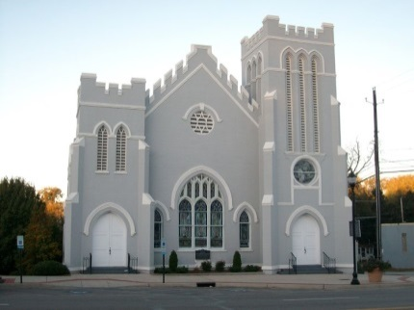

Visit our website:

www.firstmethodistwinnsboro.com

and like us on Facebook!

Jim Futrell, Volunteer with Most Service hours this Quarter (144 hours from April to June 2014) at the Billy Graham Library.

Treasurer’s Report (Through August 12)
Collected: $118,872.00
Needed: $118,557.76



Fairfield Council on Aging needs volunteers to deliver Meals on Wheels. Delivery times are between 11 am and Noon. Please call Beth Bonds at 635-3015 if you are interested.

The Winnsboro Senior Center is open to the public Monday-Friday 9:00am-4:00pm. Lunch is offered every weekday for participants who are 60 or older. Reservations must be made one day in advance and assessments are required to be completed for anyone who wishes to participate in the lunch program. There is money available for programs thru the SC Lt. Governor's Office on Aging, but due to low participation numbers, the Winnsboro Senior Center has not been able to qualify for this funding. Please join us for lunch and programs and help us keep this valuable resource available to our seniors in Fairfield County.

 When you can, please make donations to the Fairfield County Food Bank. We have a container at the back door or you can leave food items in the Narthex. Cash or checks are always welcome!

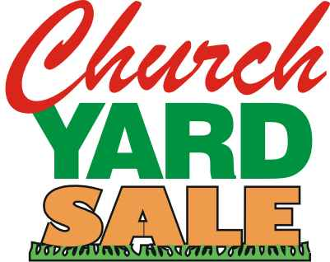

Mark You Calendar!!

Friday, September 5 and
Saturday, September 6

The First United Methodist Women will host the Yard Sale on Friday, September 5 and Saturday September 6, 2014 at the church. Volunteers are still needed to sort and price the items. Volunteers are also needed to work the event. This year’s inventory is larger than last year’s inventory. We have been blessed with many unbelievable donations. We expect to have a huge turnout and need your help. Please mark your calendar and help us work this event and support the ministries of the women of the church.

Last year the monies went to Red Cross, Salkahatchie, Food Bank, as well as various other local ministries.

Please call Frances Porter at 718-6293 to get your name on the volunteer list!



Altar Flower Schedule

SEPTEMBER FLOWER CALENDAR

September 7 – Wanda Neese

September 14

September 21 – Bob and Sarah McMaster

September 28

If you would like to put flowers in the sanctuary, please call the church office or sign up on the flower calendar located in the hallway between the fellowship hall and the sanctuary.

OCTOBER FLOWER CALENDAR

October 5

October 12

October 19

October 26 – Win McMaster

NOVEMBER

November 2

November 9

November 16

November 23

November 30

First Methodist News
 We are so proud to announce the newest member of First United Methodist Church will arrive in February, 2015! Congratulations to Julie and Travis!

Reminder: The Men’s Club will resume September 23, 2014

Summary of Committee Meetings:

Shepherd Committee – Met August 7 with 12 in attendance. The list of “sheep” will receive calls, cards and prayers. An updated list is being created identifying non-resident members. The shepherds send special prayers to Carl and Katherine Douglas and Julie Reese. Next meeting will be October 23, 2014 at 6:00 p.m.
Finance Committee – Met August 13. The committee reviewed the rules and regulations of the Book of Discipline. The committee requested a credit card to be used by the office staff for purchasing items at various locations so “best price” practice can be utilized. The committee will meet every 3rd Tuesday of the month at 6:30. The next meeting will be September 16, 2014.
Trustees Committee – Met August 14. The committee discussed the parsonage improvements, the use of the Bruce House, a new security system and/or locks for the back door, security lighting at the back door and playground, the church cemetery and representation at other committee meetings.

Summer Vacation Bible School
Workshop of Wonders!

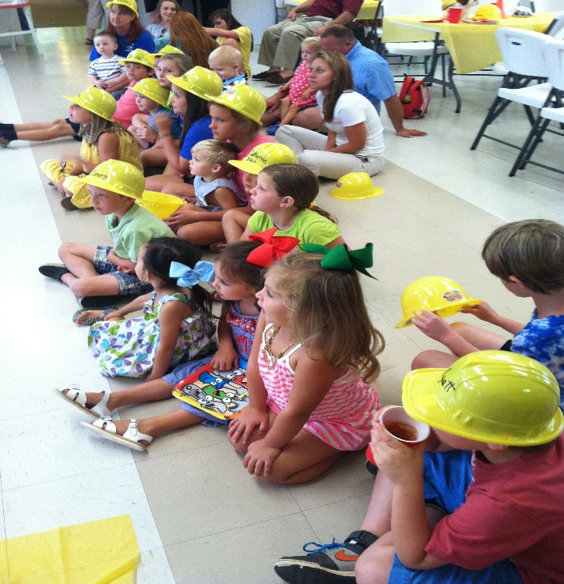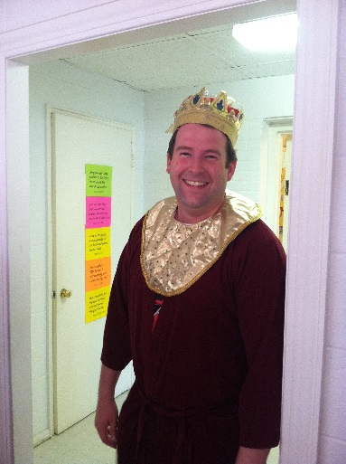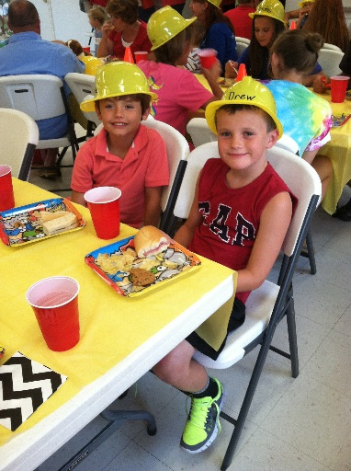
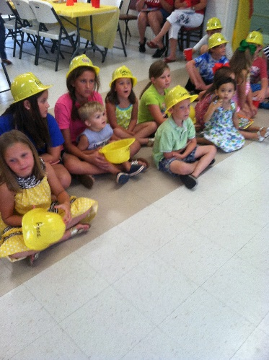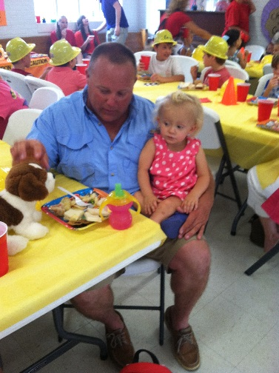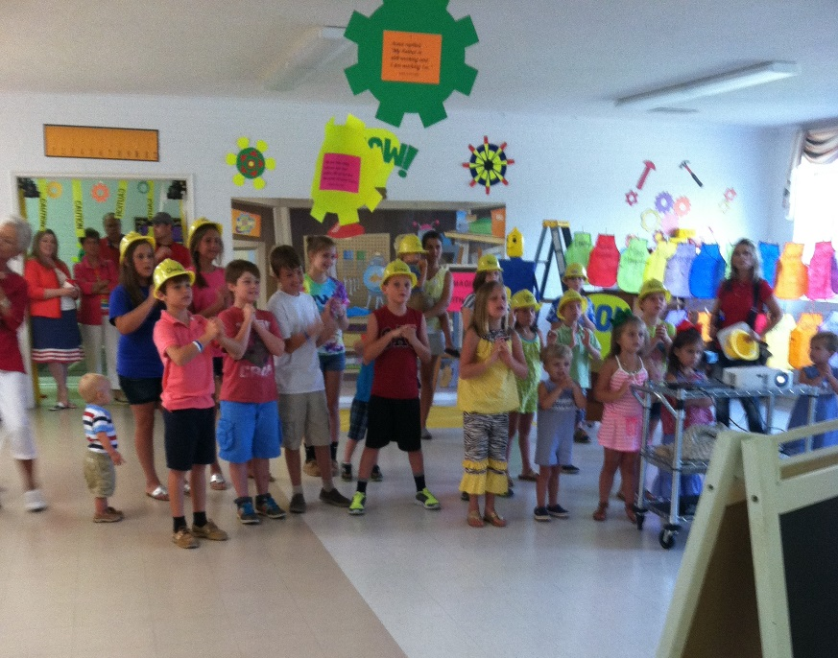
Vacation Bible School was a huge success! We had more kids than ever before! A big Methodist thank you to all who worked so diligently. A special thank you to Brice Porter, Mary Swearingen, Sallie Williams, Doug Williams, Coleman Blackwelder, Jen Lucas, Grayson Caulder, Brock Williams, Brad Williams, Justin Blackwelder, Kay Williams, Tutta Startsman, Lenora Porter, Pastor Julie and Travis Belman, and all others who worked so diligently every day to make sure the classes were taught, the children were fed, and most importantly that the love of God was shared. This was the first year we had classes for the adults and it was an overwhelming success, too!
And whatever you do, in word or deed, do everything in the name of the Lord Jesus, giving thanks to God the Father through him. Colossians 3:17

Memorials and Special Gifts

In Memory of
George Bender
By
Win McMaster
Peggy H. Ayers
Bill and Linda Haslett
McClary-Way Class
Curlee McMaster Douglas Jennings Circle
Don and Mary Jim Gunter

In Memory of
Carol Berthold
And
Alvin Raley
By
Don and Mary Jim Gunter

In Memory of
Mozelle Wright
By
Paul and Bobbie Dove

In Honor of
Travis and Julie Belman
By
Sam and Sandra Reese

Special Gift in Memory of
George Bender to the
Music Ministry of the Church
By
Hal and Pat Frish

