Order of Worship
October 26, 2014
20th Sunday after Pentecost

PRELUDE

WELCOME AND ANNOUNCEMENTS

INTROIT The Lord Is In His Holy Temple CHOIR
George Root

PRAYER
Everlasting God, you have been our dwelling place in all generations. Since the creation of the world, you have nurtured us with your love. And yet we shamefully acknowledge that we do not always share your love with others. We are selective about who we choose as neighbors . . . only those who are clean, who look like us, who talk right, who seem safe. Loving God,
teach us to love you more fully. For in loving you, our lives will show love to all others, even as your love encompasses all your creation, in all generations. We pray in the name of your greatest gift of love, Jesus Christ. Amen.

*HYMN: #430 O Master, Let Me Walk with Thee

MORNING PRAYER

LORD’S PRAYER WITH CHORAL RESPONSE

Our Father, who art in heaven,
Hallowed be thy Name.
Thy Kingdom come.
Thy will be done on earth,
As it is in heaven.
Give us this day our daily bread.
And forgive us our trespasses,
As we forgive those who trespass against us.
And lead us not into temptation,
But deliver us from evil.
For thine is the kingdom,
The power, and the glory, forever.
Amen.

ANTHEM Set Me as a Seal Upon Your Heart CHOIR
Song of Solomon 8:6-7, Psalm 51:10-13 Arr. By Anna Laura Page

*RESPONSIVE READING #777 Psalm 42

*GLORIA PATRI # 71 Greatorex

*AFFIRMATION OF FAITH #881

The Apostles’ Creed

I believe in God the Father Almighty,
maker of heaven and earth;
And in Jesus Christ his only Son our Lord:
who was conceived by the Holy Spirit,
born of the Virgin Mary,
suffered under Pontius Pilate,
was crucified, dead, and buried;
the third day he rose from the dead;
he ascended into heaven,
and sitteth at the right hand of God the Father Almighty;
from thence he shall come to judge the quick and the dead.
I believe in the Holy Spirit,
the holy catholic church,
the communion of saints,
the forgiveness of sins
the resurrection of the body,
and the life everlasting. Amen

CHILDREN’S TIME

STEWARDSHIP MOMENT Sallie Williams

OFFERTORY

*DOXOLOGY #95 Old 100th

*HYMN: #354 I Surrender All (verses 1,2, &5)

SCRIPTURE LESSON Mark 12:38-44

This is the Word of God, for the people of God
Thanks be to God

SERMON “Upside Down, Turned Around” Rev. Belman

*HYMN: #399 Take My Life, and Let It Be

During the singing of the closing hymn, you are invited to the altar for prayer, to unite with the church, or for other responses to God's love.

*BENEDICTION A Gaelic Benediction CHOIR
Jerry Ulrich

*POSTLUDE

WELCOME VISITORS!

Welcome to our church family, we're glad that you could come. We're honored to share this day with you as we worship God's risen Son. We hope that God will touch your life as we worship side by side and that you leave this place today with the peace of God inside.

THOSE WHO SERVE THIS WEEK

Ushers: Terry Melvin and Jackie Wilkes
Counters: Roy Barnett and Jim Baughman

Announcements

- 1st practice for Winnsboro Choral Society (Handel’s Messiah), today at 3:00, Bethel ARP Church
- BBQ plate tickets for sale, $7.00 (all proceeds benefit Billy Beam), pick up Saturday Nov. 22. See Heath Caldwell
- Family Night Supper – Thursday, Oct. 30th.

- Charge Conference – Wednesday, October 29, 7:30 p.m.

- Please sign up for flowers on the board behind the sanctuary. We have four open dates for November.

The altar flowers are given to the glory of God and in loving memory of her husband, Spencer McMaster, Jr. by Win McMaster.

If you would like to provide altar flowers, please sign up on the flower calendar in the hall behind the sanctuary.

Prayer List

Paul Cramer, Sara Duncan, Rev. Don McKinney, Billy Boulware, Jr., Betty Coleman, Chip, Julie and Madeline Fischesser, Brent Dorrier, Frank Martin, Taylor Novinger, Lynne Moore, Mabel Ward, Mary Thomas, Rosetta Watson, Julie Reese, Russ Pearson, Stewart Goudelock, Merrill J. Wood, Carl and Katherine Douglas, Maudie Douglas, Vicky Melvin, Annette Clowney, Scott Vanvick, Becky McAlister, Albertia Bundy, Gary Brown, Blaine Riley, Don Gunter

Please remember in prayer those serving our country in our armed forces both at home and overseas.

When you can, remember to send a card, call or visit

Doris Myfelt 3195 Rio Dosa Drive #2103, Lexington, KY 40509 (859)309-9284
Susan Jackson, Harbor Chase, 1611 Constitution Blvd., Rock Hill, SC 29732. Phone (803) 366-7431

Dot Yon Goodwin House Apt. #401, 3440 S. Jefferson Street
Falls Church, VA 22041

Elise Williams 9423 Old Douglass Road, Blackstock, SC 29014

Edith McAlister 110 Summit Hills Drive, Apt. #317,
Spartanburg, SC 29307

Becky McMaster NHC Room 311, 7601 Parkland (PO Box 25548), Columbia SC 29223

Forest Hughes Fairfield Health Care, 117 Bellfield Road
Ridgeway, SC 29130

Katherine Rabb 1330 India Hook Road, Westminister Towers, Apt. 511 Rock Hill, SC 29732
Lisa Lewis Meyer The Heritage at Lowman, PO Box 444
White Rock, SC 29177

Mabel Ward 9370 Windsor Lake Blvd. Apt. #206 Columbia, SC 29223

Stewardship Report for October 19, 2014

Sunday School Attendance | 31
Worship Attendance | 103
Sunday School Offering | 29.00
Worship Offering | 3510.51
Needed Each Week | 3,714.75
Received Year to Date | 159,306.37
Needed Year to Date | 156,019.50

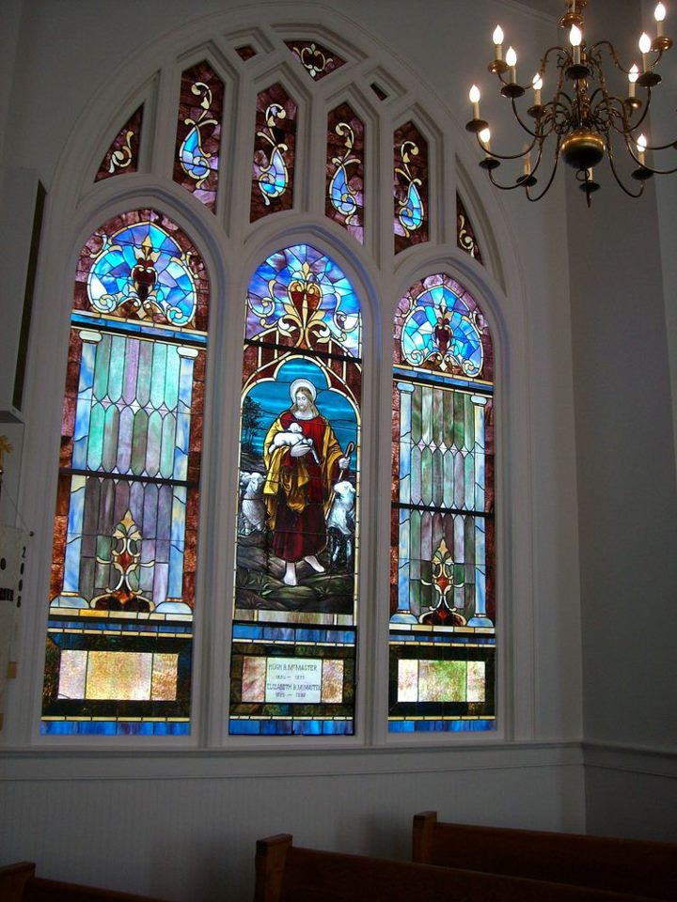

Seek God. Love All People.
Change the World.

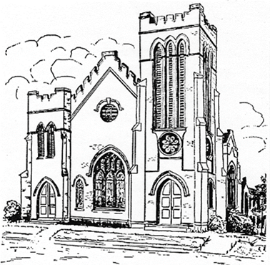
First United Methodist Church
109 W. College Street
Winnsboro, SC 29180

firstumc@hotmail.com (office)
FCWpastor@hotmail.com (pastor)
www.firstmethodistwinnsboro.com

Pastor: Rev. Julie Songer Belman
Choir Director: Wanda Neese
Organist: Esther J. Baughman
Lay Leader: Marcia Bonds
Church Secretary: Julie Barfield
Financial Secretary: Peggy H. Ayers
Treasurer: Paul Dove
Pastor Emeritus: Rev. F. Bundy Bynum

