Order of Worship
April 27, 2014
2nd Sunday of Easter

PRELUDE

Welcome Announcements
Congregational Greeting

INTROIT Lo, He Comes With Clouds Descending CHOIR
Charles Wesley

*Prayer

Almighty God,
You give us the joy of celebrating our Lord's resurrection.
Give us also the joys of life in your service,
And bring us at last to the full joy of life eternal;
Through Jesus Christ our Lord. Amen.

*Hymn : 308 Thine Be the Glory

Morning Prayer

Lord’s Prayer with Choral Response

Anthem Come Proclaim the Victory CHOIR
J.M. Martin/J.P. Williams

RESPONSIVE READING PSALM 16 Page 748

*Gloria Patri # 71 Greatorex

*Affirmation of Faith #881 The Apostles’ Creed

Children’s Time

Offertory

*Doxology #95 Praise God from Whom All Blessings Flow Old 100th

*Hymn: #310 He Lives

GOSPEL John 20:19-31 Page:114

Sermon Absent for roll call Bart Sistare

*Hymn:#500 Spirit of God, Descend Upon My Heart

*Benediction A Clare Benediction CHOIR
John Rutter
*Postlude

During the singing of the closing hymn, you are invited to the altar for prayer, to unite with the church, or for other responses to God's love.

WELCOME VISITORS!

Welcome to our church family, we're glad that you could come.
We're honored to share this day with you as we worship God's risen Son. We hope that God will touch your life as we worship side by side and that you leave this place today with the peace of God inside.

THOSE WHO SERVE THIS WEEK

Ushers: Bill Haslett and Martin Caulder
Counters: Roy Barnett and Jim Baughman
Acolyte: Berkley Derrick

Announcements

- Bible Study: The Miracles of Jesus meets in the Conference Room tonight at 6:00 p.m.
- Choir Practice: Wednesday 7:30 pm

The 2014 Flower Calendar is available if you are interested in providing flowers for worship. Please sign up in the hallway between the Fellowship Hall and Sanctuary.

 The flowers in the sanctuary this morning are placed to the Glory of God and in honor of the Choir by Marion and Vickie Robinson.

Prayer List

Marcia Bonds | Ann Bailey | Rev. Don McKinney
Billy Boulware, Jr. | Betty Coleman | Julie Reese
Brent Dorrier | Frank Martin | Taylor Novinger
Lynne Moore | Carl Douglas | Mary Thomas
Stewart Goudelock | Russ Pearson | Chip, Julie and Madeline Fischesser
Rosetta Watson | Merrill Jennings Wood | Betsy Stevenson
Maudie Douglas | Vicky Melvin | Susan Jackson
Scott Vanvick | Becky McAlister | Pat Curlee

Please remember in prayer those serving our country in our armed forces both at home and overseas

When you can, remember to send a card, call or visit

Mabel Ward: The Waterford, Columbia,
Katherine Rabb: Rock Hill,
Lisa Lewis Meyer, Lowman White Rock,
Dot Yon, Falls Church, Va
Elise Williams and Edith McAlister Spartanburg,
Becky McMaster NHC, Columbia
Forrest Hughes, Fairfield Health Care

STEWARDSHIP REPORT FOR APRIL 20, 2014
Sunday School Attendance 44

Worship Attendance 135
Sunday School Offering 33.00

Worship Offering $2,576.54
Needed Each Week 3,714.75

Received Year-to-Date $55,487.77 $6,789.61

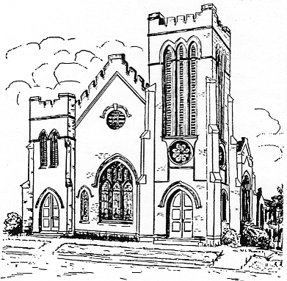
First United Methodist Church
109 W. College Street
Winnsboro, SC 29180
firstumc@hotmail.com
www.firstmethodistwinnsboro.com

Pastor: Rev. J. Bart Sistare
Choir Director: Wanda Neese
Organist: Esther J. Baughman
Lay Leader: Marcia Bonds
Church Secretary: Julie Barfield
Financial Secretary: Peggy H. Ayers
Treasurer: Paul Dove
Pastor Emeritus: Rev. F. Bundy Bynum

